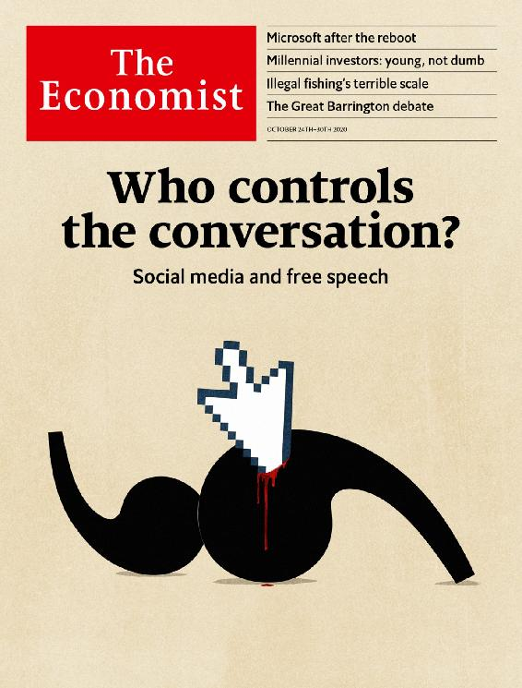

# Table of Contents

The Economist [Thu, 22 Oct 2020]

The world this week

Politics this week

Business this week

KAL’s cartoon

Leaders

Free speech: Who controls the conversation?

Brexit: Seal the deal

Some lessons from Microsoft: Blue-sky thinking

Financial markets: Young, but not dumb

Illegal fishing: Monsters of the deep

Letters

On the Uyghurs, Venus, Catholic voters, Zoom meetings: Letters to the editor

Briefing

Social media and free speech: The great clean-up

Microsoft: After the reboot

United States

Election uncertainties: The known unknowns

Donald Trump’s record: Pumped up

Trade: Tariff man

Mining for votes in Montana: Gold in them hills

Museum funding: Going, going, gone

The Equality Act: Liberalism and its contradictions

Lexington: The blue wave

The Americas

Chile: In need of a new edifice

Bello: Don’t mess up the miracle

Asia

Disinformation in Myanmar: Anti-social network

North Korea and the world: Not-so-splendid isolation

New Zealand’s election: Labour day

Drugs in India: Weed killers

Banyan: A feverish mood

China

Opinion polls: The 1.4bn-people question

Economic rebound: A big splash

Chaguan: Be China’s friend, or else

Middle East & Africa

Egypt: No contest

America and the Middle East: Waiting game

Tanzania’s elections: The bulldozer rumbles on

Conservation in Africa: Elephants’ graveyard no more

Police violence in Nigeria: The young have had enough

Europe

Covid-19 in Europe: A patchwork of red, yellow and green

Swedish defence: Less neutral, more beefy

Georgia: Misha’s return?

France: The sacred right to offend

Charlemagne: A powerful yet puny parliament

Britain

London as a financial centre: Brex and the City

Elected mayors: Our friends in the north

Social care: Big old problem

Brexit and data firms: Inadequate

Bagehot: What Biden would mean for Boris

International

Felonious fishing: The outlaw sea

Business

Italian business: How the leopard lost its spots

Technology and competition: Search query

Utilities: What next

Bartleby: Fighting spirit

Schumpeter: Free the data serfs!

Finance & economics

Millennials and finance: The generation game

The World Trade Organisation: The home straight

Lael Brainard: Top contender

Emerging markets: The rule-makers

Price gouging: Disaster profiteering

Buttonwood: A new career in a new town

Free exchange: Graduates of the world, unite!

We’re hiring: Wanted: a new writer to cover finance

Science & technology

Controlling the pandemic: When doctors disagree

Autonomous vehicles: Look, no hands!

Space exploration: Close encounters of the sampling kind

Ecology: Time to unwire

Books & arts

Internal exile: Worlds of their own

American fiction: Made for you and me

The Spanish civil war: ¡No pasarán!

North Korean architecture: Despot decor

Economic & financial indicators

Economic data, commodities and markets

Graphic detail

Voting in America: Mailing it in

Obituary

Samuel Paty: Liberty’s foot-soldier

* The world this week
* Leaders
* Letters
* Briefing
* United States
* The Americas
* Asia
* China
* Middle East & Africa
* Europe
* Britain
* International
* Business
* Finance & economics
* Science & technology
* Books & arts
* Economic & financial indicators
* Graphic detail
* Obituary

# The world this week

* Politics this week
* Business this week
* KAL’s cartoon

| Next | Section menu | Main menu |

Politics this week

Oct 22nd 2020 |

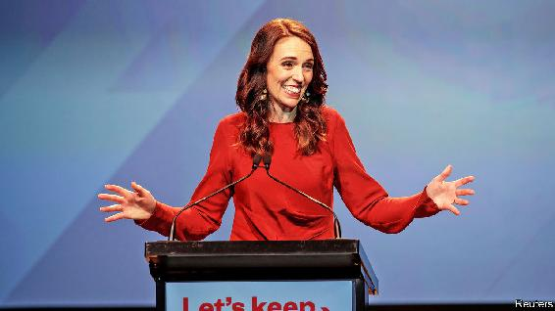

New Zealand’s Labour Party romped home to secure a fresh term at a general election, winning 49% of the vote and an overall parliamentary majority, the first for any party in the country since proportional representation was adopted in 1996. Jacinda Ardern, the prime minister, has been praised for her handling of the covid-19 outbreak. The centre-right National Party was crushed, taking just 27% of the vote, a defeat it did not envisage when it chose Judith “Crusher” Collins as its leader in July. See [article](https://www.economist.com/node/21793519).

The authorities in Thailand lifted curbs that had been imposed on protests against the government and the role of the monarchy. The restrictions did not work: they enraged people and spurred them to attend huge rallies calling for the prime minister to resign. See [article](https://www.economist.com/node/21793520).

The police force in Sindh, Pakistan’s second-most-populous province, threatened to walk out in protest at what they said was the abduction of their inspector-general by army troops, who pressed him to sign an arrest warrant for the son-in-law of Nawaz Sharif, an exiled former prime minister.

Amid a tense stand-off along a disputed mountainous border, India quickly returned a Chinese soldier who had strayed across the line and got lost. China and India are soon to hold more talks following several skirmishes this year.

Robert Destro, the newly appointed diplomat responsible for American policy on Tibet, held a meeting at the State Department with the head of the Tibetan government-in-exile, Lobsang Sangay. It was the State Department’s first hosting of such a meeting since Mr Sangay took up the position in 2011.

China’s anti-graft agency said it had placed the deputy director of the National Energy Administration under investigation. State media say at least 22 energy-industry officials have been investigated or punished this year.

Samuel Paty, a teacher in France, was beheaded by a young refugee originally from Chechnya. The killer, who was shot by police, acted after a parent condemned Mr Paty on social media for showing his pupils caricatures of the Prophet Muhammad in a lesson on free speech. Emmanuel Macron ordered the closure of one Islamist association; police raided several more. See [article](https://www.economist.com/node/21793492).

Tatar, for now

Ersin Tatar was elected president of North Cyprus, the Turkish part of the divided island. As a supporter of a two-state model, Mr Tatar’s election is likely to set back efforts to unite Cyprus under a power-sharing model.

Nigerian soldiers fired at protesters who were demonstrating against police violence, killing at least a dozen. Thousands have taken to the streets in recent weeks calling on the government to disband a police unit responsible for murder, torture and theft. See article.

At least 13 people were reportedly killed in clashes in Guinea after the opposition candidate declared victory in the presidential election in which he ran against the incumbent, President Alpha Condé. The electoral commission said it was still counting votes.

America will remove Sudan from its list of state sponsors of terrorism after the country agreed to pay $335m in compensation to American victims of terrorist attacks in Kenya and Tanzania in 1998 and in Yemen in 2000.

Boris Johnson, Britain’s prime minister, imposed the strictest “tier 3” pandemic restrictions on Greater Manchester, after talks with local leaders broke down. Financial aid was the sticking point. Andy Burnham, Manchester’s mayor, said the amount of money his city had been offered was “brutal”. South Yorkshire was also placed in tier 3. See [article](https://www.economist.com/node/21793468).

Michel Barnier, the EU’s negotiator with Britain on a post-Brexit trade pact, claimed a deal was “within reach” but acknowledged that compromises were needed on both sides. This came after Mr Johnson declared that time had run out. The talks resumed. See [article](https://www.economist.com/node/21793458).

America’s Supreme Court allowed a law to stand in Pennsylvania that permits officials to count postal votes received up to three days after the presidential election. It is estimated that by October 22nd, 40m people across America had already cast ballots, either by voting early at polling stations or by post. See [article](https://www.economist.com/node/21793474).

Luis Arce, the candidate of the Movement to Socialism, won Bolivia’s presidential election in the first round. He is the political heir of Evo Morales, who was forced from office last year by protests. See [article](https://www.economist.com/node/21793459).

Salvador Cienfuegos, who was Mexico’s defence minister from 2012 to 2018, was arrested at Los Angeles’s airport and charged with drug-trafficking and money laundering.

Cheeky

Brazilian police raided the home of Chico Rodrigues, a senator allied with the president, Jair Bolsonaro, and discovered 30,000 reais ($5,000) wedged between his buttocks. Mr Rodrigues denies diverting funds meant for the pandemic.

Asbestos, a town of 7,000 people in Quebec near a mine from which the toxic mineral was once extracted, voted to change its name to Val-des-Sources (it is near three lakes).

Coronavirus briefs

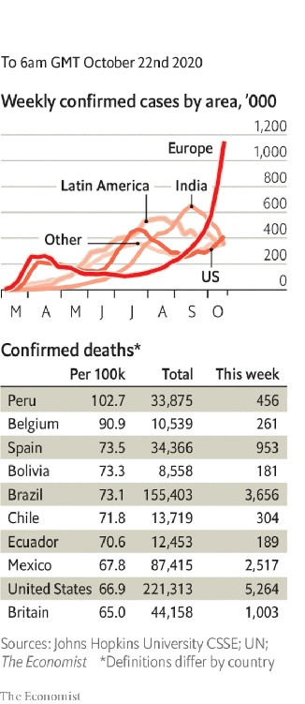

Iran again broke its single-day record for covid-19 deaths. Hospitals in Tehran, the capital, ran out of intensive-care beds and suspended all non-emergency treatments.

Israel eased a month-long nationwide lockdown, its second since the beginning of the pandemic. It has seen a significant decline in the number of new cases.

Health experts cast doubt on the claim by a government panel in India that the virus had reached its peak in the country. Cumulative cases passed 7.7m this week.

Ireland was put back into a strict lockdown. The government had resisted implementing the measures, which scientists were calling for.

The go ahead was given in Britain for the world’s first “human-challenge clinical trials”, in which volunteers will be dosed with the virus.

This article was downloaded by calibre from <https://www.economist.com/the-world-this-week/2020/10/22/politics-this-week>

| Section menu | Main menu |

| Next | Section menu | Main menu | Previous |

Business this week

Oct 22nd 2020 |

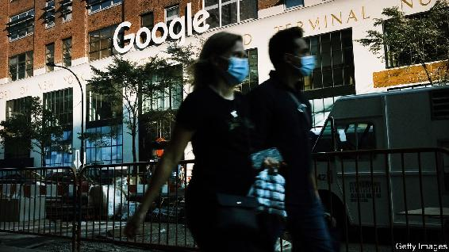

America’s Justice Department sued Google for violating antitrust laws, accusing what it described as “the gatekeeper of the internet” of choking off competition for search engines by striking deals with Apple, mobile-phone carriers and other companies. It is the department’s biggest antitrust suit since taking on Microsoft in 1998. With lots of cash on hand, Google is digging in for a long legal fight. It says there is plenty of competition, pointing to consumers who search and shop on Amazon. See article.

In a busy week, the Justice Department also announced a settlement with Purdue Pharma, the maker of OxyContin, which will plead guilty to criminal charges in relation to the opioid crisis and pay $8.3bn in penalties, the most ever imposed on a drugs company. The Sackler family, which owns Purdue, agreed to pay $225m in related damages.

The space race in cloud computing gathered speed, as Microsoft launched a plan to connect its data centres, operating from anywhere in the world, with low-orbit satellites provided by SpaceX. The project is aimed at private firms and government agencies that gather satellite data but don’t want to spend on ground infrastructure to process the information. Amazon unveiled a similar service in June. See article.

Sweden’s telecoms regulator banned Huawei and ZTE from providing equipment for 5G networks following advice from the intelligence services about the potential threat to national security. The move comes ahead of an impending decision from the German government on whether it will also shut out Chinese makers of 5G network equipment.

In another deal that reshapes its business, Intel disclosed that it is selling its NAND solid-state storage division to sk Hynix, a South Korean chipmaker, for $9bn. Last year Intel sold its smartphone modem business to Apple.

Ant Group received the final regulatory approval for its forthcoming dual listing in Hong Kong and Shanghai. The Chinese fintech firm’s IPO is expected to be world’s largest.

Tearing up the rule book

America’s federal government racked up a budget deficit of $3.1trn for the fiscal year ending September 30th, $2trn more than the White House forecast in February when it released its budget. The government spent $6.5trn in all, about a third of it on the covid-19 emergency relief package in March.

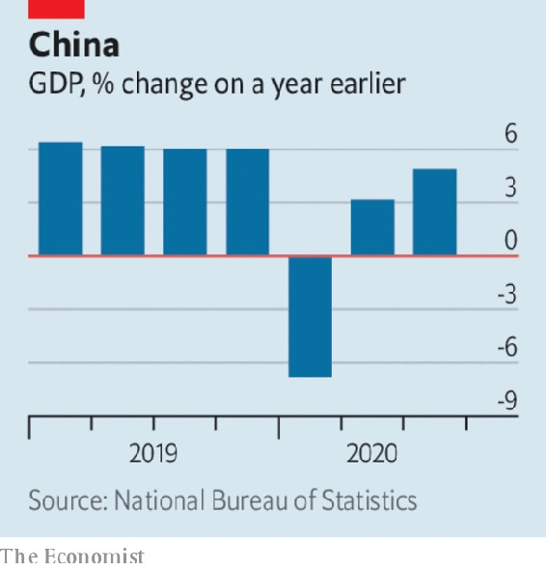

China’s economy grew by 4.9% in the third quarter compared with the same three months last year. That was below the expectations of most economists, but an improvement on the second quarter’s 3.2%. The rate of output in Chinese industrial production has returned to pre-pandemic levels and retail sales have picked up. See [article](https://www.economist.com/node/21793479).

Moody’s cut its credit rating on Britain’s sovereign debt by one notch. The rating is still of high quality, though one factor ominously underpinning Moody’s downgrade is the “diminished” quality of Britain’s “legislative and executive institutions”.

More takeover deals were announced in America’s shale energy industry, as companies scramble to consolidate in an oil market beset by falling demand. ConocoPhillips agreed to buy Concho Resources for $9.7bn. And Pioneer Natural Resources said it would acquire Parsley Energy in a $7.6bn transaction.

A study by the OECD warned that covid-19 was slowing the flow of migration, with the number of new residency permits granted to workers in OECD countries down by 46% in the first half of the year compared with the same six months last year, the largest drop on record. The organisation thinks that mobility will not return to previous levels for some time, because of weak labour demand, persistent travel restrictions, the take-up of working from home and remote learning by students.

Stranger things

Netflix pulled in just 2.2m new subscribers in the third quarter, down from the 15.8m and 10m it added in the first and second quarters, when people turned to the video-streaming service during lockdown. Having been a one-man show for years, Netflix now faces competition from Amazon Prime, Disney+ and others. Like its rivals, it has been hampered by pandemic restrictions that have curtailed production of new films and series.

Cathay Pacific said it would shed 8,500 jobs because of the pandemic. Like others in the industry the airline, based in Hong Kong, has been hit hard by flight restrictions and has also had to contend with headwinds from the city’s recent political turbulence. As part of its restructuring its regional airline, Cathay Dragon, has stopped flying.

Heathrow airport began offering speedy virus tests to departing passengers for £80 ($105). It is unclear how many destination countries will accept the results.

This article was downloaded by calibre from <https://www.economist.com/the-world-this-week/2020/10/22/business-this-week>

| Section menu | Main menu |

| Next | Section menu | Main menu | Previous |

KAL’s cartoon

Oct 22nd 2020 |

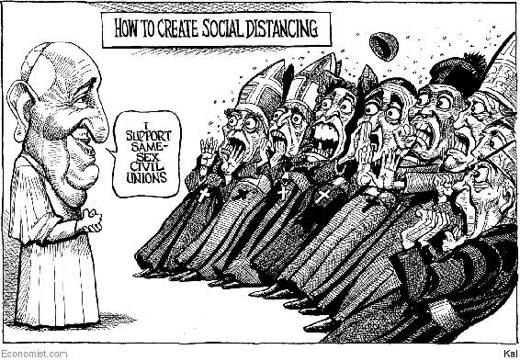

This article was downloaded by calibre from <https://www.economist.com/the-world-this-week/2020/10/22/kals-cartoon>

| Section menu | Main menu |

# Leaders

* Free speech: Who controls the conversation?
* Brexit: Seal the deal
* Some lessons from Microsoft: Blue-sky thinking
* Financial markets: Young, but not dumb
* Illegal fishing: Monsters of the deep

| Next | Section menu | Main menu |

Who controls the conversation

How to deal with free speech on social media

It is too important to be determined by a handful of tech executives

Oct 22nd 2020 |

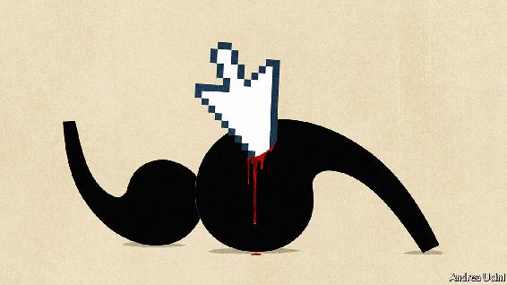

IT IS THE biggest antitrust suit in two decades. On October 20th the Department of Justice (DOJ) alleged that Google ties up phone-makers, networks and browsers in deals that make it the default search engine. The department says this harms consumers, who are deprived of alternatives. The arrangement is sustained by Google’s dominance of search which, because of a global market share of roughly 90%, generates the advertising profits that pay for the deals (see article). The DOJ has not yet said what remedy it wants, but it could force Google and its parent, Alphabet, to change how they structure their business. Don’t hold your breath, though: Google dismisses the suit as nonsense, so the case could drag on for years.

Action against Google may seem far from the storm gathering against Facebook, Twitter and social media. One is laser-focused on a type of corporate contract, the other a category 5 hurricane of popular outrage buffeting unaccountable tech firms for supposedly destroying society. The left says that, from the conspiracy theories of QAnon to the incitement of white supremacists, social media are drowning users in hatred and falsehood. The right accuses the tech firms of censorship, including last week of a dubious article alleging corruption in the family of Joe Biden, the Democratic presidential nominee. And yet the question of what to do about social media is best seen through the same four stages as the case against Google: harm, dominance, remedies and delay. At stake is who controls the rules of public speech.

A tenth of Americans think social media are beneficial; almost two-thirds that they cause harm. Since February YouTube has identified over 200,000 “dangerous or misleading” videos on covid-19. Before the vote in 2016, 110m-130m adult Americans saw fake news. In Myanmar Facebook has been used to incite genocidal attacks against the Rohingyas, a Muslim minority (see article). Last week Samuel Paty, a teacher in France who used cartoons of the Prophet Muhammad to talk about free speech, was murdered after a social-media campaign against him (see Obituary). The killer tweeted an image of Mr Paty’s severed head, lying in the street.

The tech firms’ shifting attempts to sterilise this cesspool mean that a handful of unelected executives are setting the boundaries of free speech (see Briefing). True, radio and TV share the responsibility for misinformation and Republican claims of bias are unproven—right-wing sources often top lists of the most popular items on Facebook and Twitter. But pressure is growing on the tech firms to restrict ever more material. In America the right fears that, urged on by a Democratic White House, Congress and their own employees, the firms’ bosses will follow left-leaning definitions of what is acceptable. Contrast that with the First Amendment’s broad licence to cause offence.

Elsewhere, governments have also used social media companies to go beyond the law, often without public debate. In London the Metropolitan Police requests that they take down legal, but troubling, posts. In June France’s Constitutional Council struck down a deal between the government and the tech companies because it curbed free speech—an initiative that is sure to be revisited after Mr Paty’s murder. Citing Western precedents, more authoritarian governments in countries such as Singapore expect the tech firms to restrict “fake news”—potentially including irksome criticism from opponents.

This might not matter were the networks less dominant. If people could switch as easily as they change breakfast cereal, they could avoid rules they dislike. But switching is like giving up your mobile-phone number: it cuts you off from your friends. Social networks have also become so central to distributing news and opinion that they are, says Mark Zuckerberg, Facebook’s founder, a “town square”. If you want to be part of the conversation you have no choice but to be there, soapbox in hand.

This hold over users has one further dismal implication for truth and decency. In order to sell more ads, the tech companies’ algorithms send you news and posts that they think will grab your attention. Political cynics, con artists and extremists take advantage of this bias towards virality to spread lies and hatred. Bots and deep fakes, realistic posts of public figures doing or saying things that never happened, make their job cheaper and easier. They are rapidly becoming more sophisticated.

The purest remedy for this would be to change the tech firms’ business model and introduce more competition. That is already working well in other areas of tech, like the cloud (see Leader). One idea is for people to own their data individually or collectively (see Schumpeter). The social networks would become utilities paid a flat fee, while people or collectives earned the rent from advertisers and set the parameters for what was served up to them. At a stroke that would align the gains from advertising with the burden upon the people being advertised to. If users could port their data to another network, the tech firms would have to compete to provide a good service.

The obstacles to this are immense. The tech firms’ value would tumble by hundreds of billions of dollars. It is not clear you own the data about your online connections. You could not migrate to a new network without losing the friends who stayed behind unless the platforms were interoperable, as mobile-phone networks are. Perhaps the authorities could impose less sweeping remedies, such as giving users the right to choose feeds set by a neutral rule, not an attention-grabbing algorithm.

The keys to the hype house

Such ideas cannot be implemented quickly, but societies need solutions today. Inevitably, governments will want to set the basic rules at the national level, just as they do for speech. They should define a framework covering obscenity, incitement and defamation and leave judgments about individual posts to others. International human-rights law is a good starting-point, because it leans towards free speech and requires restrictions to be relevant and proportionate, but allows local carve-outs.

Social-media firms should take those standards as their basis. If they want to go further, attaching warnings to or limiting content that is legal, the lodestars should be predictability and transparency. As guardians of the town square, they ought to open their processes to scrutiny and particular decisions to appeal. Ad hoc rule changes by top executives, as with the recent Biden decision, are wrong because they seem arbitrary and political. Hard cases, like kicking opponents of Bashar al-Assad in Syria off a platform for mentioning terrorists, should be open to review by representative non-statutory boards with more power than the one Facebook has created. Independent researchers need much freer access to anonymised data so that they can see how platforms work and recommend reform. Such rule-making should be open to scrutiny. In America politicians can use removing the protection from prosecution granted by Section 230 of the Communications Decency Act as a lever to bring about change.

This will be messy, especially in politics. When societies are divided and the boundary between private and political speech is blurred, decisions to intervene are certain to cause controversy. The tech firms may want to flag abuses, including in post-election presidential tweets, but they should resist getting dragged into every debate. Short of incitement to violence, they should not block political speech. Politicians’ flaws are better exposed by noisy argument than enforced silence. ■

This article was downloaded by calibre from <https://www.economist.com/leaders/2020/10/22/how-to-deal-with-free-speech-on-social-media>

| Section menu | Main menu |

| Next | Section menu | Main menu | Previous |

Britain and Europe

How a “no deal” Brexit can be avoided

It starts with acknowledging the consequences of one

Oct 22nd 2020 |

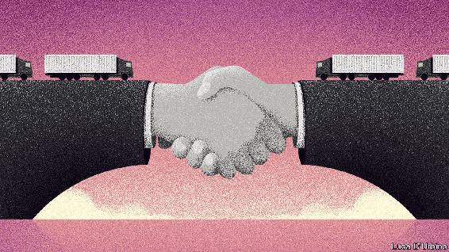

BRITAIN’S CONSERVATIVES are fond of Australia, an Anglosphere place with a flourishing economy, fine weather and fabulous beaches. So when trade talks with the European Union were briefly suspended before resuming this week, and Boris Johnson told Britons they might end up not with the Canada-style free-trade agreement he wanted, but instead leave on “Australian terms”, he made the prospect sound beguilingly sunny.

This is typical Johnsonian spin. If the latest face-to-face talks should collapse and Britain end up with no deal, the terms on which it leaves would not be those that apply to Australia, which has many side-deals and is seeking its own free-trade agreement with the EU. They would be closer to those of Afghanistan, Bhutan or Congo: Britain would have no trade deal at all with its largest trading partner, and little prospect of getting one.

The government’s own modelling suggests the hit to GDP after 15 years would be almost 8% with no deal, against less than 5% for a thin Canadian-style one. Many businesses would be devastated by tariffs, including 10% on cars and 5% on car parts, threatening an industry that employs 800,000 people and accounts for 14% of Britain’s goods exports. The food industry would suffer from EU protectionism, with farmers facing tariffs of 40% or more on lamb and beef exports. Research by UK in a Changing Europe, an academic think-tank, suggests that food prices would rise by as much as 4%.

Non-tariff barriers now matter more than tariffs, and for services they would be erected with or without a deal. But in two cases an acrimonious no-deal Brexit could be damaging. The financial-services industry (see [article](https://www.economist.com/node/21793464)) would suffer more than it already has if the EU refused to accept the equivalence of Britain’s regulation, and many firms, especially those in the digital economy, would struggle without a similar agreement on the adequacy of data protection. Failure to reach a deal would probably exclude Britain from the lucrative European energy market, and might even threaten mitigation measures to allow lorry-drivers and airlines to keep operating on the continent.

Then there is Northern Ireland. No deal would resurrect the threat of a border in Ireland between north and south, which all sides wish to avoid. It would also create problems within the United Kingdom. The protocol that is part of January’s Brexit withdrawal treaty in effect keeps Northern Ireland inside the European single market and customs union, with Great Britain outside. As Mr Johnson has belatedly conceded, that necessitates controls on goods moving between the two. These could be manageable with a trade deal; without one, which would mean not just customs checks but tariffs, the protocol would be far more intrusive. The government’s solution would be to rewrite it unilaterally, but that would create new problems. As the House of Lords made clear in voting against it this week, such a naked breach of international law would undermine trust in Britain.

Worst of all, leaving without a deal would make it hard to talk further. Even a thin trade agreement could be built on, for instance, with renewed efforts to extend its range to more services. Most security co-operation, crucially including access to common intelligence databases, would halt completely after no deal. The bad blood would imperil broader joint diplomacy, a serious loss in a dangerous world. And it would be difficult to restart negotiations, because the EU may well begin by putting back on the table the demands that had prevented a deal in the first place.

Time is short: Britain’s final departure from the EU is on December 31st. However, the latest talks begin with a deal tantalisingly close. The only big obstacles are fish and the EU’s desire for a credible regime to police state aid to industry.

Compromise is possible on both. Given that Britain resorts to subsidies less than other European countries, it is mystifying why a Conservative government would hold out against a deal in order to gain the dubious privilege of handing out lots more taxpayers’ money to private companies. As for fisheries, which contribute barely 0.2% of European GDP, both sides would suffer from there being no deal. European vessels would lose access to richer British waters; British fishermen would lose tariff-free access to the EU market, which buys 70% of their catch. The French are insisting that the EU’s over-generous quotas should persist after Britain leaves. They need to budge on fish, and Britain should drop its newfound enthusiasm for subsidies and its bid to rewrite the Northern Ireland protocol. With those concessions, a deal would be eminently doable.

Britons did not vote to leave the EU without a trade deal in 2016; rather, they were told they would have the easiest trade deal in history. Walking out of talks was not in the manifesto in the election in 2019: an accord was “oven-ready”. A year ago Mr Johnson said that to leave the EU without an agreement would be a failure of statecraft. He was right. It is past time to seal the deal. ■

This article was downloaded by calibre from <https://www.economist.com/leaders/2020/10/22/how-a-no-deal-brexit-can-be-avoided>

| Section menu | Main menu |

| Next | Section menu | Main menu | Previous |

Microsoft and tech competition

Is tech getting more competitive?

In cloud computing, at least, the contest is fierce

Oct 22nd 2020 |

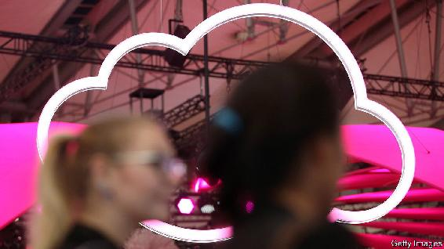

THE TERM “big tech” is often used as shorthand to describe the small group of digital firms that tower over the 21st-century economy. Together, they make up over a fifth of America’s stockmarket. But behind that phrase a lot is going on. As business lines have become monopolised, it has become commonplace to complain that tech firms are offering consumers a toxic deal. But in a growing number of areas the picture is healthier.

The largest tech companies have expanded into a dizzying range of industries. Amazon faces credible e-commerce rivals in the form of Walmart and Shopify. Video-streaming is a fight for supremacy between half a dozen firms. And cloud computing has become a fiercely contested market, too, as our analysis of the adventures of Microsoft shows (see [Briefing](https://www.economist.com/node/21793471)). Its experience is a reminder of the benign power of competition—and of how governments should be surgical about taming tech.

Cloud computing took off about 15 years ago, as businesses began to outsource their web-hosting, data centres, core computer systems and many applications to a few big providers, particularly the pioneer AWS, run by Amazon. The pandemic has shown just how critical the cloud has become. Many of the economy’s main functions depend on it, including a wide range of e-commerce sites and applications that let you work from home. The scale of this activity is huge; approaching 10% of all technology spending is on the cloud. So are the sums of money being invested. Perhaps $40bn is being ploughed this year into data centres and other physical gear by AWS and others.

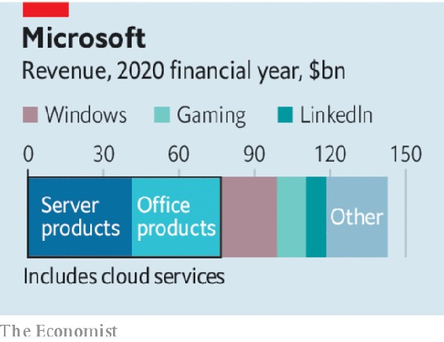

The cloud brings obvious benefits. The firms using it replace lumpy capital expenditure on rickety bespoke IT with a variable payment for a service that can easily expand its capacity as needed. That is one reason firms such as Zoom have been able to grow so fast during the lockdown. Having many users for each piece of infrastructure means they are put to work more efficiently.

The cloud has also been seen as an example of the internet’s fragmentation. Alibaba’s and Tencent’s cloud arms dominate in China and are making some inroads elsewhere in Asia. Europe is so anxious about American firms that it has launched a state-backed rival, called Gaia-X. Businesses in poor countries may struggle for access to the cloud, slowing their development.

The biggest fear has been of a cloud monopoly. Here the news is encouraging. AWS remains the cloud’s biggest firm, but Microsoft, the original antitrust bad boy, is putting up a fierce fight with its own service, Azure, and hopes to get more of its Office and Windows customers to use it for the cloud, too.

Alphabet is also putting its cloud forward. On October 8th IBM said it would spin off part of its services business to focus on the “hybrid-cloud”, which marries old-fashioned on-site work with the cloud. Likewise Oracle’s proposed bid for TikTok, a social-media firm, is in part an effort to secure an anchor-customer for its nascent cloud operation. Regulators need to be vigilant to ensure that cloud firms are not abusing other companies’ data, erecting unfair barriers to entry or misusing their dominance in other businesses to get ahead. But broadly, the boom means more choice and keener prices.

This rivalry also offers a signal to governments. Treating big tech as a monopolistic monolith does not make sense when some markets are competitive. Nor does banning tech firms from entering adjacent new markets—as a recent congressional report proposed. Better for governments to ensure that users have control over their data, and then vigorously tackle the areas like search and social media where monopolies have taken hold (see article). If the main source of competition for big tech firms ends up being other big tech firms, so be it.■

This article was downloaded by calibre from <https://www.economist.com/leaders/2020/10/22/is-tech-getting-more-competitive>

| Section menu | Main menu |

| Next | Section menu | Main menu | Previous |

Millennials and markets

In defence of millennial investors

They are changing finance for the better

Oct 24th 2020 |

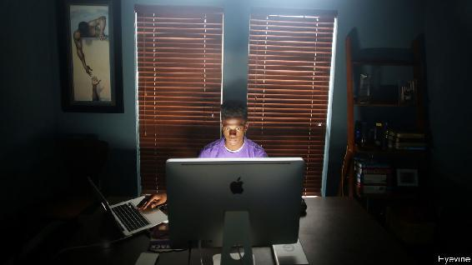

THE URGE of the old to lament the folly of the young is as ancient as civilisation itself. “The beardless youth…does not foresee what is useful, squandering his money,” scowled the poet Horace, in 15BC. This year silver-haired Wall Street pros have tutted at the enthusiasm of youthful stock-pickers, who have taken to punting on markets in the lockdown. Manic millennials tapping screens piled into Hertz—after it declared bankruptcy. They dabbled with derivatives and bid up shares in Nikola, an electric-lorry-maker that later admitted to letting a prototype roll down a hill during a “demonstration” because it could not have powered itself. It may seem as if the only lesson is how not to invest. Yet as we explain this week, young people are changing how finance works (see [article](https://www.economist.com/node/21793505)) and often for the better.

Every generation leaves its mark, but those aged 56-74 today, known as baby-boomers, had an outsize impact on America’s capital markets. Thanks to solid economic growth, rising asset prices and fat pensions, they have accumulated piles of financial savings—about $600,000 on average, held in retirement accounts and other vehicles for shares and bonds. The asset-management industry has been built around this mountain of money. Specialists run pensions, index providers such as Vanguard let you track the market while snoozing, and wealth managers offer personalised service and perks to the rich. No wonder the number of jobs in finance has risen by 31% since 1990.

At first glance the young don’t look as if they have enough money to reinvent Wall Street. Those under 35 have, on average, just $35,000 in financial assets, and those born between 1981 and 1996 own just 7% of all such assets in America, a far cry from the 26% share that boomers had amassed by a similar age and the 50% slice they now hold. Having faced two economic crises in about a decade, the young are less likely than their predecessors to own a home or a car. Half of those aged 18-29 say they have a positive view of socialism, according to Gallup, a polling firm.

Yet much of this is about to change as the young approach their peak earnings and the boomers retire and die. In recent years the churn in investible asset holdings has been relatively small, at around $1.3trn every five years, or 5% of total wealth in America. This pace is expected to double in a decade or so, as boomers begin to hand wealth to their children—either in their dotage or in their wills. By 2042 millennials are expected to have inherited roughly $22trn.

The young are also early adopters of new technologies and investment philosophies. In America digital-payments networks such as Venmo and Zelle are dominated by younger users even as their elders still scribble on cheques. Huabei, a credit service launched in China in 2014 by Ant Group, a fintech firm, now has a vast army of users—the pioneers were young people who could not get credit cards or bank loans. Younger American savers are happy using robo-advisers, which automate investment across a range of cheap index funds. As technology has cut the cost of trading, it has become easier and cheaper for them to trade assets actively, too. The leading adherents of the sustainable-investing boom that has gripped asset-managers are those aged 24-39. More than two-thirds of these young savers say they are very interested in making a positive social and environmental impact with their investments, compared with about half of the general population.

Some big financial firms are alive to the coming shift. Last year Morgan Stanley bought Solium, a startup that manages stock options and equity as they vest, largely for young tech workers. Goldman Sachs purchased United Capital, an investment-advisory firm popular with young professionals. But much of the financial industry, still drunk on the colossal windfall from the baby-boomers, is unprepared. If those firms want to stay in business, then instead of laughing as the new generation experiments with finance they should be taking notes.■

This article was downloaded by calibre from <https://www.economist.com/leaders/2020/10/24/in-defence-of-millennial-investors>

| Section menu | Main menu |

| Next | Section menu | Main menu | Previous |

Monsters of the deep

Illicit fishing devastates the seas and abuses crews

Here’s how to hook the culprits

Oct 22nd 2020 |

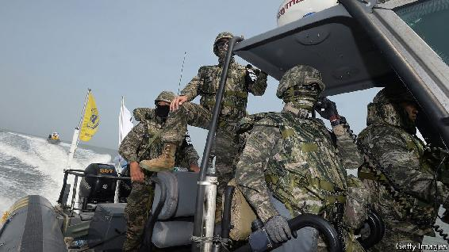

For more coverage of climate change, register for The Climate Issue, our fortnightly [newsletter](https://www.economist.com/theclimateissue/), or visit our [climate-change hub](https://www.economist.com/news/2020/04/24/the-economists-coverage-of-climate-change)

“CONSIDER THE subtleness of the sea,” warned Herman Melville in “Moby Dick”; “how its most dreaded creatures glide under water...treacherously hidden beneath the loveliest tints of azure.” Nearly 170 years later, another marine horror is just becoming visible. Satellite and other imagery has revealed “dark fleets” of fishing boats that turn off their transponders and plunder the ocean’s bounty. Illegal, unreported and unregulated fishing accounts for a staggering 20-50% of the global catch. It is one reason fish stocks are plummeting: just a fifth of commercial species are sustainably fished. Illegal operators rob mostly poor coastal states of over $20bn a year and threaten the livelihoods of millions of small fishermen. North Korean coastal waters have been so pillaged that its fishermen have to motor their rickety craft far out into stormy seas to fill their nets. Thousands have drowned.

A huge amount of illicit fishing happens on licensed boats, too. They might catch more than their quota, or falsely declare their catch as abundant albacore tuna instead of the more valuable bigeye. In port fisheries inspectors are always overstretched. If an operator is caught, for instance, fishing with too fine a net, the fine and confiscation are seen as a cost of doing business. Many pay up and head straight back out to sea.

The damage from illicit fishing goes well beyond fish stocks. Operators committing one kind of crime are likely to be committing others, too—cutting the fins off sharks, or even running guns or drugs (see [article](https://www.economist.com/node/21793451)). Many are also abusing their crews. Tens of thousands of migrant workers, mainly from South-East Asia, man the world’s fleets. Many toil at sea in vile conditions with violent masters, sometimes for years at a time. A lot of them are in debt bondage; and a fishing boat is a lot harder to escape from than a factory.

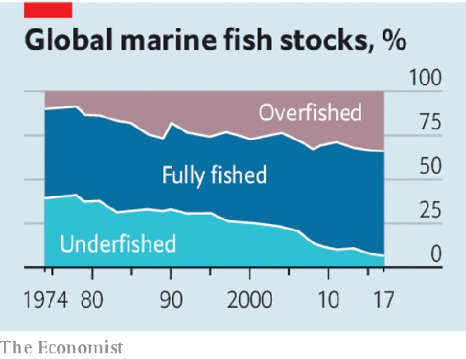

Too often, the ultimate beneficiaries of this trade are hard to hook because they hide behind brass-plate companies and murky joint ventures. Pursuing them requires the same kind of sleuthing involved in busting criminal syndicates. An initiative led by Norway to go after transnational-fisheries crime is gaining support. Much more cross-border co-operation is needed.

At sea, technology can help. Electronic monitoring promises a technological revolution on board—Australian and American fleets are leading the way. Cameras combined with machine learning can spot suspicious behaviour and even identify illicit species being brought on board. They should be compulsory as a condition of access to the exclusive economic zones that define a country’s control over resources such as fish. They should also be made compulsory even when vessels are on the high seas. Equally, national regulators should set basic labour standards at sea. If countries fail to follow the rules, coastal states should bar their fishing fleets from their waters. Fish-eating nations should allow imports only from responsible fleets.

Above all, governments should agree at the WTO to scrap the subsidies that promote overfishing. Of the $35bn a year lavished on the industry, about $22bn helps destroy fish stocks, mainly by making fuel too cheap. Do away with subsidies and forced labour, and half of high-seas fishing would no longer be profitable. Nor would that of China’s environmentally devastating bottom-trawling off the west African coast. Such abuses would disappear overnight. Some of the money that was saved could help restore coastal fisheries for millions of small-scale fisherfolk—underwriting temporary moratoriums on fishing and creating no-catch zones. And it could help establish fish farming, nourished by insect larvae. Fishing does not have to be a fishy business.■

This article was downloaded by calibre from <https://www.economist.com/leaders/2020/10/22/illicit-fishing-devastates-the-seas-and-abuses-crews>

| Section menu | Main menu |

# Letters

* On the Uyghurs, Venus, Catholic voters, Zoom meetings: Letters to the editor

| Next | Section menu | Main menu |

On the Uyghurs, Venus, Catholic voters, Zoom meetings

Letters to the editor

A selection of correspondence

Oct 24th 2020 |

Letters are welcome via e-mail to letters@economist.com

The Uyghurs: China responds

The Economist’s articles on Xinjiang made groundless accusations against China’s policy and was a gross interference in China’s internal affairs (“[Torment of the Uyghurs](https://www.economist.com/leaders/2020/10/17/the-persecution-of-the-uyghurs-is-a-crime-against-humanity)”, “[Orphaned by the state](https://www.economist.com/china/2020/10/17/how-xinjiangs-gulag-tears-families-apart)”, October 17th). The issues you raised have nothing to do with human rights, ethnic groups or religions, and everything to do with fighting violent terrorism, separatism and extremism. Extremist forces have carried out thousands of violent attacks in Xinjiang. For this reason its government has taken resolute action to crack down on such violence, in accordance with the law. The deradicalisation measures have curbed terrorist activities; there has not been a single attack for over three years. Feeling more safe, these measures have won the extensive and heartfelt support of people from all ethnic groups in Xinjiang.

You described the region’s vocational education and training centres as akin to concentration camps and re-education camps. They are neither of these. They are useful and positive explorations of preventive and deradicalisation measures. The centres were established to address the root causes of extremism and to prevent further terrorist activities. They fall in line with the principles embodied in a number of international documents on counter-terrorism, such as the UN Global Counter-Terrorism Strategy. In nature, they are no different from the Desistance and Disengagement Programme in Britain, community corrections in the United States, or deradicalisation centres in France.

At these vocational education and training centres, those who have been led astray by extremism or who have committed minor crimes learn the common language, legal knowledge and vocational skills. This helps them break with extremism. The constitutional and legal principles that respect and safeguard human rights are strictly followed. The trainees’ dignity, freedom, right to use languages of their own ethnic groups, customs and habits, and freedom of religious belief are all fully respected.

A few anti-China organisations invented the lie that nearly a million Uyghurs are detained. Their absurd conclusion is based on interviews with only a handful of people, and some news reports from an extremist organisation outside China, which therefore lacks any factual basis. An online video, which is said to have been authenticated by Western intelligence agencies, is used as proof that a large number of Uyghurs are imprisoned. Actually, the video shows the transfer of a group of prisoners at the Kashgar Detention House, which is a normal judicial practice.

It is also a lie that forced sterilisation is carried out in Xinjiang. A family-planning policy was introduced to all areas of Xinjiang in 1992 to comply with the national population law and achieve the balanced and sustainable development of the population. Between 2010 and 2018 the Uyghur population soared by 25%, the local Han population by just 2%.

As for the so-called victims of prosecution in some online videos, their true identities are not what they claim. The truth is, they are either “East Turkistan” elements engaged in anti-China and separatist activities, or actors trained by anti-China forces in America and other Western countries to spread rumours about China.

Xinjiang is purely China’s internal affair. Human rights in the region continue to develop and progress. From 2014 to 2019, GDP in Xinjiang grew at an average annual rate of 7.2%. The incidence of poverty has fallen to 1.2%. You have turned a blind eye to our previous clarifying statements and are spreading fallacies, fanning the false charge that China is engaged in a “crime against humanity”.

We urge The Economist to address this negative impact, respect the facts, and write objective and impartial articles on Xinjiang.

ZENG RONG  
Spokesperson of the Chinese Embassy  
London



Volcanoes on Venus

Reporting on the possibility of “[A sniff of life?](https://www.economist.com/science-and-technology/2020/09/14/scientists-find-possible-signs-of-life-in-the-clouds-of-venus)” (September 19th) in the clouds of Venus, you said that for “billions of years the Sun has been growing brighter, thus changing the boundaries of its habitable zone” and that on Venus “it prompted what atmospheric scientists call a ‘runaway greenhouse effect’, boiling away the seas which many scientists believe to have graced the planet’s youth.”

There have long been serious problems with this hypothesis. Around 4.2bn years ago Venus had approximately 40% more incident solar radiation than Earth receives today. The proposed mechanism to keep the planet cool via clouds is rather robust against increasing solar brightness through time. For this reason there is a growing consensus that it is not the increasing brightness through time that may have changed Venus from a happy habitable world to its present hellscape today.

Earlier this year my colleagues and I proposed that widescale volcanism was the trigger, and that Earth has been (thus far) fortunate to escape a similar fate.

MICHAEL WAY  
NASA Goddard Institute for Space Studies  
New York

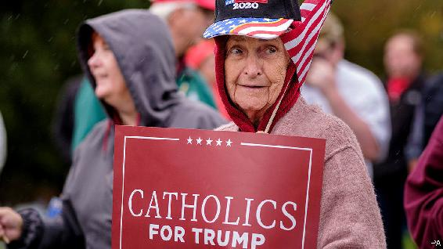

Religious orders

I enjoyed reading your article about American Catholicism and the election (“[Render unto Caesar](https://www.economist.com/united-states/2020/10/03/priestly-guidance-on-voting-is-dividing-the-catholic-church-in-america)”, October 3rd). But just as parishioners’ voting patterns are not monolithic in either a liberal or conservative way, neither is the clergy voicing their opinions. Cardinal Joseph Tobin of Newark, for example, said in a carefully worded statement, “I think that a person in good conscience could vote for Mr Biden. I, frankly, in my own way of thinking have a more difficult time with the other option.” There are countless other such examples.

Catholics should not be instructed to vote a certain way, nor should they allow a single issue to dominate their thinking. This is explicitly stated in “Forming Consciences for Faithful Citizenship”, the American bishops’ teaching document on voting. There is strong evidence that this guidance is being adhered to. The creator of the “hell video” you mentioned received a public rebuke from his superior bishop, and Bishop Thomas Tobin’s comments earned a rebuke from Cardinal Blase Cupich of Chicago. All this shows that Catholic social teaching does not neatly align with a single political party’s views.

JOE MORAN  
Philadelphia

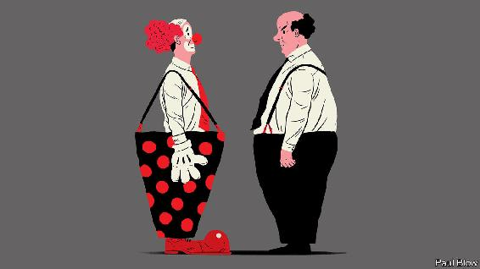

Streaming humour

[Bartleby](https://www.economist.com/business/2020/10/03/why-we-need-to-laugh-at-work) complained that you cannot make jokes during Zoom meetings (October 3rd). Yes you can. Forget raising the blue-hand signal, looking for a pause in the conversation. The chat function is perfect for jokes. The beauty is that you can chat with a single person privately, a bit like passing notes in school. A word of warning. It is all too easy to select the “Reply to everyone” option when responding to a private message, which can be a little embarrassing.

SUROOR ALIKHAN  
Geneva

I was astonished to read that staff at The Economist use the “raise hand” feature on Zoom instead of just talking over each other. How polite.

ANDREW MOLDOVAN  
Vancouver

This article was downloaded by calibre from <https://www.economist.com/letters/2020/10/24/letters-to-the-editor>

| Section menu | Main menu |

# Briefing

* Social media and free speech: The great clean-up
* Microsoft: After the reboot

| Next | Section menu | Main menu |

Big tech and free speech

Social media’s struggle with self-censorship

Tech giants are removing more content, but are they making the right choices?

Oct 22nd 2020 |

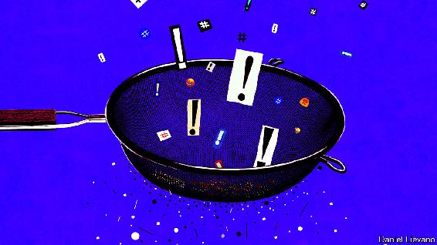

WITHIN HOURS of the publication of a New York Post article on October 14th, Twitter users began receiving strange messages. If they tried to share the story—a dubious “exposé” of emails supposedly from the laptop of Hunter Biden, son of the Democratic presidential nominee—they were told that their tweet could not be sent, as the link had been identified as harmful. Many Facebook users were not seeing the story at all: the social network had demoted it in the news feed of its 2.7bn users while its fact-checkers reviewed it.

If the companies had hoped that by burying or blocking the story they would stop people from reading it, the bet did not pay off. The article ended up being the most-discussed story of the week on both platforms—and the second-most talked-about story was the fact that the social networks had tried to block it. The Post called it an act of modern totalitarianism, carried out “not [by] men in darkened cells driving screws under the fingernails of dissidents, but Silicon Valley dweebs.” Republican senators vowed to extract testimony on anticonservative bias from Mark Zuckerberg and Jack Dorsey, the dweebs-in-chief of, respectively, Facebook and Twitter.

The tale sums up the problem that social networks are encountering wherever they operate. They set out to be neutral platforms, letting users provide the content and keeping their hands off editorial decisions. Twitter executives used to joke that they were “the free-speech wing of the free-speech party”. Yet as they have become more active at algorithmically ranking the content that users upload, and moderating the undesirable stuff, they have edged towards being something more like publishers. Mr Zuckerberg says he does not want to be an “arbiter of truth”. The Post episode fed the suspicion of many that, willingly or not, that is precisely what he is becoming.

America’s fractious election campaign has only made more urgent the need to answer the unresolved questions about free expression online. What speech should be allowed? And who should decide? Rasmus Nielsen of the Reuters Institute at Oxford University describes this as a “constitutional moment” for how to regulate the private infrastructure that has come to support free expression around the world.

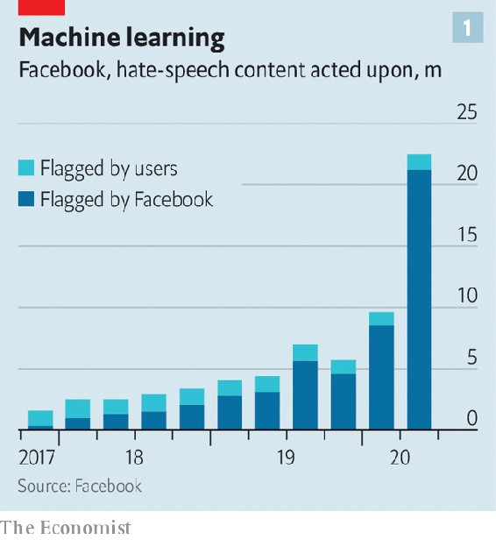

Social networks have been on the mother of all clean-ups. Facebook’s removal of hate speech has risen tenfold in two years (see chart 1). It disables some 17m fake accounts every single day, more than twice the number three years ago. YouTube, a video platform owned by Google with about 2bn monthly users, removed 11.4m videos in the past quarter, along with 2.1bn user comments, up from just 166m comments in the second quarter of 2018. Twitter, with a smaller base of about 350m users, removed 2.9m tweets in the second half of last year, more than double the amount a year earlier. TikTok, a Chinese short-video upstart, removed 105m clips in the first half of this year, twice as many as in the previous six months (a jump partly explained by the firm’s growth).

Artificial intelligence has helped to make such a clean-up possible. Most offending content is taken down before any user has had a chance to flag it. Some lends itself readily to policing with machines: more than 99% of the child-nudity posts Facebook takes down are removed before anyone has reported them, but most of the bullying or harassment is flagged by users rather than robots. Two years ago Facebook’s AI removed a post referring to “merciless Indian Savages”, before human moderators realised it was a quote from the Declaration of Independence. Facebook now employs about 35,000 people to moderate content. In May the company agreed to pay $52m to 11,250 moderators who developed post-traumatic stress disorder from looking at the worst of the internet.

Discussions about free speech that may once have seemed abstract have become all too practical—the murder of Samuel Paty near Paris last week being the latest shocking reminder. Social networks tightened their policies on terrorism after Islamist attacks in Europe in 2015 and an anti-Muslim rampage in New Zealand last year, which was live-streamed on Facebook and shared on YouTube. The American election and Brexit referendum of 2016 forced them to think again about political communication. Twitter banned all political ads last year, and Facebook and Google have said they will ban them around the time of this year’s election on November 3rd.

The companies have also improved their scrutiny of far-flung countries, after criticism of their earlier negligence in places such as Myanmar, where Facebook played a “determining role” in the violence against Rohingya Muslims, according to the UN (see article). This week Facebook announced that it had hired more content-reviewers fluent in Swahili, Amharic, Zulu, Somali, Oromo and Hausa, ahead of African elections. Its AI is learning new languages, and hoovering up rule-breaking content as it does so.

The room where it happens

Some tech bosses have been rethinking their approach to the trade-offs between free expression and safety. Last October, in a speech at Georgetown University, Mr Zuckerberg made a full-throated defence of free speech, warning: “More people across the spectrum believe that achieving the political outcomes they think matter is more important than every person having a voice. I think that’s dangerous.” Yet this year, as misinformation about covid-19 flourished, Facebook took a harder line on fake news about health, including banning anti-vaccination ads. And this month it banned both Holocaust denial and groups promoting QAnon, a crackpot conspiracy.

The pressure from the media is to “remove more, remove more, remove more”, says one senior tech executive. But in some quarters unease is growing that the firms are removing too much. In America this criticism comes mostly from the right, which sees Silicon Valley as a nest of liberals. It is one thing to zap content from racists and Russian trolls; it is another to block the New York Post, one of America’s highest-circulation newspapers, founded by Alexander Hamilton (who admittedly might not have approved of its current incarnation, under Rupert Murdoch).

Elsewhere, liberals worry that whistle-blowing content is being wrongly taken down. YouTube removed footage from users in Syria that it deemed to break its guidelines on violence, but which was also potential evidence of war crimes. Until last year TikTok’s guidelines banned criticism of systems of government and “distortion” of historical events including the massacre near Tiananmen Square.

Where both camps agree is in their unease that it is falling to social networks to decide what speech is acceptable. As private companies they can set their own rules about what to publish (within the confines of the laws of countries where they operate). But they have come to play a big role in public life. Mr Zuckerberg himself compares Facebook to a “town square”.

Rival social networks promising truly free speech have struggled to overcome the network effects enjoyed by the incumbents. One, Gab, attracted neo-Nazis. Another, Parler, has been promoted by some Republican politicians but so far failed to take off. (It is also grappling with free-speech dilemmas of its own, reluctantly laying down rules including no sending of photos of fecal matter.) Outside China, where Facebook does not operate, four out of ten people worldwide use the platform; WhatsApp and Instagram, which it also owns, have another 3bn or so accounts between them. “Frankly, I don’t think we should be making so many important decisions about speech on our own either,” Mr Zuckerberg said in his Georgetown speech.

Say no to this

Bill Clinton once said that attempting to regulate the internet, with its millions of different sites, would be “like trying to nail Jell-O to the wall”. But the concentration of the social-media market around a few companies has made the job easier.

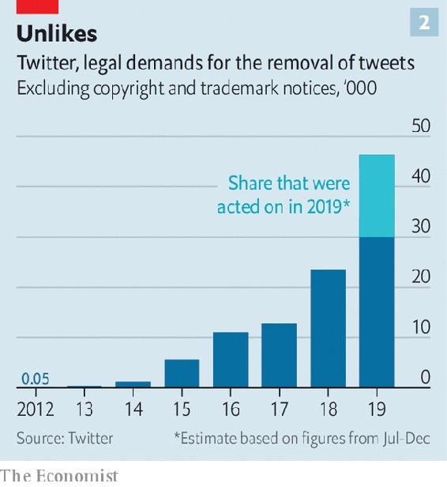

Twitter has faced steep growth in the number of legal requests for content removal, from individuals as well as governments (see chart 2). Last year Google received 30,000 requests from governments to remove pieces of content, up from a couple of thousand requests ten years ago (see chart 3). And Facebook took down 33,600 pieces of content in response to legal requests. They included a Photoshopped picture of President Emmanuel Macron in pink underwear, which French police wanted removed because it broke a law from 1881 restricting press freedom.

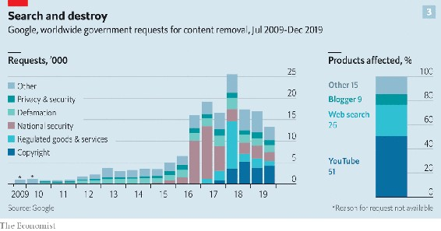

In America the government is prevented from meddling too much with online speech by the First Amendment. Section 230 of the Communications Decency Act gives online platforms further protection, exempting them from liability for the content they publish. But carve-outs to this exemption are growing. Firms cannot avoid responsibility for copyright infringements, posts that break federal criminal law, or which enable sex trafficking. The latter exemption, made in 2018, had an impact on speech that was greater than its drafting implied: sites including Tumblr and Craigslist concluded that, rather than risk prosecution, they would stop publishing adult material of all sorts.

In Europe regulation has gone further. In 2014 the European Court of Justice (ECJ) established the “right to be forgotten” when it found in favour of a Spanish man who wanted Google to remove old references to his history of indebtedness. Since then Google has fielded requests for about half a million URLs to be removed each year, and granted about half of them. Last year the ECJ ruled that European countries could order Facebook to remove content worldwide, not just for users within their borders. The European Audiovisual Media Services Directive requires online video services to take “appropriate measures” to protect viewers from harmful or illegal content, including setting up age checks. The European Commission is to publish a Digital Services Act, expected to impose further obligations on internet companies.

National governments have also set their own rules, notably Germany, whose Network Enforcement Act of 2017 threatens platforms with fines of up to €50m ($60m) if they fail to take down illegal content within 24 hours of notification. In response Facebook opened a new moderation centre in Germany. The trouble with privatising the enforcement of the law in this way, points out Mr Nielsen, is that the companies have big incentives to err on the side of caution. A judge may use discretion to ignore rules on speech that are seldom applied (such as a German law that until recently banned insulting a foreign head of state). But a social-media company has no reason to risk ignoring a law.

Who tells your story

Some governments are leaning on social networks to remove content that may be legal. The social-media platforms have their own rules that go further than most governments’. A ban on material that could interfere with “civic integrity” may sound like something from communist China; it is actually in Twitter’s rules. London’s Metropolitan Police has a unit that scours platforms for terrorism-related content, which it “requests” be taken down for breaching the platform’s terms of service—even though the material may not break any law.

“Authoritarian governments are taking cues from the loose regulatory talk among democracies,” writes David Kaye, a former UN special rapporteur on free expression. Last year Singapore passed what it described as an anti-fake-news law, banning the online publication of lies that could harm the public interest. Thailand has enforced its lèse-majesté laws online, in August ordering Facebook to block a critical group called Royalist Marketplace, which with more than 1m members was one of the largest on the platform. (Facebook complied, but is suing the Thai government for breaking human-rights law.)

If neither governments nor executives make reliable custodians of free speech, what can be done to keep the internet a tolerable place while protecting freedom of expression? An increasingly common answer in Silicon Valley is to draw a distinction between freedom of speech and “freedom of reach”: leave posts up, but make them less visible and viral.

Last year YouTube changed its algorithm so that videos that were borderline cases for deletion were recommended less often. After the bombings of churches and hotels in Sri Lanka at Easter in 2019, Facebook prevented the resharing of posts by friends of friends, to stop inflammatory content travelling too far or fast; this rule is in place in Ethiopia and Myanmar. Twitter has tried to stop people from mindlessly sharing fake news by prompting them to read articles before they retweet them. Platforms are adding more labels to content, warning users that it is misleading.



Another idea gaining momentum is that firms should make their data available for audit just as listed companies must open up their accounts. Their internal processes could also be more transparent. At Facebook there is an odd tension between its earnest approach to policymaking, with fortnightly “mini-legislative sessions”, and the fact that every month Mr Zuckerberg personally takes a handful of the hardest decisions on content moderation. Treating the big calls as “corner-office decisions” is a mistake, believes Mr Kaye: better for companies to say, “We have these rules, we’re going to apply them neutrally. And we don’t want that process to be corrupted by political pressure.”

Facebook took a step towards such a system on October 22nd with the launch of its Oversight Board, a watchdog made up of 20 members of the great and good who will scrutinise its moderation decisions and issue binding rulings. The board’s scope is narrower than some had hoped. It can consider only whether deleted posts should be reinstated. It merely applies Facebook’s rules, rather than setting them. It cannot consider posts that have been algorithmically demoted, as opposed to deleted. So some of the most prominent recent controversies—Facebook’s decision to leave up a contentious post by Donald Trump, its removal of QAnon, its reversal on Holocaust denial and its demotion of the Post story—are outside the board’s jurisdiction.

History has its eyes on you

Yet as Alan Rusbridger, a former Guardian editor and member of the new board, puts it, it is a “revolutionary thought”. “A company that has notoriously been very reluctant to surrender control on anything has handed over…the power to make some pretty consequential decisions on its behalf,” he says. He hopes the board will get more powers over time. Facebook says this is premature. But Sir Nick Clegg, its head of global affairs, hopes the board’s remit might one day expand to consider cases submitted by other social networks.

Others have similar ideas. Article 19, a free-speech lobby group, has suggested that platforms could outsource their moderation decisions to non-governmental “social-media councils”, something like the press watchdogs that in many countries hold newspapers to a voluntary code.

For now, the social networks have to get through perhaps the hardest fortnight in their short history. They face the possibility of having to deploy content-moderation tools developed for fragile, emerging democracies in their home country. Facebook removed 120,000 pieces of content aimed at voter suppression in America in the past quarter. The New York Post affair does not bode well for how the companies might handle the fallout from a contested election. “When they appeared to depart from their policies they opened themselves up to the very charges of bias that followed,” says Evelyn Douek of Harvard Law School. As the election approaches, they need to “tie themselves to a mast” of clear rules, she says. A storm is coming. ■

This article was downloaded by calibre from <https://www.economist.com/briefing/2020/10/22/social-medias-struggle-with-self-censorship>

| Section menu | Main menu |

| Next | Section menu | Main menu | Previous |

After the reboot

How Satya Nadella turned Microsoft around

Now for the hard part

Oct 22nd 2020 |

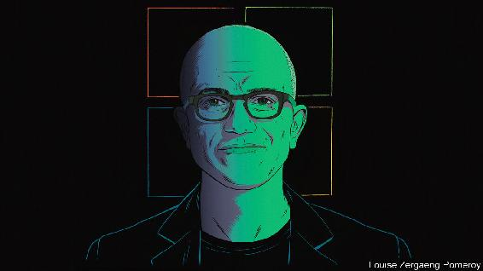

WHEN SATYA NADELLA became the third boss of Microsoft in 2014 one photograph captured the moment. It shows him flanked by Bill Gates, the co-founder and chairman, and Steve Ballmer, Mr Gates’s successor as chief executive. The two white tech tycoons strike a confident pose in casual dress. Mr Nadella, an Indian-American, skulks in a suit, smiling awkwardly.

He had a reason for that awkward smile. The company was in a ditch. While it hunkered down at its headquarters in Redmond, Washington, Apple invented the iPhone, and Google and Facebook rose from Silicon Valley. Its share price barely budged for years. When he took over, says Mr Nadella, outsiders questioned if Microsoft will “make it to the other side”.

It did—with aplomb. Mr Nadella dethroned the Windows operating system as its core product. He brought Microsoft’s software and services to other operating systems, including “open source” Linux, as well as Google’s and Apple’s. Most important, he put Microsoft’s cloud-computing arm, Azure, launched in 2010, at the heart of the business. The result has been double-digit revenue growth and a market capitalisation of $1.6trn. Only Apple and Saudi Aramco, an oil colossus, are more valuable.

Microsoft succeeded in its reinvention where other tech firms seeking a second life, such as IBM and Oracle, have not. But nothing lasts for ever in the fast-changing world of technology. The old personal-computer (PC) business has slowed. The firm’s products are not always the best or most popular. Azure is considered by many experts to be technologically behind the market leader, Amazon Web Services (AWS), which the e-commerce giant launched four years earlier. Many users prefer to make video calls on Zoom and chat on Slack rather than use Microsoft’s Teams. This year Microsoft failed to buy TikTok, which might have boosted its consumer-facing business that includes the Xbox games console and (less interestingly for TikTokers) LinkedIn, a careers network; the popular Chinese-owned short-video app inked a nebulous technology partnership with Oracle instead. And Microsoft has to square up not just to Amazon but to younger tech giants such as Alphabet (Google’s parent) and China’s Alibaba and Tencent.

The pressure to succeed is immense. The firm’s shares have more than quintupled in value since Mr Nadella took over (see chart 1). They now trade at 37 times earnings, a higher multiple than those of Alphabet, Apple or Facebook (though far below Amazon’s ratio of 123). The company is priced for perfection, says Mark Moerdler of Bernstein, a research firm. And for further expansion.

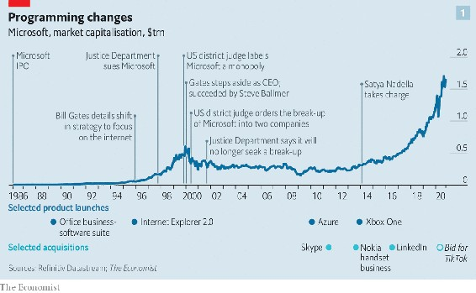

Mr Nadella acknowledges the challenge. “This is not some linear transition,” he says. “When the first hockey stick plateaus the question is: have you got the other things?” In an effort to live up to the hype he is dusting off old weapons—bundling and licensing—the aggressive use of which got Microsoft in trouble with antitrust authorities from the late 1990s and earned it the moniker “evil empire”. An insider since 1992, he remembers those days, when the firm narrowly avoided a forced break-up. Can it continue to grow while steering clear of the old pitfalls?

Until 2014 Microsoft had five different business areas. Most of the profit came from three of them: Windows, its Office software (spreadsheets, word-processing, PowerPoint and the like) and programs to run the servers used in data centres and corporate networks. Entertainment and devices, including the Xbox, made a bit of money. Online services such as the Bing search engine and MSN web portal did not.

Mr Nadella reconfigured this structure. Today Microsoft’s 20 or so businesses fall into three big buckets: cloud, productivity software and business processes, and personal computing. Each contains one of the lucrative stalwarts—servers, Office and Windows—alongside lots of others such as Surface PCs and digital whiteboards, or Dynamics business software. Many of the businesses revolve around Azure, which has grown into the internal computing backbone for Microsoft’s applications, as well as a product to sell to customers. Forays into futuristic quantum computing or virtual and augmented reality stand on their own, while boosting Azure’s capabilities. So do artificial-intelligence (AI) algorithms, trained on data from Bing, LinkedIn and other places.

If any of those whizzy bets succeed at scale, they would sharpen Microsoft’s innovative edge, which looks blunter than either Amazon’s or Alphabet’s. Even if they do not, Microsoft may succeed by commercialising products rather than inventing new ones. As insiders quip, the firm is never first to market and often not second, but “man, we will make all the money”.

That has certainly been true of Office. Excel was not the first spreadsheet (remember Lotus 1-2-3?). But it is deemed by many software engineers to be the most consequential program ever written, in part because it has been so widely adopted. Around 1.2bn workers use Office or Office365, a web-based version served up through Azure. Here, too, Microsoft lagged behind Google’s G-suite software, which, among other things, enabled multiple users to work on one document at the same time. Googlers make digs at what they see as Microsoft’s offline, “save as” mentality.

Still, managers prise Office—and especially Excel—from desk-jockeys at their peril. As a result, Microsoft controls 87.6% of the market for such software, to Google’s 11.5%, according to Gartner, a research firm. To boost Teams, Microsoft has started bundling it with Office365 free of charge; by April Teams had 75m daily users. Unfair, rivals say; in July Slack launched an antitrust suit against Microsoft. It calls Teams a copycat product aimed at killing it—just as Microsoft’s Internet Explorer vanquished Netscape, a rival web browser, which led to its battle with trustbusters.

Critically, Microsoft has been a superfast follower in the cloud. In Mr Nadella’s book about the firm’s transformation, “Hit Refresh”, he described how, by the time he took over, AWS had built a vast cloud business with no competition. “Amazon was leading a revolution and we had not even mustered our troops,” he wrote.

The stakes are huge. Over time most of the world’s companies are expected to move computing to the cloud. The share of IT spending going to the cloud is approaching 10%. But that already amounts to an annual market of $240bn. Given expected annual growth rates of nearly 20% it could reach $1trn before long.

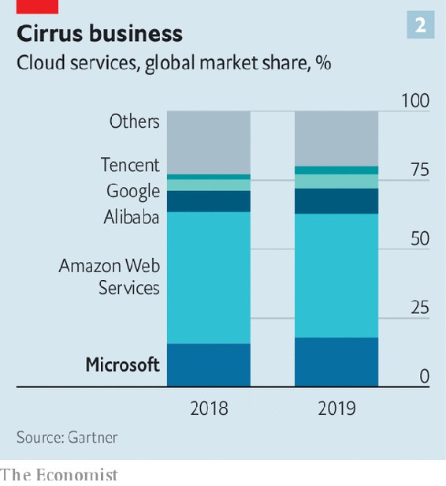

In the cloud Azure faces two big rivals—AWS and Google Cloud Platform (GCP)—and two others—Oracle and Alibaba Cloud. Its market share has risen steadily, to 18% (see chart 2). Again, Microsoft’s rapport with firms’ IT departments has served it well. It still dominates parts of business software and nearly four in five personal computers run on Windows, as do 72% of all servers. It can offer corporate clients a single price that bundles Azure with Office and other software. That way Azure can end up costing only a fifth as much as AWS. And it is easier to use than Amazon’s offering, whose advanced features overwhelm even some IT professionals.

It is also easier to swallow for many clients than Amazon products. When Microsoft pitched for business, recalls a former executive, Azure would lose the technical evaluation but win out of customers’ fear that Jeff Bezos, Amazon’s insatiable boss, might use their money and data to invade their turf. Suspicion of Mr Bezos may explain why AWS lost a $10bn Pentagon cloud contract to Microsoft, despite being tipped to win. Amazon believes Microsoft benefited from Donald Trump’s feud with Mr Bezos, who also owns the Washington Post, a newspaper the president does not like. Amazon has legally challenged the award, unsuccessfully so far.

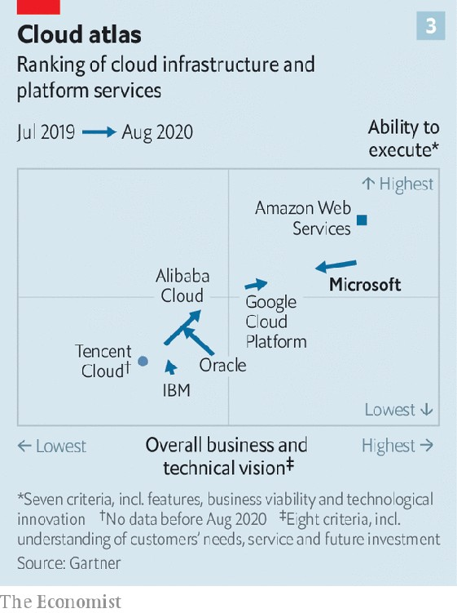

Azure aims to match or overtake AWS in the cloud. Yet in Gartner’s closely followed ranking of cloud providers Azure comes in well behind AWS and has lately slipped down (see chart 3). The way Microsoft has built its global cloud infrastructure, covering more geographical ground than AWS but more thinly, may make it less reliable. Gartner cites insufficient redundant capacity to deal with data centres knocked out by bad weather or other problems. Even without disruptions, capacity has proved problematic. As demand has surged in the pandemic, with millions of remote workers switching to the cloud, Azure has at times been unable to keep up. Microsoft Teams suffered a blackout in March. That month Microsoft put in place temporary resource limits on new Azure subscriptions. AWS has not needed to.

Azure blues

Microsoft cannot afford to get Azure wrong. It is what drives its share price. Azure is estimated to make up only a tenth of Microsoft’s $53bn in annual operating profit. But every quarter Wall Street fixates on how fast the cloud is growing, notes Heather Bellini of Goldman Sachs, an investment bank. Recently analysts have been disappointed to see growth slow, from 59% year on year in the first three months of 2020, to 47% from April to June. (It is some comfort that AWS’s growth has also slowed in recent quarters.)

Azure is sure to get a fillip from new licensing rules, just as Teams has from bundling. Up to now Microsoft let customers use its software on dedicated servers run by AWS or any cloud provider under a practice called “bring your own licence” (BYOL). That freedom enabled easy switching; of all cloud-based Windows software, 57% runs on AWS, nearly twice as much as on Azure.

Last summer Microsoft did away with BYOL and introduced restrictions for customers wishing to put its software on certain big clouds. If a client wanted to run desktop and server programs on those clouds after October 1st, it would have to buy a new subscription, rather than a one-off licence. Not to offend antitrust rules Microsoft put Azure on its list alongside AWS, GCP and Alibaba Cloud. But it separately offered customers a better deal to move to Azure, offsetting the extra cost.

Amazon said Microsoft was trying to restrict what clouds companies can use. Several neutral observers concur. “Microsoft is taking its arsenal of Windows Server, a massive installed software base, and using it punitively against competitors,” says Raj Bala, Gartner’s main cloud-infrastructure expert and author of its cloud ranking. It is the antithesis of Mr Nadella’s more open strategy, adds Wes Miller of Directions on Microsoft, a research firm. After all, he had eased Office’s move to non-Windows devices such as Apple’s iPad. “Satya wants to make people think he’s different, but he’s old-school Microsoft, just with a little softer exterior,” sums up an executive at a rival.

Microsoft is the only big cloud provider which also sells lots of programs that clouds host. “Is there a piece of software that Amazon or Google has built that runs on Azure? Zero,” Mr Nadella says. That also gives Azure a big advantage to exploit. Mr Nadella does not intend to repeat the mistake of letting Windows workloads all migrate to Amazon’s cloud, as happened early on. “We were stupid, not realising what was happening,” he says. “We will absolutely monetise our intellectual property on their clouds.”

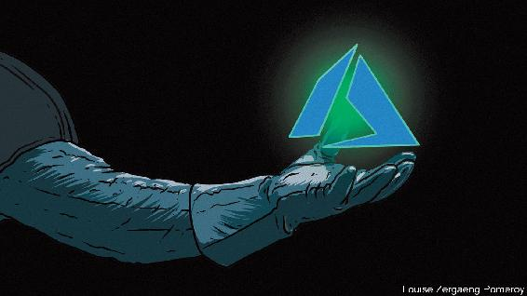

Since the licensing changes went into effect Gartner has received several hundred inquiries about them. An executive from a Fortune 500 health-care company that had picked AWS as its cloud provider says that the new rules meant an extra annual cost of $100m, forcing the firm to slow down its transition to the cloud. “They are writing licence terms to get customers to believe their only choice is Azure,” complains a vice-president of a medium-sized firm in Wisconsin that felt forced to switch from AWS. “There is no law against it but it removes choice,” he adds. An IT chief at another midwestern firm likens the new rules to a long lease on a car where “the lessor says you can only use Chevron gas, not BP or Exxon”. Two of the three customers are set on writing Microsoft software out of their stacks over time.

Avoiding defenestration

That points to a risk for the tech giant. By tugging reluctant customers onto Azure too aggressively Microsoft may put a lot of them off Windows—or, possibly, provoke mass flouting of rules, daring the software giant to enforce them. Takeshi Numoto, chief marketing officer of Microsoft’s commerical business, says the feedback Microsoft is receiving on cloud choice after the new rules is positive, adding that “We want to hear from all customers if there are ways we can improve our partnership and support of their businesses.”

How closely is Microsoft flirting with the kind of behaviour that got it in trouble in the late 1990s? After its bruising antitrust battle it is likely to proceed cautiously. If Europe proves sympathetic to Slack, the messaging firm could bring a similar case in America. If that happens, Microsoft may offer concessions to make it go away.

Mr Nadella resists the idea that Microsoft is overstepping the mark. “Look at the number of enterprise SAAS [software-as-a-service] and infrastructure firms,” he says—hardly suggestive of “a monopoly company collecting monopoly rent”.

In its defence Microsoft can certainly argue that Azure has brought competition to cloud computing, which AWS might otherwise have cornered. Tellingly, Mr Nadella was spared the indignity of testifying in front of a congressional antitrust subcommittee, which recently grilled his opposite numbers at Alphabet, Amazon, Apple and Facebook. A congressional report on big tech’s digital dominance did not finger Microsoft. America’s trustbusters have gone after Google instead (see article). Google denies wrongdoing.

Microsoft’s rebuffed $25bn-30bn bid for TikTok could have been a boon to competition. Had it succeeded, Microsoft would have challenged Google and Facebook in digital advertising in short order. TikTok’s reams of data on its teenage users would have fuelled Microsoft’s AI, which competes against algorithms being developed by all its big tech rivals in America and China. The purchase of ZeniMax Media, a games developer, for $7.5bn to bolster its flourishing cloud-gaming platform does not make up for the failed bid.

Google’s antitrust troubles could offer consolation. The case may shake up internet search, helping Bing. It is a tiddler despite having a quality of search results that is not all that different from Google’s. In a hint that Microsoft might want to revive its search engine, this month it was rebranded as “Microsoft Bing”.

Mr Nadella is confident about future growth, his early awkwardness long since replaced by a justified and resolute assuredness. “We’re lucky enough to be in the tech business, and IT spending is going from 5% of GDP to 10% over the next ten years,” he says. But competition for those IT dollars is white-hot. Microsoft’s response—leaning heavily on customers not to defect—may work in the short run. But as the pace of change in the technology industry accelerates, thanks to abundant brainpower and oodles of capital, customers may put innovation ahead of loyalty to long-standing providers. One successful reinvention is unlikely to be enough. ■

This article was downloaded by calibre from <https://www.economist.com/briefing/2020/10/22/how-satya-nadella-turned-microsoft-around>

| Section menu | Main menu |

# United States

* Election uncertainties: The known unknowns
* Donald Trump’s record: Pumped up
* Trade: Tariff man
* Mining for votes in Montana: Gold in them hills
* Museum funding: Going, going, gone
* The Equality Act: Liberalism and its contradictions
* Lexington: The blue wave

| Next | Section menu | Main menu |

The known unknowns

If Donald Trump were to win re-election, how would he do it?

We think the president will lose. Here is how we could be wrong

Oct 24th 2020 | WASHINGTON, DC

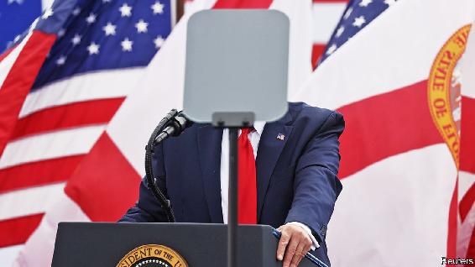

AROUND THIS time four years ago, on October 28th 2016, the then director of the FBI, James Comey, announced the discovery of new emails that might be pertinent to his investigation into Hillary Clinton. Her polling lead in mid-October had been almost as big as Joe Biden’s is now. Twelve days later she was giving a concession speech. Election day is closer than it was when Mr Comey made his intervention—quirks of the calendar mean this year’s falls on November 3rd rather than November 8th, which is when Donald Trump won four years ago. So Mr Trump is running out of time to catch up. Still, that recent precedent has Americans wondering what they might be overlooking this time.

Mr Biden holds a large polling lead: The Economist’s forecast accordingly gives him a comfortable 92% chance of victory. In the 8% of our simulations where the president wins the electoral college, Mr Trump’s route to victory is almost identical to the path he took in 2016. If he wins his adopted home state of Florida, holds states he won handily—including Arizona, Georgia, Iowa, North Carolina, and Texas—then Pennsylvania and either Michigan or Wisconsin, both of which he won last time, would put him over the top. Polls suggest that path is unlikely, but polls underestimated Mr Trump’s strength in battleground states four years ago.

Mr Biden’s lead has also been remarkably steady, rarely dipping below five or above ten points. But this election is taking place during a pandemic, which is already changing how people vote (see Lexington). With less than two weeks left before polls close in America, what are the contest’s biggest remaining uncertainties?

One is whether the Republican gains in voter registration in key states will matter. During the epidemic Republicans have been canvassing in person more than Democrats, many of whose traditional registration sites, universities and churches, have been closed or restricted in much of the country. In both Florida and Pennsylvania, Republicans have registered over 100,000 more voters than Democrats since March. The Republican advantage in Arizona since mid-August exceeds 30,000.

Normally, party registration and voting are not tightly correlated. Kentucky and West Virginia, for instance, both have more registered Democrats than Republicans, but are all but guaranteed to back Mr Trump. We calculated the relationship between changes in Democratic registration and vote share in Florida from 2004 to 2016 and found there wasn’t one.

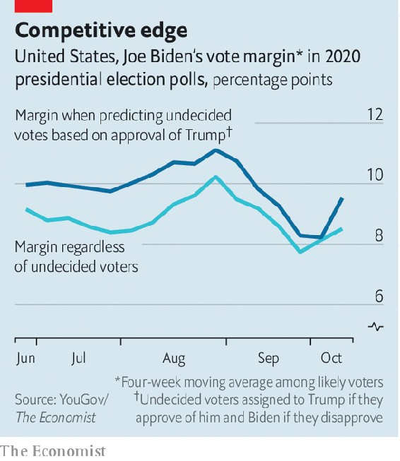

One factor that caused forecasts to flop in 2016 was that undecided voters broke late for Mr Trump. Could that happen again? It could. Yet this year there appear to be far fewer undecided or third-party voters: just 6% in our Economist/YouGov poll, compared with 14% at this point in 2016. They seem likely to favour Mr Biden, because they are younger and less white than the average voter who has decided. And they do not seem well-disposed towards the president. Just 31% of undecided voters approve of the president.

A different kind of uncertainty concerns election day itself. Mr Trump has urged his supporters to “go into the polls and watch very carefully”. Read one way, this exhortation is not alarming. Poll-watchers are a routine presence. Both parties are training and deploying thousands of them. Rules vary between states, but generally political parties or campaigns can appoint, register and train voters to watch for irregularities.

Watchers are not supposed to interact with voters, though. If they believe a voter is ineligible, they are supposed to tell a poll worker (challenged voters can still cast provisional ballots, which will be counted once the voter proves his eligibility), and challenges generally require a rational basis—not race or age, for instance.

But many read Mr Trump’s remark as a call for voter intimidation. During the first presidential debate he declined to denounce white supremacists, calling on the Proud Boys, a group with a history of violence, to “stand back and stand by”. Devin Burghart, who heads the Institute for Research and Education on Human Rights, says that armed groups in Georgia, Michigan, Pennsylvania and Wisconsin have discussed going to polling places. “They show up in body armour with AR-15s,” warns Mr Burghart. “They felt emboldened by Trump’s calls during the first debate and will make sure they show up.”

Only about 40% of voters plan to cast ballots in person on election day, though, a record low. Amid all America’s early voting, there have been just two small kerfuffles at voting sites. A group of chanting Trump supporters in Virginia formed a line that voters had to walk round, and a woman claiming to be a poll-watcher for the Trump campaign tried to get into an election office (which is not a polling place). If this was a co-ordinated effort, it was rather pathetic. Moreover, election officials and police officers say they are prepared for the threat.

The last big uncertainty concerns the acceptance and counting of ballots. Many worry that posted ballots will be rejected at higher rates than in-person votes. Because Democrats appear likelier than Republicans to vote by mail this year—and because remedying a rejected postal ballot is harder than doing so in person—ballot rejections could disproportionately help Mr Trump.

Evidence of widespread rejections is thin so far (see Graphic Detail). In North Carolina, 1.3% of mailed ballots have been rejected, down from 2.6% in 2016—though in a high-turnout election, a single percentage point means hundreds of thousands of votes. Rejection rates are higher for African-Americans: this year black North Carolinians have cast 17% of postal ballots, but make up 42% of rejections.

As for counting, a poll taken in September showed that two-thirds of Americans do not expect to know the contest’s winner on election night—a sign that messages about delayed results have sunk in. But delays will not be evenly spread. Florida will probably have a result on November 3rd. But neither Wisconsin nor Pennsylvania will begin counting postal ballots before election day. And the Supreme Court has let stand a Pennsylvania law requiring postal ballots received up to three days after polls close to be counted. If, once again, it all comes down to fine margins in the Midwest, Americans may not know who their next president is for another month.■

Dig deeper:  
Read the [best of our 2020 campaign coverage](https://www.economist.com/us-election-2020) and explore our [election forecasts](https://projects.economist.com/us-2020-forecast/president), then sign up for Checks and Balance, our [weekly newsletter](https://www.economist.com/checksandbalance/) and [podcast](https://play.acast.com/podcasts/2020/01/24/checks-and-balance-our-new-weekly-podcast-on-american-politics) on American politics.

This article was downloaded by calibre from <https://www.economist.com/united-states/2020/10/24/if-donald-trump-were-to-win-re-election-how-would-he-do-it>

| Section menu | Main menu |

| Next | Section menu | Main menu | Previous |

Pumped up

What Donald Trump did for hydrocarbons

The president has pursued a high-risk, low-reward energy strategy

Oct 24th 2020 | NEW YORK

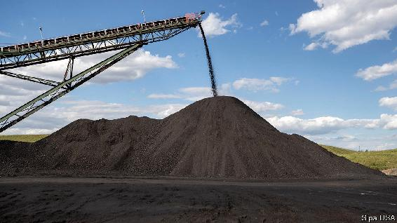

AS LEADERS IN Europe and China push their countries towards clean energy, Donald Trump is proud to tug in the opposite direction. In 2016 he promised to save American coal. In 2020 he has championed “energy dominance” and cast himself as fracking’s last defence against a looming leftist assault. Indeed, Mr Trump would seem to be responsible for a golden age for carbon-emitters. During his presidency America has become the world’s largest producer of crude oil, a big shift for a country that has fretted over energy security for decades. Yet America’s oil boom is subsiding and coal-fired power in decline.

That is despite Mr Trump’s best efforts. “We will never again be reliant on hostile foreign suppliers,” the president declared in July. “And we will defend America’s newfound energy independence.”

His Environmental Protection Agency has, among other things, sought to weaken requirements for reducing greenhouse-gas emissions in the power sector, undermine the legal basis for limiting coal plants’ mercury emissions, loosen fuel-efficiency standards for cars and ease rules for oil and gas producers’ emissions of methane. To invite more drilling, Mr Trump is in the process of removing protection from a swathe of public lands larger than Austria and Switzerland combined.

Many measures remain mired in court. For all Mr Trump’s talk of deregulation, his administration’s rulemaking and litigation have been inept. “Imagine where we’d be if they knew what they were doing,” says David Doniger of the NRDC Action Fund, an environmental lobby group.

If Mr Trump is re-elected, there is a greater chance that his new rules become permanent, particularly if the Supreme Court affirms his interpretation of the Clean Air Act. Less efficient cars would remain on the road, boosting demand for petrol. Coal plants might avoid installing new scrubbers, making them dirtier and, by lowering their costs, extending their lives. It would be harder to curb emissions of methane, a greenhouse gas which over 20 years is 84 times more potent than carbon dioxide. More land could see drilling, including the Arctic National Wildlife Refuge, home to caribou and polar bears. The Rhodium Group, a research outfit, estimates that Mr Trump’s policies might add 1.8 gigatonnes of carbon-dioxide to the atmosphere by 2035. None of this, however, would ensure a revival for coal or a sustained surge in oil and gas production.

Start with coal. Coal-mining employment slumped by 5% from 2016 to 2019, despite Mr Trump’s campaign promises. Coal-fired power-generation has dropped by 22% over the same period, threatened by cheap gas and, increasingly, cheap renewables. Four years ago American coal produced twice as much electricity as renewables did; this year renewable power is poised to match the coal-fired kind for the first time ever, according to the government’s most recent forecast. Mr Trump’s changes might ensure that some coal plants stay open longer and emit more harmful gases. But they would not prevent the sector from decline.

America’s oil and gas dominance also looks rather wobbly. America’s fracking bonanza began under Barack Obama, as oilmen found new ways to blast hydrocarbons from layers of shale. It was Mr Obama who signed a bill ending a 40-year ban on crude oil exports, opening new markets to American producers. During Mr Trump’s presidency, sanctions on Iran and Venezuela, two petrostates, have supported oil prices, but his trade war with China has depressed them. The limit of America’s oil power has also become evident.

Rising American output does not mean the country is independent —in 2019 it imported 9.1m barrels a day of foreign petroleum. Nor is America immune from swings in the global market. Last year crude prices spiked after an attack on oil facilities in Saudi Arabia. Because America’s oil industry has grown, says Jason Bordoff of Columbia University, “we are more vulnerable to the economic harm that comes from an oil price collapse.” When Mr Trump faced sinking prices this year, he had to ask Riyadh and Moscow to cut output. “The consequence,” Mr Bordoff argues, “was to strengthen the relationship between Saudi Arabia and Russia.”

Oil and gas companies themselves are in turmoil. Even before covid-19 ravaged oil demand, investors had fallen out of love with American shale, fed up with poor returns and the continuous need for reinvestment. Last year an index of American exploration and production companies sank by nearly 20%, compared with a jump of almost 30% for the S&P 500. If Mr Trump succeeds in auctioning leases in the Arctic, it may be at fire-sale prices. Several big companies, including BP and Royal Dutch Shell, have already left Alaska.

More surprising, then, than Mr Trump’s support of the fossil-fuel industry is how little he has improved its prospects. Yet the sector would still far prefer a second Trump term to a President Joe Biden. The Democratic nominee would not ban fracking, as Mr Trump claims, but he would seek to end new oil and gas leasing on federal lands. More important, Mr Biden’s effort to reduce greenhouse-gas emissions—for instance, through a target for clean power and support for infrastructure and electric cars—would sap broader demand for hydrocarbons. “It would be a real, dramatic shift,” says Frank Macchiarola of American Petroleum Institute, the oil industry’s main lobby. Investors have already placed their bets. Since the start of the year the value of a the S&P Global Clean-Energy Index has climbed by 70%. ■

Dig deeper:  
Read the [best of our 2020 campaign coverage](https://www.economist.com/us-election-2020) and explore our [election forecasts](https://projects.economist.com/us-2020-forecast/president), then sign up for Checks and Balance, our [weekly newsletter](https://www.economist.com/checksandbalance/) and [podcast](https://play.acast.com/podcasts/2020/01/24/checks-and-balance-our-new-weekly-podcast-on-american-politics) on American politics.

This article was downloaded by calibre from <https://www.economist.com/united-states/2020/10/24/what-donald-trump-did-for-hydrocarbons>

| Section menu | Main menu |

| Next | Section menu | Main menu | Previous |

Tariff man

Donald Trump and trade

What have the president’s threats and deals achieved?

Oct 24th 2020 | WASHINGTON, DC

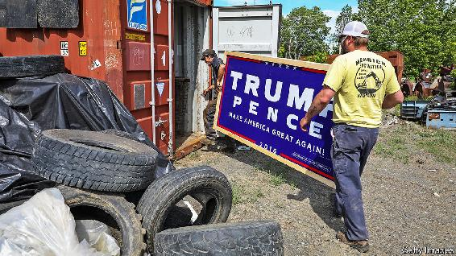

“WE WILL stand up to trade cheating,” Donald Trump promised in 2016. He pledged to end “the era of economic surrender” and put America first, even if that meant kicking others down. He said he would renegotiate “horrible” trade deals bilaterally, scorning any larger agreement “that ties us up and binds us down”. International trade rules were for suckers. And if other countries refused to play along, he promised tariffs.

Mr Trump’s bite turned out to be almost as bad as his bark. On his first day in office he withdrew America from the Trans-Pacific Partnership (TPP), a deal with 11 other countries around the Pacific Rim. He appointed as United States Trade Representative the hawkish Robert Lighthizer, who proceeded to scupper the World Trade Organisation’s system of settling disputes. Without independent referees, foreign governments with complaints have to negotiate directly with Uncle Sam.

The president also lived up to his claim of being a “tariff man”. Allies in Europe and Canada took offence at tariffs on their steel and aluminium, both in the name of America’s national security. He lifted average tariffs on Chinese exports from 3% at the beginning of 2018 to 19% today, at first to slam China for its theft of American companies’ intellectual property, and then in retaliation for China’s counter-tariffs. He used threats to push along some deals too, securing narrow agreements with South Korea, Japan and China, as well as the broader USMCA with Mexico and Canada.

Beneath the all-caps tweets and triumphant handshakes, what did this flurry of activity achieve? His team has not solved any of the structural problems afflicting the global trading system, including the distorting effects of China’s industrial subsidies on international markets. But neither has his team achieved nothing.

The bullying did secure concessions. Japan offered access to its agriculture market (though the TPP would have gone further), without gaining any new access to America’s car market. The Mexican government agreed to tight rules for the standards a car would have to meet to enter America tariff-free. And the “phase-one” deal with China scrapped technical barriers to American exports of pork, dairy and beef, made openings for some financial-services companies and allowed for tariffs to return quickly if the Chinese did not play along.

American companies operating in China do not seem to be particularly grateful for the help. A membership survey conducted in May and June by the US-China Business Council, a trade group, found that for 37% of respondents the cost of the tariffs outweighed the benefits of the trade agreement, and 56% said it was too soon to say. But perhaps the trade war was not entirely being fought on their behalf. If the administration was trying to reduce America’s reliance on China as a supplier, the achievements look more obvious.

These successes came at a cost. One study found that the correlation between higher trade uncertainty and depressed global growth meant that the disputes could have dragged back global GDP growth by 1%. A survey run by the Atlanta Federal Reserve found that domestic-goods manufacturers expected tariff increases and trade policy jitters to squash investment in the second half of 2019 by 8%.

The tariffs shuffled resources around: towards American producers of products shielded by the tariffs, away from the businesses and people having to pay for more expensive imports, as well as producers affected by foreign retaliation. One study found that, for manufacturing employment, the depressive effects outweighed the stimulative ones. Another found that the companies facing tariffs accounted for 84% of American exports and 65% of manufacturing employment. Taking an average cost of $900 per worker, those companies’ exports slowed as though they had faced a foreign tariff of 2%.

Although Mr Trump claimed foreigners were paying the $80bn of revenue the tariffs raised, economists found that, in fact, American importers paid it. A complicated process of applying for tariff exclusions left businesses tangled in bureaucracy. Thousands of companies have sued, claiming that some of the tariffs on China are unlawful. The policy has, at the very least, created a bonanza for trade lawyers.

Trump supporters argue that without pain there is no gain. His critics retort that bigger gains could have been achieved for less pain. What if the president had not threatened America’s allies, and instead focused energies on tackling China’s subsidies? What if he had not weakened his own team’s hand, by going back on his word? With the ink barely dry on the USMCA, he threatened Mexico with tariffs. That made other negotiating partners question the point of offering concessions. Mr Trump’s reputation as an unreliable dealmaker limited what his threats could achieve.■

Dig deeper:  
Read the [best of our 2020 campaign coverage](https://www.economist.com/us-election-2020) and explore our [election forecasts](https://projects.economist.com/us-2020-forecast/president), then sign up for Checks and Balance, our [weekly newsletter](https://www.economist.com/checksandbalance/) and [podcast](https://play.acast.com/podcasts/2020/01/24/checks-and-balance-our-new-weekly-podcast-on-american-politics) on American politics.

This article was downloaded by calibre from <https://www.economist.com/united-states/2020/10/24/donald-trump-and-trade>

| Section menu | Main menu |

| Next | Section menu | Main menu | Previous |

Gold in them hills

Mining for votes in Montana

How to spend $150m on campaigning in a state of 1m people

Oct 24th 2020 | BIG TIMBER, MONTANA

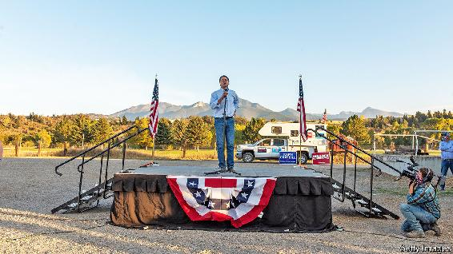

THE RESIDENTS of Big Timber, a mining town near the Crazy Mountains in Montana, can’t wait for the elections to end. Campaigning is too exhausting. Each day they must empty a dozen glossy political pamphlets from overstuffed letterboxes. Local television news is interrupted 15 times every half-hour by candidates’ 30-second spots. These are usually fearmongering attacks on rivals, with ominous voice-overs. Negative ads arrive just as frequently on the radio and in digital form. “Ads sneak onto your phone like a snake in the grass,” grumbles one man.

They are right to feel overwhelmed. In all, campaign spending in Montana is likely to pass $150m, smashing all records in the state. “It’s theatre of the absurd, the cost per vote is through the roof,” says a senior figure in a statewide campaign. Even if turnout passes 80%, that money is chasing about 600,000 ballots. Everything is so saturated, he says, he can find no more television advertising inventory to buy. Even when it is available, the cost of a “gross rating point”, a measure of the reach of a given advert, has soared.

Money has gushed from out-of-state to a Senate contest that is unexpectedly close. The outgoing two-term governor, Steve Bullock, a Democrat, may yet topple a first-term incumbent senator, Steve Daines. The Republican, who is closely aligned with Mr Trump, is suffering as the president’s popularity wanes. Mr Bullock, meanwhile, is well-known in Montana, well-liked for his record as governor and has hugely out-raised his rival. In the third-quarter alone he took in $26.8m.

Spending is also exceptionally high in other small and politically important states, such as Maine, where the campaigns may spend $100 on ads for every vote cast. Yet in Montana the outlay could reach $200. Much goes to local television companies. Then consultants take a cut. One says there are “so few people and a tsunami of ads, it’s overwhelming”. Digital firms take a quarter of ad-spending, says Erika Franklin-Fowler of the Wesleyan Media Project, which tracks money in politics. Spending is “through the roof”, she says.

A few local producers get a cut. In Bozeman, JP Gabriel, who runs Filmlites Montana, says he has never seen such an election gold rush in his 32 years of making ads and lighting political rallies: “This kind of amazing boom, oh my God.” He jokes that he has joined the green party—“bring the green and let’s party”. David Parker of Montana State University sees “absolutely crazy” flows of money to races for governor, attorney-general, Senate and a single House seat. He notes campaign outlays for Montana’s population are more than double what is usually spent (some £40m, or $50m) on an entire British national election, for example.

Mr Bullock has long opposed out-of-control election spending, especially through Super PACs, political action committees that operate alongside candidates’ campaigns. Last year, in his run to be the Democratic presidential nominee, he vowed to fight “a corrupt system that lets campaign money drown out the people’s voice”. This time round, most of the drowning-out is being done for his benefit.

Does the deluge make a difference? Campaigning is easier, notes Jason Thielman, chief-of-staff to Mr Daines: “You don’t have to choose between your children, we can do both digital and TV”. But diminishing returns kick in as voters face their 10,000th ad alleging that Mr Daines does the bidding of Chinese masters, or that Mr Bullock is soft on guns. ■

Dig deeper:  
Read the [best of our 2020 campaign coverage](https://www.economist.com/us-election-2020) and explore our [election forecasts](https://projects.economist.com/us-2020-forecast/president), then sign up for Checks and Balance, our [weekly newsletter](https://www.economist.com/checksandbalance/) and [podcast](https://play.acast.com/podcasts/2020/01/24/checks-and-balance-our-new-weekly-podcast-on-american-politics) on American politics.

This article was downloaded by calibre from <https://www.economist.com/united-states/2020/10/24/mining-for-votes-in-montana>

| Section menu | Main menu |

| Next | Section menu | Main menu | Previous |

Going, going, gone

American museums rush to sell artworks

A brief relaxing of the rules gives them a window of opportunity

Oct 22nd 2020 |

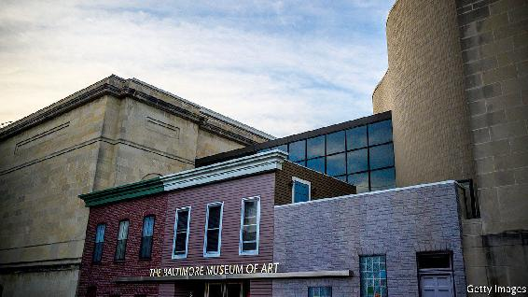

CLYFFORD STILL may have been the most gifted of America’s Abstract Expressionist painters; he was certainly also the most uncompromising. He would suddenly withdraw works he had promised to exhibitions if he considered the curating to be substandard, and he almost never let go of any of his paintings and drawings. When he died in 1980, he still had 2,400 works in his studio.

But Still had made an exception for the painting, in his characteristic jagged strokes of rust and black, which he called “1957-G”. In 1969 he gave this work to the Museum of Art in Baltimore, located 30 miles away from where he and his second wife had settled in rural Maryland eight years earlier. Now the museum is auctioning off the picture, which it hopes might earn it $18m.

“1957-G” is part of a wave of artworks being sold this month by American museums that are taking advantage of a brief loosening of the rules surrounding collections. The Association of Art Museum Directors (AAMD) has long insisted that any money museums gain from such sales can be used only for new acquisitions; it cannot fund shortfalls in revenue when times are hard. In April, though, it agreed to a year-long fillip, which would allow funds from sales to be used for “direct care of the collection”. The Brooklyn Museum joins six other institutions in California, Indiana, Texas, Massachusetts, New Jersey and New York that are hoping to raise tens of millions of dollars by auctioning part of their collections.

Of the $65m that Baltimore hopes to gain from selling the Still and two other paintings, a grey abstract by Brice Marden and Andy Warhol’s famous take on “The Last Supper”, $10m will be used for traditional acquisitions and $55m will go towards an endowment fund to care for the collection, according to Artnet, a website that tracks sales. TheAAMD decision came just as covid-19 was beginning to badly affect museums and other cultural institutions. Baltimore wants to bend the rules and use part of the interest that the endowment will generate to raise salaries for museum staff. Other museums are likely to do the same before the AAMD rules tighten up again in six months’ time.

Whether Still would have approved of how his gift is being treated by Baltimore’s museum is debatable. When he died, he left all the artworks he still owned to any American city that promised to build a museum dedicated entirely to him. Nearly a quarter of a century later, in 2004, his widow signed a deal with Denver, on one condition: that it would never sell a single work by him that was given to the city.

This article was downloaded by calibre from <https://www.economist.com/united-states/2020/10/22/american-museums-rush-to-sell-artworks>

| Section menu | Main menu |

| Next | Section menu | Main menu | Previous |

Liberalism and its contradictions

Who could object to the Equality Act?

A well-intentioned effort by Democrats to protect trans Americans risks discriminating against female Americans

Oct 22nd 2020 | WASHINGTON, DC

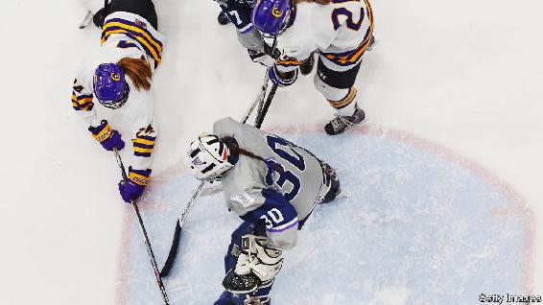

WHEN SHE was ripping through the water during swimming races as a little girl, it did not occur to Nancy Hogshead-Makar that she might one day make a career out of it. But that changed during high school, when she won a full athletic scholarship to university. Four years later Ms Hogshead-Makar won three gold medals at the 1984 Olympics.

Her achievements would have been impossible without Title IX, a brief one-paragraph amendment made to the Civil Rights Act in 1972, when she was ten years old. Title IX banned discrimination “on the basis of sex” in educational institutions that receive federal funding. This meant that most schools and all universities were legally required to provide equal opportunities in activities. It covered things like scholarships; it also resulted in the provision of separate programmes for girls.

Its effect on female participation in sport was immediate and dramatic. Two years after Title IX was passed, the number of girls playing high-school sports jumped from under 300,000 to 1.3m. Today the figure is 3.4m. The lost ground it enabled women to make up has been one of the biggest achievements in the battle for sexual equality in America. It has also had important knock-on effects: research suggests that girls who play sport stay in education longer and get better jobs.

Nearly half a century later, there is still some way to go: Ms Hogshead-Makar, who went on to become a lawyer and establish Champion Women, a women’s-rights non-profit, says many universities do not comply with Title IX’s requirements. And yet some of its protections may soon be erased.

This is because of the demands of another group that has long suffered discrimination: transgender men and women. Their call to be recognised as members of the gender with which they identify—amplified by the merging of their rights with those of gay and lesbian Americans—has led to demands for an Equality Act, which would ban “discrimination on the basis of sex, gender identity and sexual orientation”. The House of Representatives passed it in 2019; Joe Biden has said making it law would be a priority during his first 100 days in the White House.

A federal anti-discrimination law of this kind is sorely needed. In its absence a clashing patchwork of laws and regulations has sprung up across states, counties and cities. Conflicts over such matters are increasingly decided by the courts; they should be settled by elected lawmakers. Eliza Byard, executive director of GLSEN, which campaigns for the rights of LGBT students, says the passing of the Equality Act would be “a transformative moment of liberation for millions of Americans who have had to live as second-class citizens”.

The problem is that parts of the bill appear to put the needs of transgender people above those of women. This is because the act redefines “sex” in Title IX and other amendments of the Civil Rights Act to include “gender identity” rather than making transgenderism a protected category of its own. Its definition of “gender identity” is fuzzy and appears to downplay the reality of sex, listing as it does, “gender-related identity, appearance, mannerisms, or other gender-related characteristics of an individual, regardless of the individual’s designated sex at birth.” The way the act is written suggests that women-only spaces, from public bathrooms to sports teams and prisons, would have to be open to transgender women.

The problem is clearest-cut when it comes to Title IX. That is because although opening up spaces once reserved for females to transgender women carries security and privacy concerns, these can be mitigated to an extent: toilets can be made both unisex and more private (prisons would pose more of a problem). But the protections of Title IX are rooted in the differences between the sexes, chiefly, the physical advantages bestowed by testosterone, which allows boys of average sporting ability to run faster or jump higher than exceptionally talented girls. The Equality Act would require female sports teams to include transgender players, even if their transition from male to female was not obvious: if, for example, they had not taken testosterone-suppressing drugs.

Transgender activists tend not to accept that this is unfair. When asked what she thought about transgender girls with undiminished levels of testosterone racing against female runners and trouncing them (as has happened in at least one state with such a policy) Ms Byard of GLSEN said, “But they are girls! They are girls. Men don’t compete in women’s sports.”

Let’s talk about sex

This denial of the meaning of “sex”, which is reflected in the language of the Equality Act, is a poor ground on which to build policy. The implications could extend well beyond spaces once reserved for women. Doriane Coleman, a law professor at Duke University, points out that if policymakers are not allowed to ‘see’ sex, “all the centres of excellence at research hospitals that currently exist to collect data on and then study sex differences in immunology, cancer, you name it, would be defunded and, indeed, become verboten”.

Ways exist to prevent discrimination against transgender Americans without denying the reality of sex. In prisons, where transgender women housed with men are much more likely to be sexually assaulted than other inmates, wings could be set aside for them. In sport, some champions of Title IX have suggested that transgender girls who have not been through puberty as males (because they have taken testosterone blockers and then oestrogen) could be included in women’s teams. A system of adjusted scores and start lines, according to testosterone levels, could also be introduced. “This is about testosterone, not whether someone is transgender or not,” says Donna Lopiano, adjunct professor of sports management at Southern Connecticut State University and a former college sports director who is lobbying for a change to the wording of the act.

Such solutions are unlikely to satisfy some feminists, who believe no person born a man should win a women’s contest. For many trans activists, these work-arounds would amount to a denial of gender identity and the continued perpetuation of discrimination. Negotiating a path through these clashing demands would be messy and time consuming. But ending discrimination against one group of people should not depend on discriminating against another.■

This article was downloaded by calibre from <https://www.economist.com/united-states/2020/10/22/who-could-object-to-the-equality-act>

| Section menu | Main menu |

| Next | Section menu | Main menu | Previous |

Lexington

Donald Trump’s effort to sow mistrust is looking like an own-goal

Time spent with North Carolina’s early voters suggests a blue wave is on the way

Oct 24th 2020 |

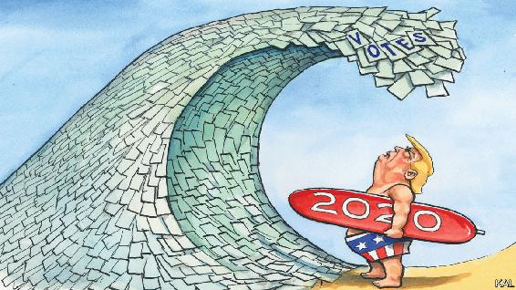

PERHAPS IT WAS only a matter of time before the land of billion-dollar election campaigns supersized the vote itself. The great wave of early voting America has experienced over the past two weeks is nonetheless bracing. By the time Donald Trump and Joe Biden are due to hold their debate this week, around 50m ballots will have been cast—almost 40% of the total in 2016. The president, it must be said, is leaving his comeback awfully late.

A tour of polling stations in North Carolina—up and down Interstate 85, which links the battleground state’s main conurbations—illustrated this new voting season. Beginning in the sprawling suburbs of Charlotte, shortly before sunrise, Lexington witnessed voters queuing up around the block, silent or in hushed conversation with a companion, with sometimes a child or two in tow. “I’ve never seen anything like it,” marvelled the Republican commissioner of Union County, Richard Helms, outside a fire-station-site in suburban Indian Trail. His county, on the city’s outer edge, cast 103,000 votes in 2016. Mr Helms expected it to have cast 40,000 by the end of this week.

Proceeding north via Winston-Salem to preppy Durham, then to the former mill-town of Henderson, close to the Virginia border, to visit a last polling-site after sunset, there were similar scenes in each place. A telltale cluster of campaign signs outside a school, fire-station or college building; a steady trickle and often a long line of silent voters; grim head-shakes or nods to the partisan “poll-greeters” handing out their lists of names. And when the voters were asked to say what was most important about this election, a great deal more fear, anguish, and even tears than are usually evident when a mature democracy votes.

“Everything is evil,” exclaimed Claudia, a middle-aged Latina in Indian Trail, to explain why she was taking such pains to vote early. Ahead of her in the line, Beverly, a first-time early-voter and independent, pointed to her T-shirt, which read: “=>÷ ”. “We need new leadership,” she said—a sentiment that Rob, standing behind her with his wife and bleary-eyed toddler son, munching on Goldfish crackers, did not share. “We’re here because of Biden’s corruption and 47 years in politics without doing anything,” he said.

There is good news here. Despite covid-19, the chaos of decentralised electoral governance, and Republican efforts to exploit it for partisan gain, the election seems—at this early stage—to be going fairly well. Most states have expanded their time-frames and opened more sites for early voting. North Carolina and other states have facilitated kerbside voting, enabling high-risk voters to cast ballots in person. A feared shortage of volunteers seems not to have transpired. Several of the poll-greeters Lexington met had come forward, out of a redoubled sense of duty, for the first time.

Some of the enduring concerns about Republican efforts to suppress non-white votes, in Georgia and Texas especially, have been slightly allayed. In North Carolina, black voters’ ballots are more than twice as likely to be rejected as the average postal vote. Yet they can be resubmitted. A worst-case projection—that 0.4% of Democratic votes could be rejected in the state—should be compared with the rejection of 2% of votes during the primaries.

Worse news is that one of America’s few shared civic rituals has become as politicised as everything else. The early-vote surge has been driven by Democrats—as indicated by the fact that registered Democrats are over one-and-a-half times as likely to have voted as registered Republicans. Most are voting by post. In contrast, registered Republicans, who used to dominate mail-voting, are in most states likelier to vote early in person. This looks like a response to Mr Trump’s insistence that postal voting is “fraudulent”—and another indication that Republicans, again in response to his misinformation, are less careful about covid-19. Almost the only unmasked voters Lexington spoke with were Trumpers. They included the Republican poll-greeter in Indian Trail, a friendly retiree called Phyllis, who said she took a daily handful of vitamins and zinc pills to ward off covid but considered mask-wearing an instrument of pernicious government control “that the whole world is waking up to”.

Republicans and Democrats seem increasingly to inhabit different realities. Little wonder they lined up together in mistrustful silence. “Normally you’re talking and laughing when you come to vote,” said Alejandro, a burly Democrat in Henderson. “This year there’s so much fear and anger everybody’s just doing what they have to do.” Most voters from the city’s black majority said that they were voting in person, despite being worried about covid, because they were afraid their ballot would not count if they mailed it in. And voting was the only form of political expression one woman said she could take part in. For fear of her “violent” white pro-Trump neighbours, she had not dared to display a Democratic sign in her yard this year for the first time. “I decided I’d rather have peace than express myself,” she said, as her eyes filled with tears.

Some of these changes to the country’s electoral culture are likely to be long-lasting. Americans of different races and political hues could end up voting almost as separately as they worship. On the other hand, the immediate cause of their disunity, Mr Trump, seems increasingly likely to be on the way out.

A taste of his own medicine

The Democratic early-vote lead does not predict his defeat. It will be somewhat pegged back by his supporters on election day. Yet it is graphic evidence of Democratic enthusiasm—which is in itself likely to generate further enthusiasm. It should also insure the Democrats against late mishaps—such as the tropical storm long-range forecasters foresee in Florida on election day—to which Republicans will remain vulnerable. Moreover, as a boomeranged consequence of the president’s efforts to undercut mail-in voting, the Democratic advantage points to another important factor in Mr Trump’s struggles: his stunning ineptitude.■

Dig deeper:  
Read the [best of our 2020 campaign coverage](https://www.economist.com/us-election-2020) and explore our [election forecasts](https://projects.economist.com/us-2020-forecast/president), then sign up for Checks and Balance, our [weekly newsletter](https://www.economist.com/checksandbalance/) and [podcast](https://play.acast.com/podcasts/2020/01/24/checks-and-balance-our-new-weekly-podcast-on-american-politics) on American politics.

This article was downloaded by calibre from <https://www.economist.com/united-states/2020/10/24/donald-trumps-effort-to-sow-mistrust-is-looking-like-an-own-goal>

| Section menu | Main menu |

# The Americas

* Chile: In need of a new edifice
* Bello: Don’t mess up the miracle

| Next | Section menu | Main menu |

In need of a new edifice

Chile’s momentous referendum on its constitution

The country will probably become more social-democratic. Will it become spendthrift?

Oct 22nd 2020 | SANTIAGO

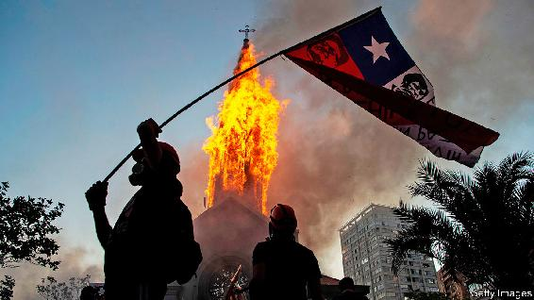

A YEAR AFTER the outbreak of huge protests in which at least 30 people died, Chileans assembled again. The combination of mass civility and minority mayhem was familiar. Tens of thousands of flag-waving demonstrators congregated peacefully on October 18th in Plaza Italia in central Santiago, the capital. In the afternoon fights broke out between football gangs. The day ended with attacks on police stations and two churches ablaze.

The pandemic has largely contained such protests. But a more enduring solution is supposed to come from a referendum, to be held on October 25th, on whether Chile should scrap its constitution and write a new one. “This provides a chance to channel in a civilised way something that got really scary,” says Javier Couso, a constitutional scholar at Diego Portales and Utrecht universities who advises the centrist Christian Democratic Party.

The problems with the current constitution start with its origins. Adopted in 1980, it is the work of the regime led by Augusto Pinochet, a despot who ruled until 1990. Although it acknowledged basic freedoms, a state of emergency suspended these until the regime’s final days. Under the influence of pro-market economists educated at the University of Chicago, it not only protected the private sector but gave it a big role in providing public services. “It is the one that most favours the private sector in the world,” says Mr Couso.

Chile prospered under Pinochet’s charter, which later governments amended dozens of times. Since 1990 the economy has grown rapidly, poverty has fallen sharply and politics have been stable. But the anger that flared last year has been building for more than a decade. Chileans fume about two-tier health care, which serves the rich better than ordinary folk; about the poor quality of state schools; and about privately managed pensions, which pay out less than many people expected.

Chileans largely blame the constitution. By giving citizens a choice of contributing towards the public health-care system or a private one, the charter makes it hard for the state to set up a taxpayer-financed health-care system like Britain’s NHS. When a left-leaning government sought to strengthen the consumer-protection agency, by allowing it to fine companies, the Constitutional Tribunal overruled it. The court might also strike down any attempt to replace privately managed pensions as an infringement of the right to choose between public and private systems. Changes to laws on education, policing, mining and elections require four-sevenths majorities in both houses of Congress.

In critics’ eyes the constitution is not just “neoliberal” but “hyperpresidential”. It gives the president the power to dictate which bills get priority in Congress. Members may not propose tax or spending bills. Regions cannot raise their own revenues, which concentrates power in Santiago. The constitution is “designed to neutralise democratic politics”, says Fernando Atria, a legal scholar at the University of Chile and head of Common Force, part of the left-wing Broad Front alliance.

On October 25th voters will also choose whether to entrust drafting to an elected assembly, half of whose members would be women, or to a convention split evenly between elected delegates and members of Congress. What might they write on the blank sheet? They will probably agree to a constitutional mention of indigenous Chileans, 9% of Chile’s 19m people, and perhaps encourage use of their languages. The president will probably lose some powers; some delegates will argue for adopting a parliamentary system. There may be more scope for referendums.

Any new constitution is likely to make Chile more social-democratic. Advocates of the new charter want to introduce the idea of “equality of opportunity”, which in Chilean terms means making better public services affordable for everyone. They will press for the creation of new social rights, such as an entitlement to housing. Some fear that all this will compel the government to spend money it does not have. The autonomy of the Central Bank, which has helped kept inflation low, could be weakened. The far left will not realise its dream of nationalising industries, believes Bernardo Larraín, president of SOFOFA, a business lobby, but a new constitution could weaken property rights.

Such risks are heightened by the political calendar. The assembly, to be elected next April, will be deliberating as the country holds presidential and congressional elections next November. Campaign promises will influence the drafters.

The danger is lessened, however, by the requirement that two-thirds of the convention must approve every clause in the new document. The odds are that the pro-business centre-right and the small group still nostalgic for Pinochet’s rule will have a blocking minority. New demands on government spending may be tamed by rules that protect fiscal stability. The shift towards more social rights will not be radical, predicts Verónica Undurraga, a professor of law at Adolfo Ibáñez University. If Chileans fail to rewrite their constitution now, demands for radicalism could grow. ■

This article was downloaded by calibre from <https://www.economist.com/the-americas/2020/10/22/chiles-momentous-referendum-on-its-constitution>

| Section menu | Main menu |

| Next | Section menu | Main menu | Previous |

Bello

Don’t mess up Bolivia’s miracle

A landslide victory brings peace to the country, at least for now

Oct 24th 2020 |

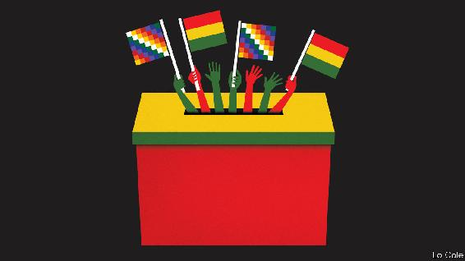

ON OCTOBER 18TH, the owner of a guesthouse on Isla del Sol in Lake Titicaca walked for an hour on a dusty path past Inca ruins to vote in a re-run of Bolivia’s election. He was worried. Last year’s contest had sparked a year of protests, driving up food prices and keeping tourists away. This time, polls predicted a runoff between Luis Arce, the candidate of the Movement to Socialism (MAS), which held power for 14 years until last November, and Carlos Mesa, a centrist former president. “I don’t care who wins,” said Óscar, the hotelier. “I’m worried about what happens after.”

Most Bolivians shared his fears that violence would break out, especially if a candidate lost narrowly and challenged the result. In fact, Mr Arce won by a landslide. With 93% of tally sheets counted, he got 54% of votes, 25 points more than Mr Mesa, who quickly conceded. Anti-MAS voters gathered in a few cities to denounce “electoral fraud” but dispersed. Peace, if it holds, would be “a little miracle”, says a diplomat.

Also miraculous is the MAS’s comeback. Evo Morales, its founder and, from 2006, Bolivia’s first indigenous president, was popular for years. The government spent money from gas exports to reduce by two-thirds the number of people living on less than $1.90 a day. On Isla del Sol Aymara entrepreneurs took advantage of an expansion of credit to build tiny hotels. The children of potato farmers and sheep herders became tour guides and boat drivers. But with the end of the commodity boom public services worsened. Corruption proliferated and Mr Morales became more authoritarian. Last October he ran for a fourth term in defiance of a referendum vote in 2016. A pause in the count led to suspicions that he was rigging the election. Protests erupted. Mr Morales fled the country.

Anger soon turned on Jeanine Áñez, the right-wing senator who took his place. She sent the army to quash protests, launched her own campaign and mismanaged the response to the pandemic. Nostalgia grew for the stability of Mr Morales’s early years. Mr Arce, who had been his finance minister, profited from that.

To succeed as president, Mr Arce must try to revive economic growth. He should also avoid weakening institutions and alienating half of Bolivians, as Mr Morales did. None of this will be easy. As a uniter, Mr Arce has begun promisingly. “I am not Evo Morales,” he insists. Whereas the former president was a populist, Mr Arce is a technocrat. As finance minister, he kept long hours and few assistants. Middle-class and educated partly in Britain, he has tried to connect with poor voters, cooking pork chicharrones with street vendors. His running mate, David Choquehuanca, is an Aymara intellectual beloved by the MAS’s rural support base. He resigned as foreign minister in 2017 and has criticised Mr Morales’s bid for a fourth term.

After his victory Mr Arce promised to “correct our mistakes” and govern “for all Bolivians”. Speaking in the pod of a cable car over La Paz, he said that he would welcome Mr Morales home, but not in a government role. Whether he keeps his word will be an early test of his independence. Both Mr Morales and Ms Áñez used the justice system to jail rivals. Mr Arce promises not to interfere in investigations of former MAS officials—including Mr Morales—for corruption, terrorism and electoral fraud. Mr Arce faces a corruption probe.

But promises of presidential restraint will be hard to keep, especially as the MAS will retain a majority in the legislature. Mr Arce may face pressure to wage lawfare against members of Ms Áñez’s government. “The pendulum could swing back,” warns Jorge Derpic, a Bolivian sociologist at the University of Georgia.

Mr Arce, who as finance minister presided over low inflation and fast economic growth, must now cope with a slump and empty coffers. He wants to maintain social spending and renegotiate debt owed to multilateral lenders. To lessen dependence on gas, he would build up industries like lithium batteries and plastics. That will take time. “There’s no lithium industry,” notes Alberto Bonadona, an economist. “What we have is salt for a good barbecue.”

Bolivians will not put up with failure. “We’re not ignorant anymore,” says Óscar, recalling that 20 years ago a señor arrived before elections to tell islanders how to vote. Now they get news on smartphones. Óscar hopes that Mr Arce stays for just one term. “You can’t sell the same product...year after year,” says the hotelier, who also hawks alpaca jumpers. That is a lesson that Mr Morales’s successor would do well to learn.

This article was downloaded by calibre from <https://www.economist.com/the-americas/2020/10/24/dont-mess-up-bolivias-miracle>

| Section menu | Main menu |

# Asia

* Disinformation in Myanmar: Anti-social network
* North Korea and the world: Not-so-splendid isolation
* New Zealand’s election: Labour day
* Drugs in India: Weed killers
* Banyan: A feverish mood

| Next | Section menu | Main menu |

Anti-social network

In Myanmar, Facebook struggles with a deluge of disinformation

Weeks before an election, Burmese social media are awash with fake news and vitriol

Oct 22nd 2020 | SINGAPORE

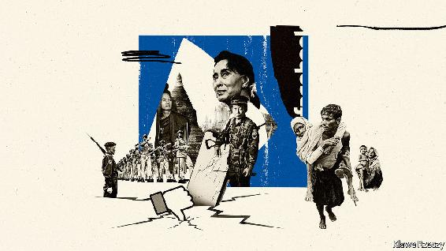

MG MG KYAW can still remember the day he got his first mobile phone. It was 2012, and Myanmar was emerging from decades under the heel of a military junta. In a country where GDP per person was $1,000, SIM cards, which sold for as much as $2,000, were like gold dust. Only North Korea had fewer mobile phones per person.

When a civilian government took power a decade ago, it ended pre-publication censorship and liberalised telecommunications. Mr Mg Mg Kyaw applied to the government to purchase a SIM card, then in limited supply. He won the “lucky draw”, as he puts it, and shelled out 500,000 kyat ($387) for the chip. When he took his new phone to the university where he was a student, he was thronged by curious friends. “I felt like a star,” he says.

Facebook was already installed on Mr Mg Mg Kyaw’s phone when he bought it. As the price of a SIM card plunged, to as low as $1.50 by 2014, and the number of cards relative to the population skyrocketed, from 2% in 2011 to 126% in 2020, Facebook stepped up its effort to get onto Burmese smartphones. In 2016 it rolled out its “Free Basics” program, which gives users who sign up for a Facebook account free access to a limited number of pre-selected websites. With Free Basics, Facebook hoped to conquer much of the developing world. In Myanmar, the tactic worked.

The platform now has 27m users in Myanmar, equivalent to half of the population. This is no big feat in South-East Asia, where there are roughly two Facebook accounts for every three people. Yet the company has captured 99.4% of the Burmese social-media market, according to StatCounter, a market-analysis company. When Ronan Lee of Queen Mary University of London conducted field work in Myanmar, “it was common to find mobile-phone users who did not understand that the Internet existed beyond what was available to them” through the site, he writes. Even Burmese slang reflects the fact that in Myanmar, Facebook is the internet. The word for “going online”, line paw tat tal, is synonymous with “active on Facebook”.

Getting a phone was “exciting”, says Mr Mg Mg Kyaw, now a 27-year-old customer-service agent, especially as data became more affordable. Now he spends about ten hours a day on the internet, he reckons, much of it on Facebook, talking to other users about politics and the military. “People in Myanmar were silenced [by the junta] for so long,” says Christina Fink, a cultural anthropologist at George Washington University in Washington. They have “revelled” in being able to express themselves on Facebook, she says.

But there is a dark side to this freedom. Since 2012, a Buddhist nationalist movement has created a virtual community on Facebook bound together by its fear of Muslims. According to the UN, in 2017 there were more than 150 highly influential Facebook accounts, pages and groups that regularly preached hate against Muslims and the Rohingya, a Muslim ethnic minority in the western state of Rakhine. That same year the Burmese army and mobs of Buddhist Rakhines, another ethnic minority, attacked Rohingya villages, sparking the exodus of some 725,000 Rohingyas to neighbouring Bangladesh. UN experts investigating the pogrom determined that Facebook had been “a useful instrument for those seeking to spread hate”.

As the country gears up for an election on November 8th, independent social-media monitors have recorded growing volumes of hate speech and disinformation—such as claims that Aung San Suu Kyi, Myanmar’s de facto leader, has died of covid. On October 8th Facebook announced that it had removed a popular network of accounts it says were run by the army, which promoted the view that the Rohingya do not belong in Myanmar.

But supporters of the National League for Democracy, the party of Ms Suu Kyi, are also targeting Muslims and pushing falsehoods in an effort to convince ethnic minorities to vote for their party, according to Myat Thu of Myanmar Tech Accountability, a monitoring firm. The targets of bigotry now encompass anyone who is not “pure Bamar”, the ethnic majority, says another analyst who monitors Burmese social media, and asked not to be named.

Facebook is the primary source of news for two out of five Burmese users. They are highly susceptible to manipulation online for several reasons, explains Ms Fink. Critical thinking is absent from school curricula, depriving pupils of the skills necessary to distinguish fact from fiction. Myanmar is a hierarchical society, and divisive posts are often written by powerful figures, from senior monks to generals. Islamophobia also taps into an anxiety, unleashed by the opening up of the economy, that Muslims will enrich themselves at the expense of others. That fear harks back to Myanmar’s past as a British colony, when hundreds of thousands of Indians migrated to Burma, as it was known, and often prospered there.

Facebook argues that it is better equipped to deal with abusers than it was a few years ago (see [Briefing](https://www.economist.com/node/21793457)). It has banned some generals and monks from the platform, and its “integrity systems”—a mix of artificial intelligence (AI) and human monitors—scrub content that violates its policies, according to Rafael Frankel, Facebook’s director of public policy. For the duration of the election campaign, Facebook has expanded its hate-speech policy to include attacks on religion: users may no longer say, for instance, that they hate Islam, something that was previously allowed. Misinformation that might undermine confidence in the polls is also banned. “As a result we’re basically at near-historic lows for hate speech on the platform in Myanmar,” says Mr Frankel.

Its monitors are certainly hard at work. They removed 280,000 pieces of content in the second quarter of this year, more than five times what they took down the previous quarter. Yet much may be slipping through the net. The platform aims to wipe prohibited content within 24 hours—but a post does not need to be up for long to be seen by hundreds of thousands of users. Moreover, Facebook’s AI reviews only Burmese content; it has not been trained in any of the country’s ethnic-minority languages, spoken by a third of the population. But at least the site is trying. The government makes little effort to curb incitement to violence against minorities, nor to promote the idea that Myanmar belongs to everyone who lives there. ■

This article was downloaded by calibre from <https://www.economist.com/asia/2020/10/22/in-myanmar-facebook-struggles-with-a-deluge-of-disinformation>

| Section menu | Main menu |

| Next | Section menu | Main menu | Previous |

Hermit kingdom

North Korea is lonelier than ever

With borders shut and diplomats confined, the only things improving are the missiles

Oct 24th 2020 | SEOUL

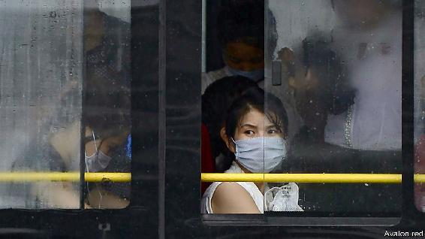

IT WAS SATURDAY morning on the Korean peninsula and Friday evening in America when pundits and policymakers around the world tuned into North Korean state television. They had hoped to watch a military parade in Pyongyang, the capital, to mark the 75th anniversary of the ruling party’s creation on October 10th. But instead of the expected display of military hardware, they were treated to patriotic soap operas and a programme on how to care for ornamental fish. It was only at 7pm in Seoul, South Korea’s capital, that a special broadcast confirmed earlier rumours. The parade had already happened—in the middle of the previous night.

The nocturnal parading shows just how much more isolated the secretive dictatorship has become since covid-19 erupted. North Korea’s borders, hardly bustling to start with, have been shut since the end of January. Official trade with the outside world, already sharply curtailed by UN sanctions, has all but ceased. Diplomacy with South Korea and America has been moribund since last year’s failed summit in Vietnam. With most foreign diplomats and NGO people expelled from Pyongyang and the remaining few largely confined to their houses, it is harder than ever for outsiders to pierce the autocratic fog.

The anniversary celebration is a case in point. For the last big parade, in September 2018, the regime invited a large contingent of foreign journalists and dignitaries, as well as diplomats stationed in Pyongyang, to witness a relatively emollient display of flower-clad floats with economic themes. This time round there were fewer flowers, more arms—and no independent coverage.

Beyond the capital, self-isolation takes a more sinister form. As part of its anti-covid measures, the regime instituted a shoot-to-kill order along its border with China at the end of August to prevent smugglers from crossing; several have reportedly been killed. The rule may also have contributed to a gruesome incident last month when North Korean border guards shot and killed a South Korean official who had ended up in their waters.

North Korea’s decision to self-quarantine seems to have caused much economic distress both to ordinary North Koreans in the countryside and elites in the capital. In the border regions near China, where residents supplement their incomes with small-scale smuggling, a survey of ten households suggests that people have cut back on spending by around a third so far this year, reports DailyNK, a South Korean website. Damage from floods and typhoons has compounded the misery in rural areas. Shops in Pyongyang have rationed staple foods amid panic-buying.

Kim Jong Un, the North’s dictator, shed tears earlier this month when he theatrically apologised that his efforts had been insufficient to free his people “from the difficulties in their lives”. His contrition is likely to have elicited hollow laughter from the North Koreans who recently told researchers from Human Rights Watch, a monitor, about beatings, rape and starvation in pre-trial jails.

Thanks to unofficial Chinese aid, things are unlikely to deteriorate to the point of collapse, reckons Andrei Lankov of Kookmin University in Seoul. Because China’s relations with America are so poor, he says, “keeping North Korea stable is more important to China than ever.” He cites fuel supply as an example of China’s discreet aid: according to trade data reported to the UN, oil imports, already capped by sanctions, dropped to near zero in August. But there has been no rise in domestic fuel prices, suggesting that, despite the quarantine, supplies are still arriving by unofficial channels from China and possibly Russia.

The one thing unaffected by quarantine is the progress of Mr Kim’s arsenal. At the recent parade he presented a huge—if unwieldy and untested—new road-mobile intercontinental ballistic missile, thought to be the largest of its sort in the world, plus several other new arms. Despite the diplomatic overtures of 2018 and 2019, Mr Kim clearly values flashy weapons above full plates (for his subjects, anyway). With borders shut and diplomats confined, he need not worry much about external scrutiny. ■

This article was downloaded by calibre from <https://www.economist.com/asia/2020/10/24/north-korea-is-lonelier-than-ever>

| Section menu | Main menu |

| Next | Section menu | Main menu | Previous |

Labour day

A hard task ahead for Jacinda Ardern’s new government

New Zealand has kept out covid-19, but is not immune to its economic consequences

Oct 24th 2020 | SYDNEY

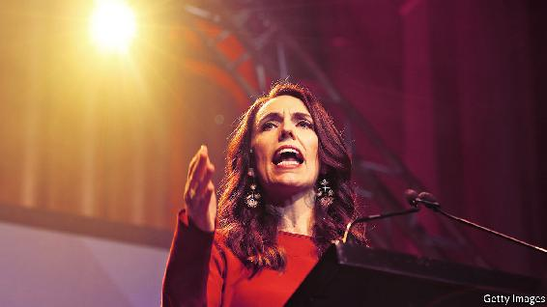

EVERYONE KNEW that the Labour Party would win. But even its leader, Jacinda Ardern, seemed startled by its landslide victory in New Zealand’s general election on October 17th. Ballots must still be counted from prisoners and expats, but so far Labour has mopped up 49% of the vote, compared with 27% for the main opposition, the conservative National Party. New Zealand’s proportional voting system is designed to curb the power of big parties, by making it hard for them to govern without smaller coalition partners. Yet with an absolute majority in parliament (64 seats out of 120), Labour will be able to do just that.

Although she does not need them, the prime minister is now in talks with the Green Party’s ten MPs, to find what she calls “areas of potential co-operation”. They might not enter teha full-blown coalition, but the pair could form a looser partnership whereby the Greens vote with the government on certain issues, in return for a ministerial portfolio or two, says Neale Jones, Ms Ardern’s former chief of staff. The Greens’ co-leader, James Shaw, was climate-change minister in the last government. One idea is that he could be re-appointed to that post. Such an arrangement would have the appeal of keeping criticism at bay. What is more, Labour has lots of ministerial jobs to fill, now that it has a parliamentary majority. Many of its MPs are rookies, so experienced Greens could help fill the ranks.

Ms Ardern, New Zealand’s most popular leader in generations (and one of the world’s most popular—see chart) has avoided debate about what happens next. Her upbeat campaign focused on how well her previous government, a coalition with a populist party, New Zealand First, kept the pandemic at bay. New Zealand has all but suppressed local transmission of the virus, allowing Kiwis to have fun in crowds—a day after the election, 46,000 fans squished into a stadium to watch the All Blacks, the national rugby team, thrash Australia. But this does not mean that the country is immune to the economic symptoms of covid-19.

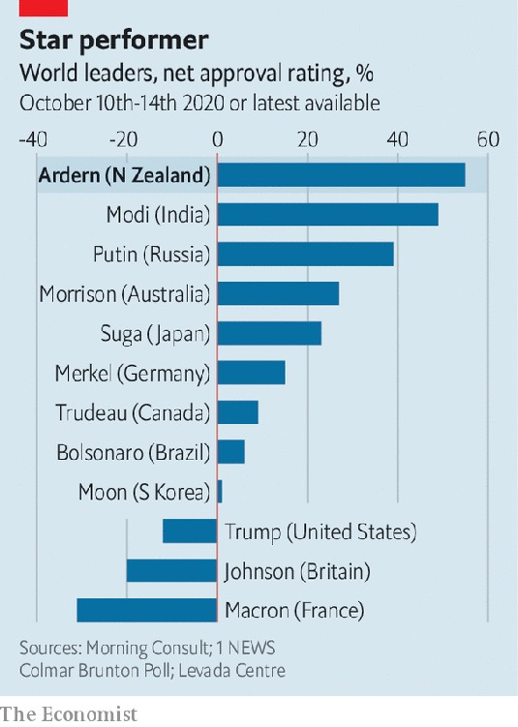

New Zealand’s small economy depends on the outside world. Since its borders closed in March, the foreign students and immigrants who power its growth have been shut out. The loss of tourists, who are normally its biggest source of export earnings, is devastating resort towns such as Queenstown. A wage subsidy, which saved vulnerable jobs in hospitality and retail, has just dried up. The government predicts that unemployment will almost double to 7.7% in the year ahead.

Kiwis strongly support their state of isolation. Although Ms Ardern intends to let in a trickle of “critical workers” and graduate students—and perhaps, at some point, visitors from Australia—government modelling suggests New Zealand will be closed until early 2022. Labour insists that it has other ideas to get the economy moving. The problem, says Jennifer Curtin, a political scientist at Auckland University, is that no one is quite sure what they are.

The party’s 29-page manifesto was released just four days before the vote. It vows to create jobs by investing in critical infrastructure. There will be more loans for small firms, and a NZ$311m ($206m) subsidy for companies which hire the jobless. To critics, this all seems rather bitsy. They gripe that Ms Ardern is better at making people feel warm and fuzzy than turning policies into action. In her first term plans for everything from a capital-gains tax to a light railway in Auckland fell flat.

Back then Labour was able to blame, often fairly, its conservative coalition partner for such failures. Now it bears sole responsibility. Left-wing voters will expect Ms Ardern to do something big about poverty and inequality—problems which she promised, but failed, to tackle in her first term. However, the conservative voters she has just won over will be wary of sweeping changes to tax or welfare. Ms Ardern promises to govern “for all New Zealanders”. But she cannot please everyone. ■

This article was downloaded by calibre from <https://www.economist.com/asia/2020/10/24/a-hard-task-ahead-for-jacinda-arderns-new-government>

| Section menu | Main menu |

| Next | Section menu | Main menu | Previous |

Weed killer

Indian stoners face a moral crusade

Puritans fret that cannabis-crazed actors are corrupting the nation’s youth

Oct 22nd 2020 | DELHI

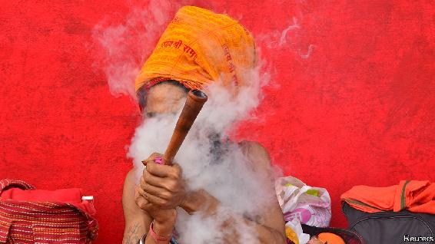

ONE MIGHT expect India to be at peace with marijuana. Before time itself, the god Shiva is supposed to have discovered the stuff. He sits high in a mythical Himalayan abode, eating gobs of it while pondering the mysteries of the universe; so do religious mendicants who emulate him today. Victorian India exported ganja to Jamaica with indentured labourers in the first half of the 19th century, long before the West surrendered to its mellow charms. But this monsoon season, moralists have raised the alarm: cannabis-crazed Bollywood stars are corrupting India’s youth.

The Indian media went to war with the killer weed in September while the Narcotics Control Bureau (NCB) and other law-enforcement agencies rolled out a series of pretexts to hold Rhea Chakraborty, a Bollywood starlet, in jail for a month—ultimately for having procured marijuana for her boyfriend, a better-known actor who committed suicide in June. In poring over Ms Chakraborty’s private communications, investigators connected her to other dissolute young actors, including the A-lister Deepika Padukone, who discussed “doob” over WhatsApp. “The ground is ready for a Bollywood clean-up,” thunders a journalist friendly to the government, connecting the film industry’s supposed “drug obsession” with ills as diverse as “smuggling, sex rackets, terrorism [and] killing wildlife”.

The notion that Indians ought to be outraged by this is curious. The oldest literary references to cannabis use are from the Hindu Vedas, which spoke glowingly of hemp’s high 3,000 years ago. Kiosks around the country sell squashy boluses of bhang, a mildly psychoactive paste made from its leaves, for two rupees apiece (less than three cents). In 2018 ABCD, a Germanmarketing firm, estimated that Delhi and Mumbai are among the top six cannabis-consuming cities in the world, together burning through more than 70 tonnes each year. Even respectable Hindu families share tumblers of a bhang-based drink to celebrate the spring festival of Holi, as do teetotal Sufi Muslims.

When America declared its ill-starred war on drugs in the 1970s, Bollywood tried joining the cause. A Hindi film in 1971 that gave Indian stoners their theme song, “Dum Maro Dum” (“Take Another Hit”), warned that madness and death lay the way of the doobie. By 1985 international pressure bent India into compliance with a series of American-driven, UN-backed anti-drug conventions, which classified cannabis alongside drugs like heroin—albeit leaving a quirky loophole for bhang.

India’s history with cannabis is unique in keeping an unbroken connection to the stuff, including in centuries when it was forgotten by Europeans. As colonists arrived, they were sceptical but intrigued. In 1890 the British undertook an exhaustive study, resulting in a seven-volume “Indian Hemp Drugs Commission Report”. Its conclusions presaged the contemporary post-post-hippie consensus, which has led to waves of medical research and decriminalisation in North America and Europe: “The moderate use of hemp drugs is practically attended by no evil results at all.” ■

This article was downloaded by calibre from <https://www.economist.com/asia/2020/10/22/indian-stoners-face-a-moral-crusade>

| Section menu | Main menu |

| Next | Section menu | Main menu | Previous |

Banyan

The pandemic has exposed South-East Asia’s poor governance

Covid-19 has shone a light on the failings of strongmen and kleptocrats

Oct 24th 2020 |



IT HARDLY FOLLOWED the script intended by Thailand’s army-backed government. In the face of growing demonstrations calling for the resignation of the prime minister, a new constitution and a reformed monarchy, on October 15th the government imposed a “severe” state of emergency, banning gatherings of more than five people. Far from being cowed, a formless protest movement morphed into a determined opposition.

Young activists, many still at school, poured onto the streets of Bangkok. They brandished symbols of defiance, such as a three-fingered salute borrowed from the “The Hunger Games”, a dystopian novel, along with flashmob tactics inspired by Hong Kong’s protests. Activists already talk of victory. In a way, they are correct: longstanding taboos, such as one against criticism of the monarchy, have been smashed. The emergency decree was withdrawn on October 22nd.

The indignation felt by the prime minister and former coup leader, Prayuth Chan-ocha, and his cronies is palpable—a sense that protests are a gross display of ingratitude. After all, in health terms, the government handled the pandemic remarkably well, with a mere 3,709 covid-19 cases and 59 deaths. Thailand, heavily dependent on tourism, now wants to reopen to visitors. On October 20th the first planeload of Chinese holidaymakers landed in Bangkok.

The protesters, however, see things differently. For a start, they say, weeks of lockdown nurtured a social-media ferment, which exploded in July after restrictions were eased. But above all, the handling of the pandemic notwithstanding, the economic consequences are dire. Thailand’s economy may shrink by nearly 8% this year. Many of over 500,000 university students who graduate in the coming weeks wonder how they will find work. One student says she and her colleagues associate their own pinched prospects with the king’s obscene wealth, kleptocratic elites and other embodiments of lousy governance.

The monarchy and its excesses are unique to Thailand. But the degree to which young people share the same perspective across South-East Asia is striking. In a region whose economy is forecast to shrink by nearly 4% this year, the World Bank warns that covid-19 will have a lasting impact, in particular, on inclusive growth, by hurting investment, human capital and productivity. The Bank predicts that, across East Asia and the Pacific, the number of poor people will rise by 38m; most of those will be in South-East Asia. The worst-hit victims are the young, especially in those countries, such as Indonesia and the Philippines, with large informal sectors.

For South-East Asia, the economic impact of the coronavirus is more serious even than that of the Asian financial crisis in 1997-98. Then, economic distress exposed the region’s dire shortcomings in governance. It brought forth calls, especially among the young, for political change. The crisis ushered in a democratic movement in Thailand. In Indonesia it sowed the seeds for the downfall of Suharto, the aged dictator, and a new, democratic era of reformasi.

Yet the pandemic has laid bare how fitful change has been. In Cambodia the strongman, Hun Sen, holds court like a medieval Khmer king, tolerating graft and locking up critics. In Malaysia, after hopes of reform, governing still involves cronyism, vote-buying and repression (and now the coronavirus is returning with a vengeance).

Indonesia’s health ministry has been so corrupted by embezzlers that when the pandemic struck, it struggled to respond. Its levels of testing are among the lowest in the world. In the Philippines, also notable for its poor handling of the virus, President Rodrigo Duterte has hounded critics, including the vice-president and local media. Now the government ombudsman has decreed that it is not the public’s business to see the declared assets of officials.

Across South-East Asia, elections exist either to entrench power or to offer a turn at the trough; some Filipino congressmen triple their wealth in a three-year term. Not just in Thailand but also in Cambodia, Malaysia, the Philippines and Indonesia—where street protests are under way against a new law that undermines workers’ rights and the environment—brave young people are speaking out against the old ways. Some divine in this inchoate anger an irresistible force. Can it prove more powerful than the immovable mass of South-East Asia’s kleptocrats, self-serving bureaucrats and strongmen? Well, that is another matter.

Editor’s note: Some of our covid-19 coverage is free for readers of The Economist Today, our daily [newsletter](https://my.economist.com/user#newsletter). For more stories and our pandemic tracker, see our [hub](https://www.economist.com/news/2020/03/11/the-economists-coverage-of-the-coronavirus)

This article was downloaded by calibre from <https://www.economist.com/asia/2020/10/24/the-pandemic-has-exposed-south-east-asias-poor-governance>

| Section menu | Main menu |

# China

* Opinion polls: The 1.4bn-people question
* Economic rebound: A big splash
* Chaguan: Be China’s friend, or else

| Next | Section menu | Main menu |

The 1.4bn-people question

Apparatchiks and academics alike struggle to take China’s pulse

Pollsters have to use roundabout ways to find out what people are thinking

Oct 24th 2020 | BEIJING

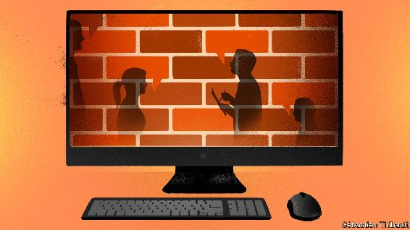

AMONG THOSE arrested after the nationwide pro-democracy protests of 1989 were students, playwrights, poets—and a pollster. Earlier that year Yang Guansan had sent the results of China’s first public-opinion surveys to Zhao Ziyang, then the Communist Party’s chief. To Mr Yang, they suggested that unrest was imminent. After Zhao was purged for opposing the use of troops to crush the demonstrations, investigators discovered Mr Yang’s submission. Found guilty of inciting the protests, the researcher was locked up for two years.

For decades the party had scorned opinion polls as bourgeois and unnecessary—it embodied the will of the Chinese people, so why ask them what they thought? But it has become more open to pulse-taking since Mr Yang’s ordeal, which was described in an article by Tang Wenfang of Hong Kong University of Science and Technology, published in 2018. Mr Yang says the party is “more paranoid” about public opinion than its democratic peers because it lacks elections or a free press for feedback. Now ministries and official media have their own polling units. Universities run state-funded social surveys.

In the internet age the party has been trying to gauge popular feeling in real time. Tech giants and consultancies such as Womin Technology offer help. In a report circulated online, apparently sent to the “central authorities” in February, Womin gave advice on how to handle swelling anger online over the death of a whistle-blowing doctor from covid-19. It suggested that recognising the doctor’s contribution and blocking information put out by “foreign forces” would restore calm. (Perhaps coincidentally, that was the tactic adopted.)

But social-media chatter can be hard to interpret, in part because the government’s own censors work hard at suppressing subversive comments and injecting pro-party ones. Netizens often use coded messages, self-censor, or avoid posting on sensitive topics. Hu Yong of Peking University has identified two types of online public opinion in China: popular sentiment and views crafted or given prominence by the state. It is often hard to tell the genres apart.

In a crisis, while officials are still unsure what line to impose, the job can be a little easier. “If you act fast, you can get good results,” says Mr Tang, noting a brief period of openness on the Chinese web early in the covid-19 epidemic. Sometimes critical opinions on public health, the environment and even official corruption are left uncensored, providing they do not support collective action. But views expressed online offer only a partial picture. It is mainly young, urban and tech-savvy Chinese who use social media.

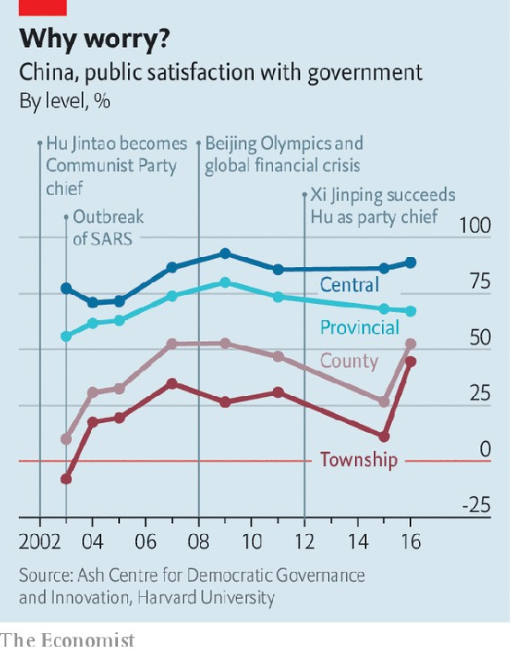

For all its embrace of opinion polls, the government often does not publish the results of state-sponsored ones. Many are narrowly focused, aiming to gauge feelings about a particular local-government project, for example. The few Chinese universities that conduct nationwide social surveys are cautious, too. They avoid sensitive social or political questions. One academic recalls having to push for questions related to labour disputes among migrant workers to be included in a survey. He succeeded, but the findings were kept confidential. Foreigners are banned from conducting direct surveys in China, forcing them to team up with Chinese pollsters or outsource to them. Between 2003 and 2016 scholars at Harvard University, working with a Chinese partner, conducted a nationwide survey of political trust. Its key finding was that levels of confidence in the central government were high (see chart).

But in the past five years it has become much harder for scholars abroad to find partners in China who are willing to help with such surveys. And in China’s increasingly repressive political environment, researchers struggle to ensure that results are not skewed by respondents’ nervousness. More are resorting to workarounds, says Xu Yiqing of Stanford University. The “list experiment”—often used in polls globally to ask about racism or drug use—can shield someone from having to give a direct answer to a political question. It involves asking respondents to give the total number of affirmative answers to a list of questions (eg, “Did you travel abroad this year?”). But half of them get the same list with one additional sensitive question (“Did you join a protest this year?”). Another way is to let respondents toss a coin and answer “yes” to a question if they get heads, or honestly if they get tails, allowing researchers to calculate a proportion from half of the total pool of survey-takers. Using the list experiment, Mr Tang finds that answers on trust in the party are inflated by only about eight percentage points (those on bribe-giving vary by up to 35).

So why not encourage independent pollsters to conduct more big-picture surveys of the public mood? Would they not help the party to sense trouble long before it erupts, and avoid another 1989-style calamity? Good questions, but those about the party’s own anxieties are among the most difficult to raise of all. ■

This article was downloaded by calibre from <https://www.economist.com/china/2020/10/24/apparatchiks-and-academics-alike-struggle-to-take-chinas-pulse>

| Section menu | Main menu |

| Next | Section menu | Main menu | Previous |

A big splash

In a world mired in recession, China manages a V-shaped recovery

Its rebound is also starting to look more sustainable

Oct 24th 2020 |

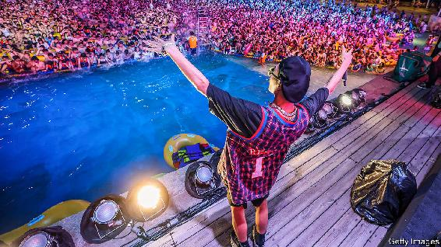

ONE SCENE more than any other from China’s coronavirus recovery has caught the world’s attention: a giant pool party in August in Wuhan, the city where the pandemic began. Nearly four months after their 11-week lockdown, revellers were crammed together in waist-high water, jumping and shouting in exhilaration as a DJ spun bass-heavy beats. The video went viral. It was a moment of pure release and a sign of how China is far ahead of most other countries in returning to normality (of a sort). Economic data are rarely as exciting as pool parties, but China’s latest GDP figures, released on October 19th, were, roughly speaking, the statistical equivalent of Wuhan’s aquatic festivities.

Officials reported that the economy expanded by 4.9% in the third quarter compared with a year earlier, just shy of its pre-pandemic pace. Whereas most other countries are mired in recession and grappling with a new wave of covid-19 cases, China has just about completed the upward leg of a V-shaped rebound. Analytically, its success is easy to explain. China got one crucial thing right. By almost stamping out the virus it was able to allow activity to resume with few restrictions. Schools are fully open, factories are humming and restaurants are buzzing. China is also lucky in one crucial way. It is better insulated from weak global demand than smaller peers such as New Zealand that have done a good job of containing the pandemic, too. Until vaccines are rolled out, others will struggle to match China’s feat.

Yet China’s headline resilience has masked an unbalanced recovery. Back in February, when the government began cautiously to relax its lockdown, it focused on reopening factories and launching infrastructure projects. It correctly reasoned that maintaining strict health protocols in factories and on construction sites, which can be managed as semi-closed environments, would be easier than in shopping malls or schools. On top of that, China’s meagre provisions for unemployment insurance meant that the millions of people who found themselves out of work had to cut back on spending. Early in its recovery, China’s economy was thus fuelled by factory production and investment. Capital formation—the category in GDP accounting that encompasses these endeavours—contributed five percentage points to growth in the second quarter, whereas consumption subtracted more than two percentage points. Back then that left China with a 3.2% year-on-year growth rate.

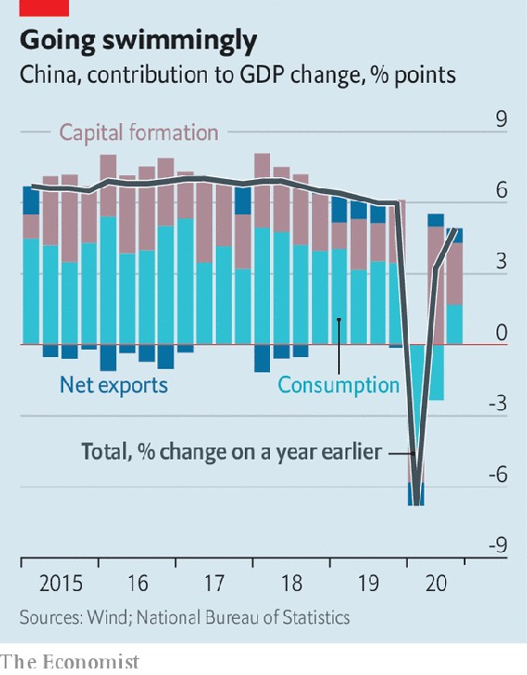

The latest data reflect a slightly more balanced recovery (see chart). The contribution to third-quarter growth from capital formation fell to less than three percentage points, in line with the pre-pandemic norm, as infrastructure spending tailed off. Consumption added nearly two percentage points, which was below its pre-pandemic heights but a big improvement—easily noticeable in the crowds that have returned to tourist sites, restaurants and shops. Trade was the cream on top. China’s share of global merchandise exports has risen to a record high during the pandemic. It received a boost by being the first manufacturing power to resume operations, in addition to being the world’s biggest producer of protective equipment, from masks to surgical gowns.

Whenever Chinese data look so rosy, it is natural to ask whether they are believable. In this case a range of non-GDP indicators, including other countries’ exports to China, lend credence to the picture of a robust rebound. The bigger worry is whether the recovery has been at the expense of efforts to rein in debt. The initial sharp economic slowdown followed by a government-directed boom in bank lending will push China’s debt-to-GDP ratio to about 275% this year, up by 25 percentage points. It will be the biggest annual increase since 2009 during the global financial crisis.

Yet China is far from alone. Governments around the world have run up huge tabs to lessen the economic fallout from the pandemic. With its growth back on track, China has a chance to tighten the spigots again. S&P, a credit-rating agency, notes that the country’s real lending rates (ie, adjusted for inflation) have recently climbed to a five-year high, a dampener on investment. If successful, China will confine irrational exuberance to pools. ■

This article was downloaded by calibre from <https://www.economist.com/china/2020/10/24/in-a-world-mired-in-recession-china-manages-a-v-shaped-recovery>

| Section menu | Main menu |

| Next | Section menu | Main menu | Previous |

Chaguan

China’s half-loving, half-threatening pitch to Taiwan doesn’t work

The contradictions of a half-loving, half-threatening pitch to Taiwan

Oct 22nd 2020 |

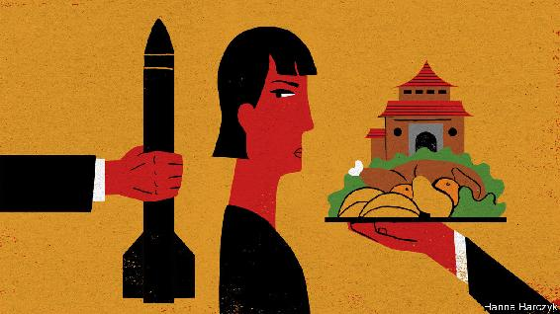

CHINA’S COMMUNIST PARTY is not known for bumper stickers—those slogans that fit a political philosophy into a six-inch space next to a car’s brake lights. (Chaguan once covered an election in Kentucky in which the Republican candidate’s bumper sticker read, in its entirety: “Coal. Guns. Freedom.”) Party slogans need not trip off the tongue to be printed on red banners and displayed on streets, as in: “Hold high the great banner of Xi Jinping Thought on socialism with Chinese characteristics for a new era.”

A tolerance for complexity comes in handy when trying to comprehend the approach of Chinese leaders to Taiwan, a democratic island which China deems a province that must unite with the mainland. For their pitch is a mess of contradictions. On the one hand China’s rulers talk of deep ties of blood and kinship with Taiwan’s 24m people, even as the proportion of islanders who define themselves as Chinese falls each year. This campaign does not just involve wooing Taiwanese business bosses with access to mainland markets. Despite covid-induced travel headaches, a small legion of Chinese officials remain employed in a hearts-and-minds industry, planning summer camps, study tours and other people-to-people exchanges across the Taiwan Strait.

On the other hand, China’s honeyed words for Taiwan are becoming hard to hear over the pounding of war drums. Each night for a whole week recently, state television carried taped confessions from alleged Taiwanese spies caught in a nationwide campaign. The People’s Daily, the party’s mouthpiece, carried a commentary on the spy probe written by the state security ministry. It restated China’s resolve to use force if needs be, using a phrase—“Don’t say we didn’t warn you”—that has preceded Chinese military action against other countries in the past. In recent months China has sent its warplanes more often than usual on sorties near Taiwan, notably during visits to the island by Trump administration officials. It has also stepped up the tempo of its military exercises. The Global Times, a strident tabloid, noted “rumours” about the recent deployment of advanced hypersonic missiles to coastal bases, and helpfully explained that they are ideal for scaring American and allied warships away from intervening in any war with Taiwan. Not to be outdone, on October 8th Chinese diplomats posted to the Pacific island of Fiji were involved in a brawl at a party celebrating Taiwan’s national day, staged at a local hotel by Taiwanese officials. Though the skirmish sent a Taiwanese envoy to hospital with head injuries, a foreign ministry spokesman in Beijing blamed the event’s Taiwanese hosts for the violence, and for provocatively displaying their island’s “self-styled flag” on a cake.

This uptick in bellicose rhetoric reflects Chinese anger at growing support for Taiwan in Washington and a desire to teach the island’s government and people that relying on America for protection will lead to their doom. Communist Party bosses will only engage with Taiwanese who agree that their island is part of a country called China. That rule allows them to talk to the Nationalist Party, heirs to the regime that ran the Republic of China until 1949, lost a civil war to Communist forces and retreated to exile in Taiwan. It excludes the island’s president, Tsai Ing-wen, and her ruling Democratic Progressive Party. Ms Tsai, a cautious, cat-loving moderate depicted as a dangerous radical in China, says that the island she governs is a country in its own right, though to avoid a crisis she fudges what is meant by that. Chinese threats are typically accompanied by a line or two about the prosperous future that awaits Taiwan if it accepts the motherland’s embrace. Distilled to sticker-length, the double-edged message to Taiwan amounts to: “Come home, or China will kill you.”

The hearts-and-minds industry is ready to invest in Taiwanese who are receptive to talk of shared blood ties. Just 360,000 people live in Jimei, a district of Xiamen, the coastal city nearest to Taiwan. In Chinese terms, it is a speck on the map. But the district government spent 50m yuan ($7.5m) on a hotel-sized “cross-strait exchange base”. It opened in 2019 to offer subsidised study camps to Taiwanese youngsters, who are mixed with mainland students to enhance the experience. Up to 500 students can be housed in its smart dormitories. Young visitors are greeted by a portrait of President Xi and his words declaring the two sides of the strait to be “one family, their hearts connected from a young age”. They are encouraged to explore such totems of shared culture as a puppet theatre, an opera house, a dragon boat and a giant floor map of China (Taiwan included). They can build moon rovers in a classroom dedicated to China’s space programme, construct model sailing-junks and pilot a drone. Some 140,000 students visited last year, 5,000 of them Taiwanese. In this pandemic year the centre hosted over 1,000 Taiwanese whose families live on the mainland. Jimei is building a second study base with room for 2,400 students, which is due to open next year. A wall plaque immortalises a tribute paid by a Taiwanese student who called Xiamen “much grander” than his island’s capital, Taipei. “It’s scary, how fast they are advancing,” he is quoted as saying.

China’s public wants Taiwan to hurry up and surrender

Young Taiwanese are far warier of China than their elders are. So China’s soft-power sector also caters to retired Taiwanese military officers and ageing members of clan associations seeking mainland roots. The Guandi temple in Dongshan, south of Xiamen, is a “mother temple” to religious sites on Taiwan and a favoured spot for cross-strait events. This week a straw poll of Chinese tourists at the temple found several who think there may be a war with Taiwan. Yet when asked whom they blame for tensions, few seemed curious about hearts and minds on the island. They described Taiwanese as Chinese and China’s armies as crushingly superior. “It’s not about who’s in the wrong, just who’s stronger,” said a woman who declined to give her name. If China allowed political bumper stickers, the cynical nationalism of her words would be a hit. ■

This article was downloaded by calibre from <https://www.economist.com/china/2020/10/22/chinas-half-loving-half-threatening-pitch-to-taiwan-doesnt-work>

| Section menu | Main menu |

# Middle East & Africa

* Egypt: No contest
* America and the Middle East: Waiting game
* Tanzania’s elections: The bulldozer rumbles on
* Conservation in Africa: Elephants’ graveyard no more
* Police violence in Nigeria: The young have had enough

| Next | Section menu | Main menu |

No contest

Another sham election highlights Egypt’s problems

The country’s rulers are making a mess of politics and business

Oct 22nd 2020 |



ALL THE publicly available evidence suggests that the Coalition of Hope was exactly what it claimed to be: a nascent political alliance that planned to field candidates in the election for Egypt’s lower house of parliament. The group, which included MPs, journalists, businessmen and labour leaders, aimed to shake up a legislature dominated by supporters of President Abdel-Fattah al-Sisi. Last year, though, the interior ministry accused the coalition of working with terrorists to “bring down the state”—a plot the ministry identified, with no hint of irony, as “The Plan for Hope”. As the election kicks off this month, several coalition members sit in jail.

Even by the standards of Egypt, where votes are routinely bought and opposition candidates imprisoned, this contest seems especially undemocratic. Using arrests, intimidation and bureaucratic hurdles, the regime has cleared the field of most of its critics. Candidates compete to sound the most pro-Sisi, while rich businessmen throw money at parties backed by the state. The results are not expected until December, but the outcome is not in doubt. Parliament will again be full of politicians who fawn over the president.

Mr Sisi, a former general, claims to disdain politics. Since leading a coup against Egypt’s first democratically elected government in 2013 he has banned protests and crushed civil society. He won rigged elections in 2014 and 2018, and seems likely to break his vow to step down after his second term, since changes to the constitution made in 2019 allow him to stay on until 2030. He styles himself the leader of all Egyptians and, therefore, above politics. “I’m not a politician. They’re all talk,” he said in 2018. His cabinet is made up mostly of technocrats. Regional governors, appointed by the president, are typically veterans of the army or security services.

Mr Sisi acts as if he is above the fray, but his men are down in the mud. They control parliament—and milk supporters—through a few big parties. The largest, called the Nation’s Future Party, was reportedly created by military intelligence. Candidates allege that spots on its electoral list have been sold for millions of Egyptian pounds (tens of thousands of dollars). One state-aligned newspaper even made light of the alleged payments in a cartoon depicting an MP carrying his own chair to parliament because the ones inside were too expensive. When a pro-Sisi lawyer claimed in a video that seats were being given to “whoever can pay”, he was swiftly arrested. The regime denies selling seats.

Businessmen have good reason to splurge on elections. It’s not just that a seat in parliament offers immunity from prosecution, a handy asset for anyone trying to do business in a place where corruption is rife. A seat also gets the holder closer to power at a time when private firms must compete with Mr Sisi’s preferred institution: the army.

Businessmen grumble about the increasing size of the army’s economic footprint. Companies run by or associated with the force manufacture refrigerators, pave roads and make pasta. They manage hotels and hospitals. Most are exempt from value-added tax and import tariffs. With these advantages, they are wreaking havoc on the private sector. Take the cement industry, which was already suffering from a supply glut when the army began opening plants in 2018. Several private firms have since suspended production. Many will close for good if the oversupply crisis continues, warns an executive.

With few mechanisms to receive feedback, such warnings may not reach the president or his inner circle. They prefer praise from the IMF, which lent the government $12bn in 2016 as it floated the overvalued currency and cut unaffordable subsidies. Regime backers give it credit for restoring order and stability after a tumultuous period following the revolution of 2011. Tourism and foreign investment were trending upwards before covid-19 struck. The economy grew by 5.6% in 2019, one of the fastest rates among emerging markets.

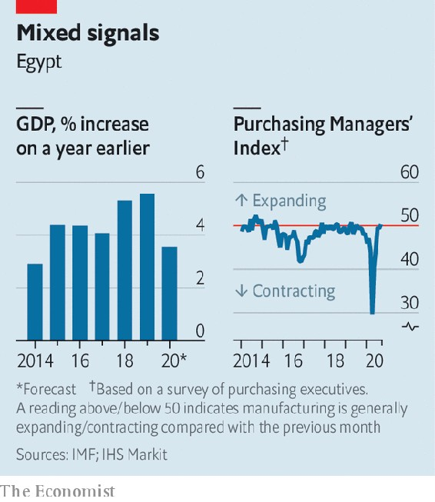

But much of the growth is due to a boom in oil and gas, which are controlled by the state. Private firms are doing less well. The Purchasing Managers’ Index, a survey-based gauge of the non-oil private sector, has shown it shrinking during most months since Mr Sisi took over (see chart). Egyptians are earning less in real terms than they did four years ago. The share of people classified as poor by the government rose from 28% in 2015 to 33% last year. Meanwhile, the pain of the government’s austerity measures has been borne mostly by the lower and middle classes. The pandemic has only made matters worse. Hundreds of people defied the ban on protests last month to express their discontent.

Under their previous dictator, Hosni Mubarak, who ruled from 1981 to 2011, Egyptians had more freedom to complain. Businessmen exerted influence through the regime’s National Democratic Party. Opposition parties were tolerated (though still not given a fair shot). Dissident politicians could talk to voters, hear their grievances and raise them in parliament. Elections acted as a pressure valve of sorts—until 2010, when Mubarak tightened up, holding an especially fraudulent poll. Two months later millions of protesters pushed him out of office.

Mr Sisi, notoriously prickly, is not inclined to let Egyptians vent. The lesson he seems to have learned from Mubarak is that if you allow people too much freedom, they may overthrow you. Still, voters sent him a message in August, when over 85% of the electorate did not cast ballots in a sham election for the upper house. The state’s absurd response was to refer all of them—54m people—to trial for breaking Egypt’s compulsory-voting law. Perhaps the message didn’t get through. ■

This article was downloaded by calibre from <https://www.economist.com/middle-east-and-africa/2020/10/22/another-sham-election-highlights-egypts-problems>

| Section menu | Main menu |

| Next | Section menu | Main menu | Previous |

Waiting game

Leaders in the Middle East are watching the polls in America

Big decisions have been put on hold until American voters make up their minds

Oct 24th 2020 | BEIRUT

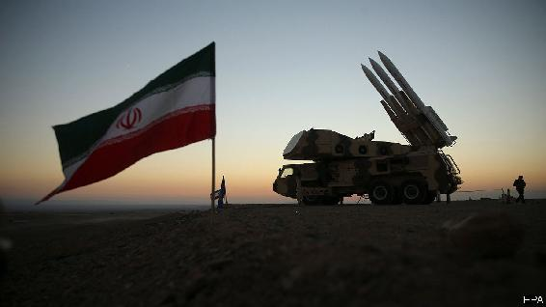

RESIDENTS OF THE Middle East sometimes quip that they deserve voting rights in America. For decades, after all, American presidents have pursued wars, sanctions and other schemes in the region. The current occupant of the White House is no different. Donald Trump’s first term has been marked by conflict with Iran, one that has brought assassination, acts of sabotage and a crippling economic blockade.

As America’s election nears, that conflict has settled into an uneasy pause. The whole region seems to be waiting. From the prospect of nuclear negotiations to the make-up of a new Lebanese government, Iran and its allies have put big decisions on hold until American voters make their own. Yet the election may matter less than leaders in the region expect.

Mr Trump took office vowing to withdraw from the nuclear deal between Iran and world powers, signed in 2015, which eased economic sanctions in exchange for limits on Iran’s nuclear programme. He did not formally pull out until 2018, though, and his term was half-over before renewed economic sanctions started to bite. Rather than negotiate a new deal, Iran’s leaders decided to wait. They saw little to discuss: Mr Trump has been unclear about his demands. And a belligerent American president was a useful foil for a regime that thrives on anti-American sentiment.

Still, it has tried to avoid overt confrontation with America, relying on proxies instead—though the veneer of deniability is thin. Iraqi militias who lob rockets at America’s embassy in Baghdad make no secret of their ties to Iran. But recently even their freedom has been limited. After Mike Pompeo, the secretary of state, threatened to close the embassy, the militias agreed to a ceasefire. The truce will last through the election, perhaps until the end of the year.

Three months after the catastrophic explosion at Beirut’s port on August 4th, Lebanese politics are paralysed. The prime minister resigned after the blast. In September the president asked a diplomat, Mustapha Adib, to form a new cabinet. His efforts failed after America imposed sanctions on Hizbullah, the Iranian-backed Shia militia and political party, and its allies. Other politicians grew nervous about joining a cabinet with Hizbullah (which won the most votes in the last election). Mr Adib handed back his mandate. Lebanon desperately needs a government to revive an ailing economy, but one seems unlikely until after America’s election.

All this creates the impression that Mr Trump has Iran on the ropes: strangled by sanctions, its allies nervous about a similar fate and its proxies on an unusually short leash. The president has ardent supporters in the Middle East who expect another four years of “maximum pressure” to reshape the region—and fear that Joe Biden will undo this progress.

Yet they may be disappointed. Whoever wins in November, Iran will probably be forced to negotiate a new nuclear deal. It cannot afford four more years of isolation. Neither candidate, though, will win many concessions on non-nuclear issues. Support for militant groups is not a bargaining chip for Iran: it is an ideological imperative and the core of its security doctrine. The supreme leader, Ali Khamenei, is 81 and keen to ensure his hardline policies survive him. So are the rough men of the Islamic Revolutionary Guard Corps, increasingly dominant in Iran’s politics.

Elsewhere, too, the election may matter less than both Iran and its foes believe. Iraq’s prime minister, Mustafa al-Kadhimi, would like to rein in the militias. But he fears moving too fast will cause bloodshed. Pressure from Washington will not change his calculus. And as Lebanon slides deeper into penury and instability, Hizbullah (like other factions) will only grow stronger, filling the void left by a failed state. America still looms large in the Middle East. But the region has its own politics as well. ■

Dig deeper:  
Read the [best of our 2020 campaign coverage](https://www.economist.com/us-election-2020) and explore our [election forecasts](https://projects.economist.com/us-2020-forecast/president), then sign up for Checks and Balance, our [weekly newsletter](https://www.economist.com/checksandbalance/) and [podcast](https://play.acast.com/podcasts/2020/01/24/checks-and-balance-our-new-weekly-podcast-on-american-politics) on American politics.

This article was downloaded by calibre from <https://www.economist.com/middle-east-and-africa/2020/10/24/leaders-in-the-middle-east-are-watching-the-polls-in-america>

| Section menu | Main menu |

| Next | Section menu | Main menu | Previous |

The bulldozer rumbles on

President Magufuli is likely to win an unfair vote in Tanzania

With the opposition hobbled, Tanzanians are resigned to another five years of him

Oct 22nd 2020 | GOMA

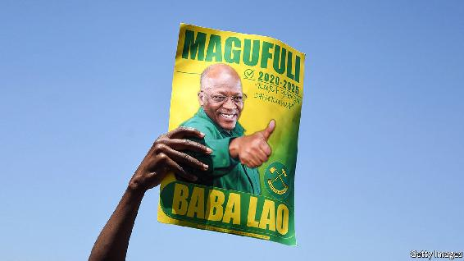

BACK IN JANUARY John Magufuli, Tanzania’s president, vowed that elections scheduled for October 28th would be free and fair. He has an odd way of ensuring it. He has banned local groups from monitoring the vote, harassed the opposition and journalists, closed a newspaper for its unfavourable coverage and banned a television station for daring to contradict his risible claim that there is no covid-19 in Tanzania. Foreign reporters must be chaperoned everywhere by an official, presumably to intimidate people they interview.

A principal target of harassment is Tundu Lissu, the main opposition candidate, recently back from self-imposed exile in Belgium. He took refuge there after being shot several times in 2017 outside his home in Dodoma, the capital. Despite needing crutches to walk and with a bullet still lodged near his spine, he has campaigned vigorously, drawing thousands of people to his rallies to hear him promise to restore democracy and boost business. He has also won the backing of Zitto Kabwe, another opposition leader, unifying much of the vote against Mr Magufuli. If the presidential poll were fair, Mr Lissu would stand a good chance of winning. But there is scant hope that the vote will be even remotely fair—a sharp deterioration for a country that turned its back on one-party rule and socialism in the 1990s.

Start with the electoral commission, which is seen as biased after the Court of Appeals ruled last year that Mr Magufuli, nicknamed “the bulldozer”, was allowed to stack it with party hacks. The commission has done little since then to suggest it is impartial. In early October it banned Mr Lissu from campaigning for a week, after he complained that the election was unfair. Electoral officials also imposed a five-day ban on Seif Sharif Hamad, an opposition leader in Zanzibar, a semi-autonomous archipelago, on similarly flimsy pretexts.

The government has also introduced various rules to stop the opposition from campaigning. Even sticking up posters is complicated, since the government put a new tax on promotional materials, making it expensive to distribute posters and flyers. Mr Lissu has decided to do without them. “Tanzania has weaponised the law to the point that no one really knows when they are on the right or wrong side of it,” said Amnesty International. Seven opposition members were arrested for “ridiculing the national anthem” because they sang it while hoisting their party flag.

Sometimes the government simply ignores the law. Policemen have fired tear gas at crowds of supporters gathering to hear Mr Lissu at rallies. They have arbitrarily stopped his convoy, in one case holding it up for most of the day. In June they arrested Mr Kabwe and eight others at an internal party meeting, accusing them of holding an “illegal assembly”. In August they arrested Joseph Mbilinyi, an opposition candidate, for organising an “unauthorised demonstration” after he went to collect his nomination papers from the electoral commission with a group of supporters.

The ruling party, known by its initials CCM, has run the show uninterrupted since 1977. Many Tanzanians are resigned to another five years under it and Mr Magufuli. Even the opposition is finding it hard to stay hopeful. “The whole process,” says Mr Kabwe, “seems to have been rigged.” ■

This article was downloaded by calibre from <https://www.economist.com/middle-east-and-africa/2020/10/22/president-magufuli-is-likely-to-win-an-unfair-vote-in-tanzania>

| Section menu | Main menu |

| Next | Section menu | Main menu | Previous |

Elephants’ graveyard no more

African governments are outsourcing their natural areas

Covid-19 may accelerate the trend

Oct 22nd 2020 | ZAKOUMA

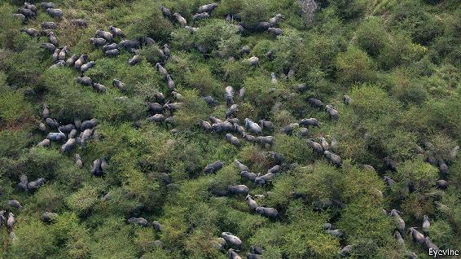

“ALL OF THESE bulls will have AK-47 bullets in them,” says Leon Lamprecht. From his porch the manager of Zakouma National Park, in southern Chad, has quite a view. A dozen or so elephants slosh around in muddy puddles. These days they are safe. But between 2002 and 2010 some 4,000 elephants, 95% of Zakouma’s population, were slaughtered for their ivory by poachers from Sudan.

At that point Chad took a step that other African countries are increasingly following. It handed management of the park to an NGO. Since African Parks took over, the elephant population has begun to rise. In 2011 just one calf was born; in 2018, 127 were. The revival is emblematic of broader success that public-private partnerships (PPPs) are having in conserving some of the most precious parts of the planet. In the wake of covid-19 it is a model that may become more attractive to African governments that are short of the cash needed to protect animals and also desperate for the tourists who come to see them.

Sixty years ago, when decolonisation was sweeping the continent, the UN counted 3,773 “protected areas” in Africa and its surrounding waters. By 1990 the figure was 6,075; today it is 8,468. Some 14% of the continent’s land has been categorised as protected, according to the World Database on Protected Areas (see map).

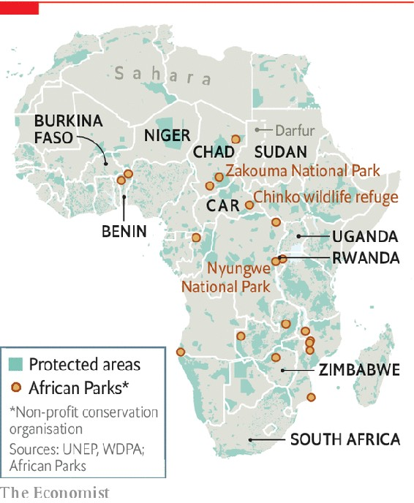

The protected designation belies reality, however. Most such areas are managed by cash-strapped government wildlife authorities. They struggle to deal with myriad pressures on the environment, such as land grabs, illegal poaching and climate change. “[W]ith few localised exceptions, African conservation was in crisis even before covid-19 hit,” notes Peter Lindsey, a Zimbabwean conservationist and co-author of a recent article in the journal Nature Ecology & Evolution.

Most “protected areas” are “paper parks”, argues Peter Fearnhead, the chief executive of African Parks. In theory their demarcation denotes stewardship; in practice there is often very little care. Since its founding in 2000 the NGO has grown to manage 19 parks in 11 countries. It is the largest of an expanding number of PPP operators across the continent.

The African Parks model relies on “three Ms”, explains Mr Fearnhead: a clear mandate from a government (which keeps ownership of the area but hands over the running to the NGO); sound management; and money from donors such as the EU.

Zakouma is African Parks’ flagship operation. When it took over its management the priority was security. The national park was caught up in Chad’s civil conflicts in the 2000s, when rebel groups, some backed by Sudan, took on government forces. Janjaweed militias, notorious for mass murder and rape in Darfur, took advantage of the vacuum to slaughter Zakouma’s elephants and launch attacks on nearby villages.

The approach to security is a blend of low and high tech. It relies on residents of surrounding areas to alert it to poachers. Local intelligence is then combined with satellite tracking of the elephants. This helps anti-poaching rangers to know where to go.

Winning the support of people on the edge of the park has been crucial. Locals are happy to help report sightings of the Janjaweed, since they fear being robbed or murdered by them. African Parks also negotiates with nomads to ensure their caravans of camels do not go through the park.

Securing the park has helped its ecosystem. Wedged between the Sahara desert to the north and rainforest to the south, Zakouma is a haven for birds as well as mammals. The park is a dream for twitchers, explains a South African guest, pointing out a red-throated bee-eater and an Abyssinian roller. Such sights, as well as elephants, lions and Kordofan giraffes, were attracting ever more tourists before covid-19 hit. In 2019 Zakouma made more than $1m from visitors, mostly from rich guests staying at the private Camp Nomade. (During a visit your correspondent bumped into another flamboyant species, Evgeny Lebedev, the owner of the London Evening Standard, and his erstwhile editor, George Osborne, who were staying at the camp.) The tourism business helps make Zakouma the largest taxpayer in that region of the country.

African Parks’ work in Zakouma is encouraging other governments to ask for its help. In May it signed an agreement with the Central African Republic, a country in which militias hold sway over vast tracts of countryside, to expand its footprint in the Chinko wildlife refuge, which could become the single largest protected wilderness in Africa. In July African Parks announced it would extend its operations in northern Benin, ensuring it has a role in trying to prevent the spillover of violence from Burkina Faso and Niger. In October it agreed to manage Rwanda’s Nyungwe National Park for 20 years.

Some governments are understandably wary about relinquishing control of their natural assets. But that may change as the impact of the pandemic squeezes budgets. The IMF reckons that sub-Saharan Africa’s GDP will contract by 3.2% in 2020—with a knock-on effect on tax revenues.

Covid-19 has brought other challenges to protected areas. Urban lockdowns have forced people to return home to farms and villages, adding to environmental pressures. Millions of tourism jobs, often in areas with little other industry, are at risk. And in many countries tourist fees help cover the budgets of wildlife agencies; 88% of Uganda’s, for example.

It is therefore probable that more African governments will form partnerships with private bodies to protect ecosystems, bring in donor cash and help protected areas raise revenue of their own, through tourism and other ventures. It is a tricky task. But so too was reviving Zakouma’s elephant population. ■

For more coverage of climate change, register for The Climate Issue, our fortnightly [newsletter](https://www.economist.com/theclimateissue/), or visit our [climate-change hub](https://www.economist.com/news/2020/04/24/the-economists-coverage-of-climate-change)

This article was downloaded by calibre from <https://www.economist.com/middle-east-and-africa/2020/10/22/african-governments-are-outsourcing-their-natural-areas>

| Section menu | Main menu |

| Next | Section menu | Main menu | Previous |

The young have had enough

Peaceful protesters against Nigerian police violence are shot

The army showers bullets on a demonstration in Lagos

Oct 21st 2020 | ABUJA

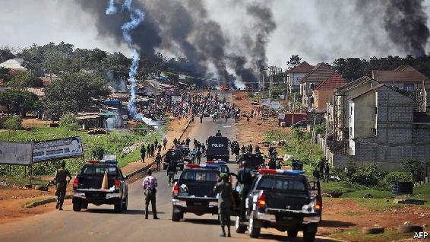

THE SOLDIERS waited until it was dark. They took down CCTV cameras. They turned off street lights. Then they started shooting, automatic gunfire ringing out late into the night. Their targets were young people kneeling peacefully in the street, waving the Nigerian flag. They were protesting against police brutality.

The killing on October 20th of at least 12 protesters in a wealthy part of Lagos, Nigeria’s commercial hub, was not the first time that the country’s security forces had fired on a crowd of demonstrators. In 2015, for instance, the army killed hundreds of Shia Muslim protesters, most of whom were unarmed, in Zaria, in the northern state of Kaduna. The officers and men responsible have never been punished. But the latest bloody episode, and the protests that preceded it, may mark a turning point for Africa’s most populous country.

The protests started in early October after the killing of a young man, allegedly by members of the Special Anti-Robbery Squad (SARS), a police unit with a reputation for brutality. In 2016 Amnesty International, a watchdog, accused it of routinely torturing people to extract confessions or extort money. A follow-up report in June documented 82 cases of murder, torture, extortion and theft by SARS members since the start of 2017, sometimes under the supervision of high-ranking officers. Amnesty said that not one member of the unit had been prosecuted for these crimes.

The difference this time was that bystanders pulled out their phones and recorded the murder. Videos spread from phone to phone on social media, sparking demonstrations that have stirred up young Nigerians, crossing lines of ethnicity and religion. Because the protests were leaderless, the government has no one to negotiate with, or to buy off. That made them especially dangerous to a state unaccustomed to its citizens demanding accountability. A “previously silent majority has now been awakened”, says Idayat Hassan at the Centre for Democracy and Development, a think-tank in Abuja.

Few expected the protests to last this long. Previous demonstrations fizzled out after minor reforms, such as the government adding an F (for Federal) to the SARS acronym and centralising its command. This time people stayed on the streets, even after the government promised to disband SARS. Sensing their power, the activists demanded that corrupt cops be prosecuted. They also want wider police reforms and better governance in general.

The state’s initial response was to truck in pro-government thugs to attack protesters. Many are thought to come from the country’s north, which is where President Muhammadu Buhari draws much of his support. The gangs, who arrived in police vehicles and set about their mayhem in full view of the men in uniform, also attacked businesses belonging to people from other parts of the country in an apparent bid to stoke up regional tensions. When that failed to quash the demonstrations, the government called in the army.

Yet instead of crushing the protest movement, the killings in Lagos have provoked a violent response. After videos of the massacre spread on social media, crowds set fire to the family home of the governor of Lagos, Babajide Sanwo-Olu. They also torched a police station, public buses and the offices of a newspaper and television channel linked to Bola Tinubu, a ruling-party politician who is widely expected to run for president in 2023.

Mr Buhari appealed for calm, but said nothing about investigating the shootings or prosecuting those responsible for them. That may be because, as he told the Nigerian Bar Association in 2018, human rights “must take second place” to “national security and public interest”. But Nigerians have heard enough excuses. ■

This article was downloaded by calibre from <https://www.economist.com/middle-east-and-africa/2020/10/21/peaceful-protesters-against-nigerian-police-violence-are-shot>

| Section menu | Main menu |

# Europe

* Covid-19 in Europe: A patchwork of red, yellow and green
* Swedish defence: Less neutral, more beefy
* Georgia: Misha’s return?
* France: The sacred right to offend
* Charlemagne: A powerful yet puny parliament

| Next | Section menu | Main menu |

A patchwork of red, yellow and green

A second wave of covid-19 sends much of Europe back into lockdown

Even the Germans and Nordics cannot be complacent

Oct 22nd 2020 | AMSTERDAM

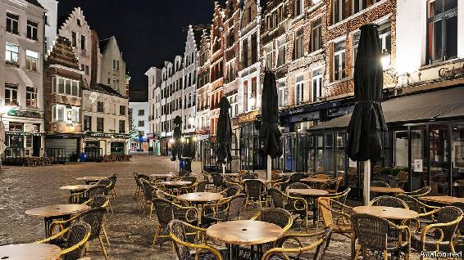

FOR A FEW months this summer it was almost possible for Europeans to believe that life had returned to normal. Parisian museums and Barcelona’s cafés were open, if less crowded. Germans, Dutch and Danes jetted off to holidays on Mediterranean beaches. In August and September, as children across the continent returned to school, covid-19 infections began to rise. Yet governments, worried about a backlash, chose not to reintroduce harsh social-distancing measures.

Their decision has had a price. A second wave of covid-19 is now washing over Europe. In many countries the daily numbers of confirmed cases exceed their spring peaks, though this is mostly because there is a lot more testing; death rates are substantially lower. A model developed by The Economist, based on serological tests showing how many people have been exposed to the virus, suggests the second wave has yet to match the first (see chart), though numbers are clearly rising, as are hospitalisations. Most countries failed to use the summer to build robust testing and tracing operations. Now they are falling back on blunt measures: shutting restaurants and introducing quarantines and curfews.

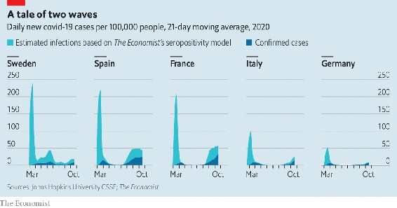

Spain is among the hardest-hit countries. That is partly because its left-wing minority government and the conservative opposition have failed to agree on a national strategy. Only some regions have set up effective test-trace-isolate systems, and rates of infection vary wildly. Madrid is under a 15-day state of emergency that bars non-essential movement in or out of the city, limits social gatherings to six people and closes restaurants at 11pm. Catalonia and Navarre have been even tougher.

France is in just as bad a pickle. The share of tests that come back positive has climbed from 4.6% on August 31st to 13%. On October 17th the government imposed a curfew on nine big cities from 9pm to 6am. Arnaud Fontanet, an epidemiologist at the Institut Pasteur, says the country must reduce new infections to 3,000 a day before it can get the epidemic under control; they are currently at around 28,000.

When covid-19 first arrived, northern Europeans snidely linked its virulence in Italy and Spain to their physically effusive cultures. That idea is harder to sustain this time: among the hardest-hit countries are Belgium and the Netherlands. “We are really very close to a tsunami. We no longer control what is happening,” warns Frank Vandenbroucke, Belgium’s health minister. The government has closed restaurants and bars and brought in a curfew from midnight until 5am. The virus is also exacerbating regional divisions. Flemish nationalists resent the national lockdown, since transmission rates are higher in French-speaking regions.

In the Netherlands the government dithered while daily cases per million rose steadily. They are now higher than in Spain or France. This month the government at last closed restaurants for four weeks and required masks in public indoor spaces. But when Mark Rutte, the prime minister, apologised last week, it was only for letting the royal family take an autumn holiday in Greece. (They cut it short.)

In south-eastern Europe and the Balkans, which tamed the virus effectively this spring with harsh lockdowns, there has been little appetite to reintroduce restrictions. Serbia’s prime minister, Ana Brnabic, vowed to “act differently” if the virus resurged, yet is taking little action now that it has. But Bulgaria, where hospitals are complaining of a shortage of doctors, has now made mask-wearing compulsory. So has Bucharest, the capital of Romania, where schools have been told to move to online learning and cinemas and theatres have been closed.

One step the EU did take this month was to settle on a Europe-wide map of regional epidemic severity, after a disagreement over the colours. Almost every province in Europe shows up red (a high rate of the virus). But one can easily discern the outlines of the success stories: Germany, Italy and the Nordics, which are mostly yellow (medium) with patches of green (low). Italy may not stay a success for long. It drove transmission rates down with aggressive lockdowns in the spring, but new cases are rising fast. On October 18th it implemented new restrictions. But they were surprisingly lax, thanks to intra-coalition rows.

Germany and the Nordics remain Europe’s star performers, though there are difficulties. Germany has the continent’s best track-and-trace systems, but in parts of Berlin there are now too many cases to follow. Hard-hit areas are imposing early closing-times for restaurants and requiring more mask-wearing. However, Germany’s federal system is causing fragmentation and disagreement. Angela Merkel, the chancellor, fears that going too slowly now could force more drastic restrictions later. That would erode the civic will needed to fight the virus. Where Europeans once embraced that battle with a spirit of shared sacrifice, many now grumble that their governments are blowing it. ■

Editor’s note: Some of our covid-19 coverage is free for readers of The Economist Today, our daily [newsletter](https://my.economist.com/user#newsletter). For more stories and our pandemic tracker, see our [hub](https://www.economist.com/news/2020/03/11/the-economists-coverage-of-the-coronavirus)

This article was downloaded by calibre from <https://www.economist.com/europe/2020/10/22/a-second-wave-of-covid-19-sends-much-of-europe-back-into-lockdown>

| Section menu | Main menu |

| Next | Section menu | Main menu | Previous |

Less neutral, more beefy

Sweden embarks on its largest military build-up for decades

The reason is Russia

Oct 19th 2020 |

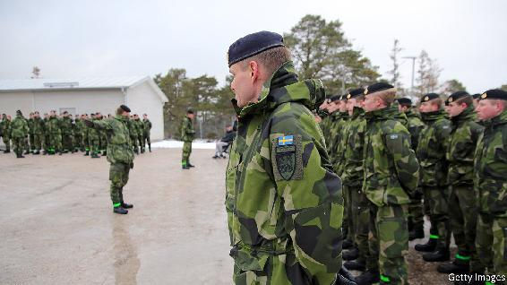

“AN ARMED ATTACK against Sweden cannot be ruled out,” warned Peter Hultqvist, Sweden’s defence minister, shortly after he introduced a new defence bill on October 14th. It promises the country’s largest military expansion for 70 years. The reason is plain. Russia’s assertive behaviour across Europe, from invasion to assassination, has alarmed Swedes.

In recent years, Sweden has accused Russia of violating its air space and waters several times. Accordingly, it has deepened military ties with NATO (though not a member of the alliance) and with America and its Nordic neighbours. If the new bill is passed, as is likely, the defence budget is set to rise by SKr27.5bn ($3.1bn) between 2021 and 2025, a 40% boost that will bring expenditure to around 1.5% of GDP—the highest level for 17 years.

The new cash will pay for a 50% increase in the armed forces to 90,000 people, including regular soldiers, conscripts and local reservists in the Home Guard (no longer the Dad’s Army of yesteryear). The army will grow from two mechanised brigades to three, each of around 5,000 soldiers, with a smaller additional brigade for the Stockholm area.

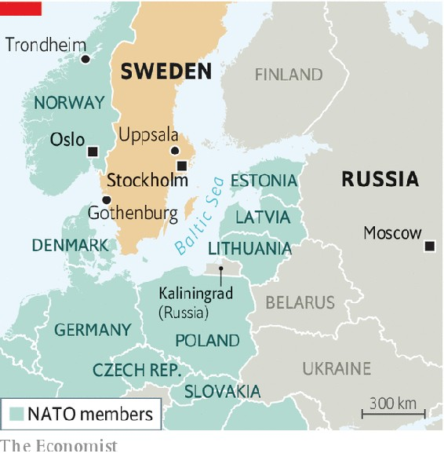

The draft, abolished a decade ago but brought back for both sexes in 2017, will double in size to 8,000 conscripts a year. Five new local-defence battalions will be set up around the country, tasked with protecting supply lines from the Norwegian ports of Oslo and Trondheim. An amphibious unit will be re-established in Gothenburg, Scandinavia’s largest port.

The air force can look forward to newer Gripen fighter jets with longer ranges and better radar, some of which will go to a new air wing in Uppsala, 70km (43 miles) north of Stockholm. The navy will get an extra submarine, money to design a new type of warship, and air-defence missiles which its ships have needed for 15 years.

Civil defence will get more funds for cyber-security, the electricity grid and health care. “We’ve begun to rebuild a newer version of what we had during the cold war,” says Niklas Granholm of FOI, Sweden’s defence-research agency. The aim is to enable Sweden to hold out in a crisis or war for at least three months until help arrives (assuming it does).

Much of this dramatic expansion is to patch up a creaking force. “The armed forces were in a state of crisis for the last 20 years,” says Henrik Paulsson of the Swedish Defence University. In 2013 Sweden’s top general admitted that his forces could defend only part of the country—and only for a week. Sweden’s army has just two dozen artillery pieces. They are in the north, more than ten hours’ drive from the brigades they are supposed to support, says Mr Paulsson. Under the new plan, the army will have a more respectable 72 pieces.

“We are finally getting our house in order,” says Mr Granholm. But “new budgetary black holes” may appear after 2026. “The debate about the bill after this one”, he says, “has already begun.” ■

This article was downloaded by calibre from <https://www.economist.com/europe/2020/10/19/sweden-embarks-on-its-largest-military-build-up-for-decades>

| Section menu | Main menu |

| Next | Section menu | Main menu | Previous |

Misha’s return?

An exiled ex-president plans a comeback in Georgia

Mikheil Saakashvili wants to be prime minister

Oct 22nd 2020 |

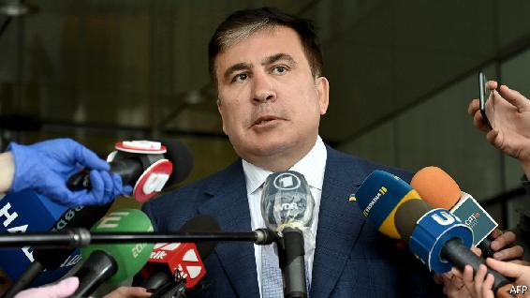

IN THE GARISH style of a video game, the former Soviet republic of Georgia’s richest man is running around in a suit, knocking out golden coins with his head, when a rotund figure pops out of a chimney, destroying the oligarch and triggering “game over”. The victor—in the mock game—is Mikheil Saakashvili, independent Georgia’s best-known ex-president. He hopes to become Georgia’s prime minister in an election on October 31st.

Mr Saakashvili led the “Rose revolution” of 2003 that propelled Georgians from post-Soviet dourness to pro-European modern governance, cracking down on petty corruption and setting up reputable state institutions. But he then spectacularly plummeted from grace. Now he is conducting a re-election campaign from exile in Ukraine, through his United National Movement (UNM). Stripped of his Georgian citizenship, he has been indicted on several criminal charges by the current government, dominated by the Georgian Dream party led by Bidzina Ivanishvili, the country’s richest oligarch, who lives in an emerald-green glass palace overlooking Tbilisi, the capital. Mr Saakashvili, who has been sentenced to nine years in jail in absentia, would doubtless return if UNM were to win, though the odds are against it.

The election is getting nasty. On October 11th Mr Saakashvili was attacked during a rally for Georgian émigrés in Athens. Back in Tbilisi, the government ordered the arrest of two cartographers on charges of mismanaging negotiations to define the border with Azerbaijan 14 years ago, a dig at Mr Saakashvili, who was president at the time. Worse for Mr Saakashvili, he has riled Georgians by expressing support for Azerbaijan in its recent quest to recapture Nagorno-Karabakh, an enclave controlled by Armenia. Georgia, bordering both countries, has hefty Armenian and Azeri populations, and has been trying to mediate. Many young Georgians heartily wish it were game over for both men.

This article was downloaded by calibre from <https://www.economist.com/europe/2020/10/22/an-exiled-ex-president-plans-a-comeback-in-georgia>

| Section menu | Main menu |

| Next | Section menu | Main menu | Previous |

The sacred right to offend

A jihadist beheading spurs the French to defend secularism

President Emmanuel Macron praises an assassinated teacher

Oct 22nd 2020 | PARIS

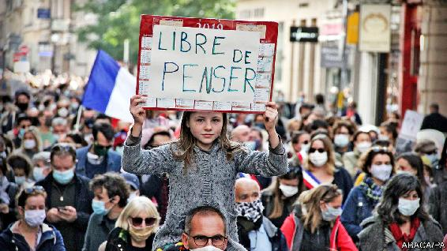

IN A COURTYARD at the Sorbonne, the paramount French symbol of learning, President Emmanuel Macron on October 21st paid homage to a teacher slain “for embodying…the freedom that is transmitted and sustained at school.” Samuel Paty (see Obituary) was a middle-school history teacher in Conflans-Sainte-Honorine, a genteel town north-west of Paris. Earlier this month he had shown pupils caricatures of the Prophet Muhammad from the satirical newspaper Charlie Hebdo during a class on freedom of expression. Those pupils who might be offended, he suggested, could choose not to look at them. On October 16th, after threats against him by a parent and on social media, Mr Paty was beheaded in an attack that police are treating as an act of terrorism.

Shortly before Mr Paty’s class discussion, on October 2nd, Mr Macron had given a speech not far from Conflans in which he warned the French about the rising threat of “Islamist separatism”. This is a radical political project, he declared, which is testing the resilience of the secular French republic, and menaces “freedom of expression, freedom of conscience and the right to blaspheme”. Mr Macron was accused in some quarters of cynically chasing the far-right vote, in others of stigmatising Muslims. Mr Paty’s beheading has rendered his analysis less extravagant than prescient.

France’s tolerance for ridiculing religion is often difficult for outsiders to understand. The land of Voltaire protects the right to believe, and not to believe, as well as the right to treat any sacred belief with irreverence. It also attempts to banish religious affairs from official public life. A law in 1905 entrenched laïcité, a strict form of secularism designed to protect private religious expression but also to keep religion out of state institutions, after an anti-clerical struggle with the Catholic church. It is buttressed by another law that protects the right to blaspheme, which dates to 1881.

For secularists this requires constant vigilance. France’s blasphemy law has protected the publication by Charlie Hebdo of satirical caricatures of the Prophet (the ones Mr Paty showed his pupils) against charges of incitement to hatred. Under French law it is legal to denigrate a religion, but not to insult or incite hatred of any individual on the basis of that religion. The overall effect, critics claim, is to legitimise Islamophobia. Defenders of the law note that a religion is an idea, and ideas should be open to debate and mockery. They add that mocking Jesus is equally protected.

Since he was elected in 2017 Mr Macron has found it awkward to talk publicly about all this. Five years ago, when he was economy minister and France was battered by terrorist attacks, including one at the Charlie Hebdo offices, he sounded more laissez-faire about secularism. As president, he seems to have had second thoughts. He is now convinced that the “soft” signs of Islamism—such as a bus driver who refuses to take female passengers dressed “unsuitably”—may mask a more sinister political plan, which can supply recruits to violence. Since 2017 anti-terrorist police have thwarted 32 attempted attacks in France.

“The problem,” Mr Macron said in early October, “is an ideology which claims its own laws should be superior to those of the republic.” Hugo Micheron, author of a book on jihadists in France, says it is no coincidence that a teacher was the target. “Education in France represents the transmission of the principles of the republic,” he says, and today’s generation of jihadists are “waging an ideological war to counter that transmission, and in which France is seen as the factory of Western ideology.”

The government has responded with a clampdown. It has outlawed one Islamist association, and the police have raided others. Gérald Darmanin, the interior minister, has ordered the closure of a mosque on the Paris fringes, and wants to expel 231 Islamist radicals and shut down aid groups he deems fronts for radicalism. He also wants better control of hate speech on social media. Before Mr Paty was slain, a parent denounced the teacher on Facebook for “Islamophobia”. Another radical known to the French intelligence services also mobilised against him. This amounted to what Mr Darmanin called a “fatwa” against Mr Paty. The perpetrator himself—an 18-year-old refugee of Chechen origin, who was shot dead by the police—posted a photo of the decapitated head on social media. Addressed to Mr Macron, it boasted of the killing of “one of your hell dogs who dared to denigrate Muhammad”.

As France tightens up, this will doubtless embolden those critics who accuse the government of “weaponising” secularism against Muslims. For his part, Mr Macron says he wants to avoid being trapped by those who seek to portray the combat against political Islam as one that “stigmatises all Muslims”. It is, rather, about the French state’s ability to educate children, believers or non-believers, as free-thinking citizens. The struggle, said Mr Macron, is nothing less than “existential”. ■

This article was downloaded by calibre from <https://www.economist.com/europe/2020/10/22/a-jihadist-beheading-spurs-the-french-to-defend-secularism>

| Section menu | Main menu |

| Next | Section menu | Main menu | Previous |

Charlemagne

The European Parliament: powerful yet puny

MEPs have plenty of clout, but no idea how to use it

Oct 24th 2020 |

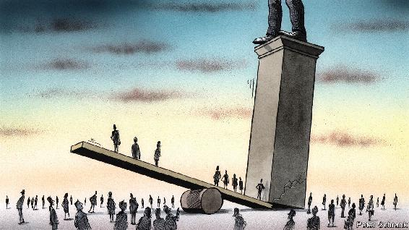

KILLING A KING is a good way of showing who is boss. In the 17th century, English parliamentarians put Charles I on trial for treason after a civil war. He was found guilty and swiftly executed. French lawmakers did something similar in the 18th century. Their 21st-century peers must rely on less bloody methods. The European Parliament is, in its own way, as mighty as its regicidal forebears. It has plenty of weapons at its disposal. It can block trade deals and veto the EU’s budget. It has as much say on European legislation as ministers from national capitals. And the European Commission, the closest thing the EU has to a government, can be dismissed—although not put to death—at parliament’s will.

Yet for all these threats, MEPs are not always treated with much respect. With negotiations ongoing over EU funding of €1.8trn ($2.1trn) between the European Parliament and the Council, which represents national governments, veto-wielding MEPs should be at the apex of their powers. Yet the EU aristocracy do not seem to fear a bout of revolutionary fervour among MEPs. When cornered by German MPs about the European Parliament’s demands in the latest round of talks, Angela Merkel’s main Europe adviser declared: “In the end, none of that is relevant.” David Sassoli, the parliament’s president, reiterated its demands for an extra €39bn for the EU budget at a summit meeting of the EU’s national leaders and was politely told to get lost.

The European Parliament may have dangerous weapons. But it has little idea where to aim them or when to use them. Since its first elections in 1979, it has slowly accrued more powers. By 2009, a raft of treaty changes had turned it from a merely advisory body into a proper legislature, deciding laws and bossing about the executive. It took time for this to sink in. The parliament was still dismissed as “Mickey Mouse”—Margaret Thatcher’s apocryphal label—long after the nickname was no longer justified. Everything from limits on bankers’ bonuses to strict data-protection rules largely owe their existence to the 705 MEPs. Now, a different (but still insulting) description is used: “monkeys with guns”.

A pattern of handing ever-increasing power to the parliament has broken down a little in recent years. Gains have been lost. In 2014 a smart piece of constitutional ju-jitsu introduced a “Spitzenkandidaten” system, whereby the lead candidate from the party that won the most seats in European elections would end up in charge of the commission. Previously, this had been stitched up by national leaders. It was presented to the member states as a fait accompli; and they grudgingly signed up. But in 2019 the parliament effectively handed this power back. Leaders could not bear the thought of Manfred Weber, the candidate of the centre-right European People’s Party, taking the job, so opted instead for Ursula von der Leyen, a German former defence minister. Rather than fight back in a constitutional tussle, MEPs acquiesced. Mrs von der Leyen squeaked through a divided parliament by nine votes. Rather than regicide, MEPs chose genuflection.

Anyway, not all parliamentarians want blood. Some behave more like diplomats, sticking up for purely national interests, rather than legislators acting in the European interest, complains one parliamentary aide. When they do venture into pure politics, MEPs often pick the wrong battles, pontificating about, say, foreign policy, where their views can be ignored. Wielding power requires skill. Holding legislation hostage that member states desperately want passed is one way of doing it. “The only language the council understands is power,” says an adviser. Unfortunately, this is a language many MEPs have yet to master. Today’s crop of MEPs is inexperienced. After the last election in 2019, 61% of them were first-timers. Even old hands do not always think strategically. Since its powers are predominantly legislative, MEPs are liable to get lost in the weeds of their own policy files.

In politics, an element of drama is necessary. “Parliaments are theatres,” says one parliament wallah. “But the [European] Parliament just plays avant-garde stuff only watched by specialists.” Other wings of the EU do drama rather better. When a European Council kicks off, leaders fly in and dish out pronouncements from a red carpet before settling in for all-night negotiations. Hundreds of journalists gather in nearby rooms and ham up any hint of a fight to justify not having gone to bed. Summits obey Aristotelian rules of drama: unity of action, unity of place and unity of time.

Voters notice. By contrast, the parliament is most powerful when it is least visible. The EU legislative process is simple but can be opaque. The European Commission proposes something. Ministers from member states in the Council cook up their version of the law. Meanwhile, MEPs agree on their own version. All sides then lock themselves in a room and hammer out a final text together, with often stark changes from the public proposals. It is at this stage that MEPs have the most clout, forcing through last-minute changes that then become law for nearly 450m people. Yet the whole performance is impossible for most voters to see.

Come at the king, you best not miss

Marginal gains make MEPs happy. While haggling over the €1.8trn package, the parliament is likely to emerge with a bit more cash for pet EU projects. Parliament will probably achieve slightly stricter terms and conditions when it comes to dishing out cash to EU governments abusing the rule of law. Yet this is for naught if voters do not notice. The EU suffers from an attention deficit, rather than a democratic one. Increase turnout in European elections from its current level of 51%, add proper coverage of what MEPs are up to, and it would quickly become a recognisable parliamentary democracy. Otherwise it will become stuck in a cycle, whereby low turnout leads to less legitimacy and less clout, giving voters even less reason to pay attention. An occasional reminder that the politics of the European Parliament is consequential is in order. Executions draw crowds. The parliament needs to find a king to kill. ■

This article was downloaded by calibre from <https://www.economist.com/europe/2020/10/24/the-european-parliament-powerful-yet-puny>

| Section menu | Main menu |

# Britain

* London as a financial centre: Brex and the City
* Elected mayors: Our friends in the north
* Social care: Big old problem
* Brexit and data firms: Inadequate
* Bagehot: What Biden would mean for Boris

| Next | Section menu | Main menu |

Financial services

What Brexit will do to the City of London

The damage will be noticeable but not disastrous

Oct 24th 2020 |

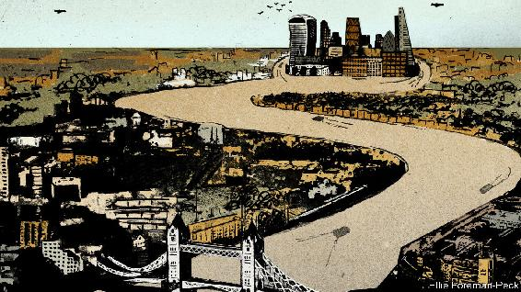

THE FORTUNES of financial centres may swing less wildly than the markets they host, but swing they do. In the 2000s London threatened to knock New York off its perch as the world’s top financial centre. Michael Bloomberg, then mayor of the Big Apple, commissioned McKinsey to study how his city could repulse the attack in 2007. Today things look different. Brexit has robbed the City of London, the capital’s financial district, of much of its swagger. World-conquering ambition has given way to anxious defensiveness.

When the post-Brexit transition period ends and Britain leaves the single market on December 31st, financial links with the EU will become, in the words of its new financial-services chief, Mairead McGuinness, “less fluid”. That is putting it mildly. British-registered financial firms will lose the “passporting” rights that have long allowed them to sell funds, debt, advice or insurance to clients across the EU unimpeded, as if they were domestic. Thousands of jobs and well over £1trn of assets have already been shifted to continental Europe as City firms confront this new friction.

Brexiteers argue that a City cut free from the EU’s red tape can be a more outward-looking entrepot, with strengthened links to the rest of the world. For now, though, the headlines are all about what London is set to lose. Covid-19 has only added to the anxiety in the City. “It’s a ghost town, just like it is between Christmas and new year but without the drunks,” laments a banker.

This jolt comes after two decades during which London became the increasingly muscular heart of the EU’s financial body. Banks are natural consolidators, and many sought to do as much of their European business as possible from London. An analyst recalls an American banker saying, of his European operations, “If it’s not bolted to the floor we move it to London”.

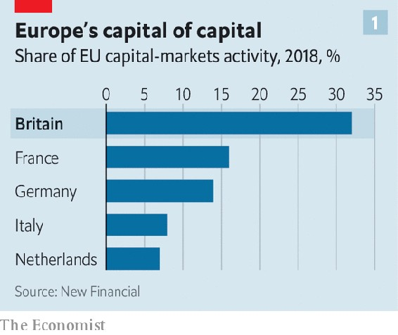

As a result, London became the overwhelmingly dominant EU hub in international finance (see chart 1), and Britain a big net exporter of financial services, with a £44bn surplus in 2017. The sector’s share of GDP has grown, despite slipping back a bit after the financial crisis of 2007-09 (see chart 2). This activity is a big generator of tax revenue: financial-services firms pay around £75bn a year, or more than 10% of all tax receipts.

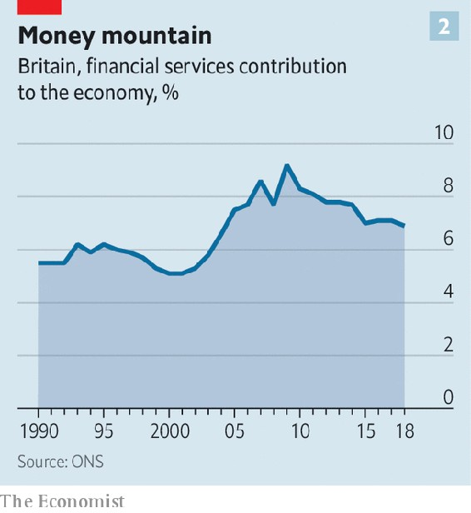

It might seem odd, then, that since the Brexit vote in 2016 governments have not considered the City a priority. But its support for Remain did not endear it to the Brexiteers who now run Britain—and who know that there are more votes in protecting fishermen than moneymen. Financial services are not part of the trade deal being negotiated with Brussels. Ministers took the view that the City is “big and smart enough to look after itself”, says Miles Celic, chief executive of TheCityUK, an advocacy group.

As a result, any deal on financial services is likely to be “very thin, a sort of ‘No Deal Plus’”, says William Wright of New Financial, a think-tank. That is what most financial firms and their regulators have long assumed would be the outcome. Much work has gone into minimising disruption, from the 16m insurance policies that Brits have with EU-based providers to the £76trn-worth of over-the-counter derivatives contracts between British and EU counterparties. This should ensure there is “no drama” on January 1st even if there is no deal, says a British regulator. “It will be more a broken-arm than broken-neck cliff edge. Some market disruption, perhaps, but not a financial-stability event.”

Britain was quick to grant EU financial firms access on existing terms for three years, after which they can seek longer-term “authorisation”. This was not reciprocated. With passporting gone, the best that British firms can hope for in the EU is “equivalence”—a poor substitute. This would allow British firms to serve EU clients only if Brussels deemed British regulations to be closely aligned with its own. Moreover, the access is limited and revocable at 30 days’ notice.

Worse, the EU seems minded to offer relatively unfettered access only in areas where not doing so could affect its own financial stability, such as critical market infrastructure. It has thus agreed to extend current arrangements for clearing euro-denominated derivatives, an activity dominated by London-based clearing houses. But even here the extension is only for 18 months, after which it will be reviewed. The EU is determined to build its own clearing capacity to reduce “excessive” reliance on British financial plumbing—though, as Sir Douglas Flint, chairman of Standard Life Aberdeen, a British fund manager, points out, how the 27 countries would share the risks of backstopping it remains to be seen. Tellingly, the London Clearing House’s (LCH’s) share of euro-swaps clearing has remained above 90% since the Brexit referendum, despite efforts by Eurex, a Frankfurt rival, to nab market share.

For many other activities, the level of access starting on January 1st remains unresolved. That is not least because the EU is using equivalence as a bargaining chip in the trade talks. European regulators are yet to decide, for instance, whether EU investors will be able to trade EU-listed stocks on British exchanges. The London Stock Exchange (LSE) says it will offer trading of EU-listed shares on the Dutch trading platform it owns if necessary.

In several key areas, equivalence has been all but ruled out. One is investment-banking sales and trading—bad news for the Wall Street giants that have long used London as a beachhead from which to serve wholesale clients across Europe. Another is retail banking. Some EU countries have already told British banks they won’t be able to serve customers there, forcing the closure of accounts.

Fund managers have another worry, related to “delegation”, the outsourcing model at the heart of the €18trn European fund industry. Thousands of funds are domiciled in places like Luxembourg or Dublin for tax or regulatory reasons, but are permitted to be managed from London, New York or Hong Kong. The EU’s markets authority recently cast doubt on this arrangement, suggesting it may be reviewed. This has caused consternation in Britain—whose fund managers oversee £8.5trn of assets, £2.1trn of which sit in EU-domiciled funds—and elsewhere. “Asset management is just as critical [as banks] to the City’s long-term future,” says Bernie Mensah, president of International at Bank of America. “If you can prise much of that industry away from London then you really start to tip the balance of power.”

The jobs toll

Brussels has always been clear what Brexit would mean if Britain left the single market: if you want to serve EU clients, as a rule it should be done from within the bloc. Its motives are complex. Playing tough is partly to do with deterring others from leaving the EU. It is also about regaining “economic sovereignty”. Some EU regulators worry about the implications for financial stability of having to rely on a third country for critical functions. Others see Brexit as a chance to renew the push for “capital-markets union”, a long-stalled project to deepen and integrate the EU’s fragmented markets, thereby lowering the cost of capital. And there is raw opportunism. “It does seem to me that some in the EU are seeking to weaponise the equivalence decisions for the UK as a third country in order to shift trading volumes in particular into the EU27,” says Kay Swinburne, vice-chair of financial services at KPMG’s British arm, and a former MEP.

EU regulators have made it clear that they want to see “substance” in EU subsidiaries. Banks are under pressure to move not just back-office staff but salespeople, traders and risk managers too. “Keeping the key staff in London, with a brass-plate operation across the water, is out,” says a British regulator. In response, banks have been moving employees in substantial numbers, albeit not the tens of thousands that City Cassandras predicted would migrate. According to EY’s Brexit Tracker, which monitors announcements by large banks and other financial firms, as of October 1st at least 7,500 jobs had left the City for the EU since the referendum. On top of this, firms have added, or plan to, over 2,800 new roles in EU subsidiaries.

These lost jobs add up to around 4% of the total in the City—hardly a devastating blow. But the actual number moving is higher; EY tracks only the 222 largest firms. And there is more to come. Some firms have been waiting to see the outcome of the trade talks before moving more staff. “We will see skeletal teams in the EU being fleshed out over coming months,” says John Liver of EY. With covid-19 complicating relocation, EU regulators have indicated that banks can finish transferring staff next year, as long as their intentions are clear. Hubertus Väth of Frankfurt Main Finance, the city’s financial cheerleader, says that in 2019 some 1,500 finance jobs moved from London to Germany’s financial capital. He expects another 2,000 to transfer as the pandemic fades.

Mr Wright estimates that around 90% of the big Wall Street banks’ European staff were based in London before Brexit, and expects the number to have fallen to 80% by the time the dust settles. Morgan Stanley is reportedly looking for a new London HQ with at least 600,000 square feet, down from its current 800,000. How much of the reduction is down to covid-induced downsizing and the rise of home working, as opposed to Brexit, is unclear.

As for assets, banks have announced the shifting of £1.2trn-worth, equivalent to 14% of British-based banks’ total assets, in preparation for Brexit; more may have been moved unannounced. Nicolas Véron of Bruegel, a think-tank, reckons that more than 20% of British banking assets could eventually go.

Barclays is transferring £150bn—over 10% of its domestic balance-sheet—to Ireland, making it the largest bank there. JPMorgan Chase is moving €200bn, over 7% of its global assets, to Germany. When asked by Bloomberg if 20-25% of the wholesale revenue JPM generates in Britain could end up elsewhere, the bank’s head of Europe, Viswas Raghavan, replied, “You are in that zip code.” Lost business means lost tax revenue: Stephen Jones of UK Finance, a lobby group, told a House of Lords committee in February that of the £37bn-38bn that banks contribute directly and indirectly to the Exchequer, £3bn-5bn is “at risk”.

Estimating the final toll is guesswork. New Financial reckons that a quarter of the City’s business is EU-linked and half of that may have to relocate. A similar lack of clarity hangs over the City’s £55bn-65bn in revenue from other parts of the world. No one knows what proportion of that is routed through London only because of its soon-to-disappear frictionless access to the EU.

The City still has charms

Despite Brexit, London retains several advantages over EU financial centres, from its language and legal system (which governs many financial contracts) to the rich corporate ecosystem of lawyers, accountants, consultants and public-relations experts entwined with the City. London is also—no small matter—the worldliest of the continent’s world cities.

This makes it attractive not just to big banks, but also to hundreds of smaller firms that “see advantages Paris and Frankfurt struggle to reproduce”, says Daniel Pinto, the Anglo-French founder of Stanhope Capital, a boutique investment firm. Paris, he says, is still seen as “wanting to penalise, not promote, the financial sector”, despite its strenuous efforts to woo business from London. Meanwhile, foreign institutional investors, from American endowments to Middle Eastern sovereign-wealth funds, “have an almost cultural attachment to London and will still want to invest through it if they can”. Moreover, London is streets ahead of European rivals in several fast-growing sectors, such as green finance and fintechs. For firms in these domains, “If you want to see 20 investors who are genuinely invested in your area, London is still the place, and we don’t see that changing,” says Mike Reid of Frog Capital, a VC firm that invests in fintechs.

Regulation might also be an advantage in the future. Some worry that standards may be allowed to slip to boost Britain’s competitiveness. The Bank of England rejects this (one of its mantras is “divergence doesn’t necessarily mean dilution”). It stresses a change in style rather than substance: making rules smarter by letting regulators, rather than lawmakers more detached from the industry, craft more of them. Improving on the EU’s one-size-fits-all-27 financial rule book is not the most fiendish of challenges. The aim is to rewrite it so it is “more open to innovation while no less attentive to financial stability”, says a British official, citing clunky European rules for small banks and the constraints of the Solvency 2 insurance directive as areas to work on. Ms Swinburne expects Britain to seek to align regulation more closely with America and Asia.

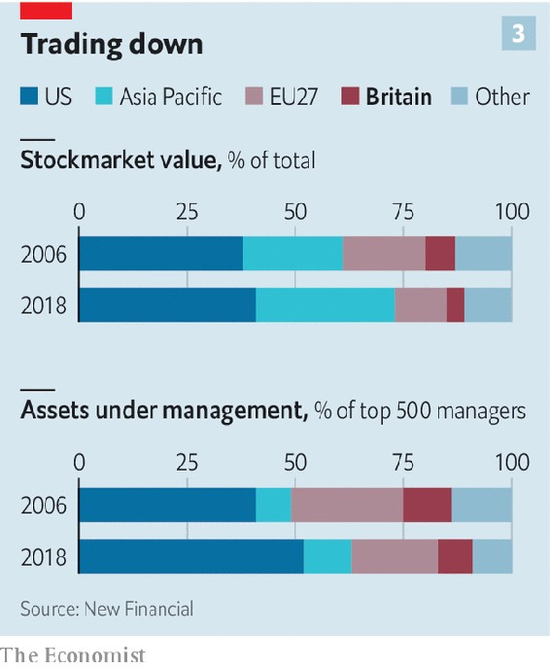

The EU, meanwhile, suffers from a lack of cohesion. The huge variation in its member states’ tax and insolvency laws is a formidable barrier to creating a unified capital market, for instance. The bloc is also riven with division over what type of financial sovereignty it wants. “It’s a delicate balancing act. The more it wraps its arms around EU borders and says activity has to take place within them, the less competitive and less connected to global flows its financial services will be, and costs will rise,” says Andrew Pilgrim of EY. Even America, the financial hegemon, has never sought to gain full control of its financial flows and currency.

Also hamstringing the EU is a lack of co-ordination in taking on London. Its financial centres compete with each other. When Paris hustles to lure asset managers, for instance, it looks to poach from Luxembourg and Dublin as well as London. “There’s no one place where they [the EU] are amassing their efforts,” says Eva Kingston, a financial headhunter. As a result, expertise is diffuse: Frankfurt is strong in banking; Amsterdam in trading platforms; Luxembourg and Dublin in fund administration; Paris comes closest to being an all-rounder but is far from world-class. In a recent global ranking of financial centres it came 18th, just ahead of Washington, DC.

There are also questions over banks’ longer-term commitment to a Britainless EU. They are being forced to relocate business against their will. “Allocating more capital to the euro zone right now feels odd, what with negative interest rates and an undynamic economy,” says a senior City figure. It does not help that the EU27’s share of global banking, insurance and capital-markets activity has been falling since before the global financial crisis: from 20% in 2006 to 13%, while America’s share has remained stable at around 40% and Asia’s has jumped from 18% to 28%. “Anyone for a market that’s relatively small in global terms, shrinking and inefficient?” asks another banker, acerbically.

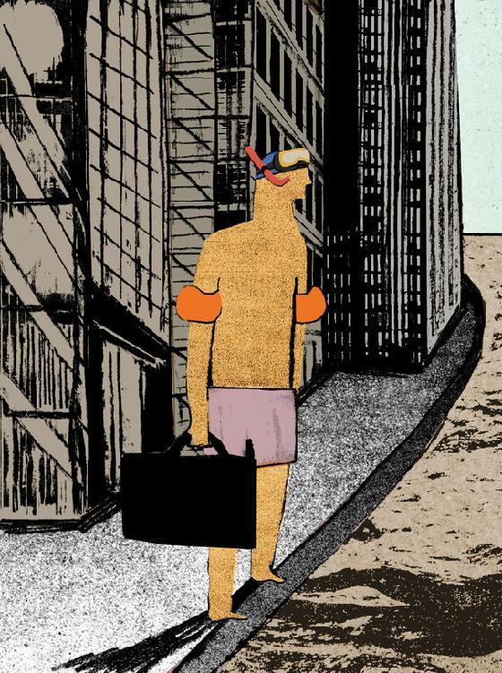

Some bankers may find ways around the diktat that they serve EU clients from within the bloc. The LCH has suggested that, faced with “forced fragmentation”, some firms might try “to reroute trades via different entities”. A central banker says: “Never underestimate the financial sector’s ability to do the business it wants, where it wants, despite regulators putting lines on maps. Arbitrage is in its DNA.”

Even if London stays well ahead of European wannabes, however, it faces intense competition from elsewhere. It remains locked in a battle with New York for top spot. Asian markets are growing fast and becoming more self-sufficient in raising capital. China has hosted more of the IPO boom of 2020 than London, partly thanks to its fast-growing, Nasdaq-style market for tech stocks. “The big risk for London is not the EU but that in the not too distant future Asia doesn’t need it,” says Mr Wright.

The full impact of Brexit won’t be clear for years. Large parts of the future relationship between the City and the EU will be thrashed out only at the end of temporary extensions, such as that for clearing, says Simon Gleeson of Clifford Chance, a law firm. In the meantime, technology, along with covid-19 and home-working, is making the question of location-based regulation, long fundamental in finance, increasingly vexed. All of which, says Jan Putnis of Slaughter and May, another law firm, “makes Brexit look almost quaint”.■

This article was downloaded by calibre from <https://www.economist.com/britain/2020/10/24/what-brexit-will-do-to-the-city-of-london>

| Section menu | Main menu |

| Next | Section menu | Main menu | Previous |

Managing the pandemic

The fight between central government and city mayors over lockdown

Local leaders are too weak to defy the government, but too strong to ignore

Oct 24th 2020 |

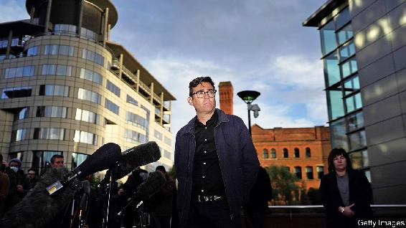

HAVING UPSET pretty much all Boris Johnson’s plans, covid-19 has found a new way to thwart the prime minister: by undermining his strategy for re-election in 2024. Other than getting Brexit done, Mr Johnson’s main policy plank when he was elected was to “level up” impoverished areas of the country far from the capital, and thus consolidate the votes that he won through his support for Brexit. A battle that is now raging between the government and city mayors over local lockdowns could damage the prime minister’s credibility as saviour of the north.

Directly elected mayors are a novelty. Labour began the experiment 20 years ago, as part of its devolution strategy. The Tories adopted the idea, hoping that urbanites who were viscerally opposed to Conservative governments might nevertheless opt for a charismatic local Tory. In typically British fashion, new mayoral arrangements have been laid on top of older ones, producing a mess. Liverpool has a city mayor, a metropolitan mayor and a ceremonial lord mayor, for good measure.

The government gave mayors few formal powers, expecting them to be little more than local cheerleaders and problem-solvers. Their ability to raise money is limited. But mayors have large mandates and high local profiles, which give them great informal power. Boris Johnson is prime minister because he won 92,000 votes in a Tory leadership election and then, last December, 25,000 votes in his constituency. By contrast, 360,000 people in Greater Manchester voted for Andy Burnham. Almost 1.2m Londoners voted for Sadiq Khan.

As the government moved from a nationwide lockdown to targeted local ones, it tried to treat mayors mostly as mouthpieces for its policies. Steve Rotheram, Liverpool’s metropolitan mayor, says he found out that his city would be placed into the highest level of lockdown by reading the Times. Sir Peter Soulsby, the mayor of Leicester, says he learned of changes to the rules in his city by studying government news releases: “We were never warned in advance, and never asked for our opinion.” Then the government tried to tighten the lockdown in Greater Manchester, and Mr Burnham dug in.

He had already demonstrated his informal power. In May, he and the city mayor of Liverpool argued against reopening schools. Although mayors are not supposed to control schools, this had a huge effect. In early June only 6% of schools in north-west England were open for children in the reception year, compared with 41% in the Midlands. Mr Burnham dished out more opinions. People in the north-west, he said, were being treated as “canaries in the coalmine for an experimental regional lockdown strategy”. In mid-October a poll by YouGov showed that people in northern England trusted him to handle coronavirus more than they trusted Mr Johnson or Sir Keir Starmer, the Labour Party leader.

Mr Burnham argued that if the government wanted to tighten the lockdown in Manchester, it should shell out more generously to cover the economic damage the city would suffer. After more than a week of negotiations, on October 20th the government refused his demands and went ahead without his approval. The two sides were just £5m ($6.5m) apart.

Still, it is striking that a man holding an office that did not even exist four years ago has made the government negotiate with him, almost as though he were a foreign leader. Mr Burnham and some of the other mayors are beginning to acquire national clout. “I think it represents the coming of age of the metro mayors,” says Lord Kerslake, a former civil-service chief who now chairs the UK2070 Commission, an inquiry into regional inequality. He thinks that more power and funding ought to flow to them eventually.

Covid-19 has exposed the failings of Britain’s centralised state, which is coping with the virus less well than countries with stronger local public-health systems such as Germany and South Korea. But the centre does not give up power easily. A white paper on devolution has been put off. And shortly after slapping down Mr Burnham, Mr Johnson picked a new fight with Mr Khan, over London’s transport system.■

Editor’s note: Some of our covid-19 coverage is free for readers of The Economist Today, our daily [newsletter](https://my.economist.com/user#newsletter). For more stories and our pandemic tracker, see our [hub](https://www.economist.com/news/2020/03/11/the-economists-coverage-of-the-coronavirus)

This article was downloaded by calibre from <https://www.economist.com/britain/2020/10/24/the-fight-between-central-government-and-city-mayors-over-lockdown>

| Section menu | Main menu |

| Next | Section menu | Main menu | Previous |

A big old problem

Will Boris Johnson keep his promise to reform social care?

A new report urges the government to put at least £7bn into the English system

Oct 22nd 2020 |



IN 1943 WINSTON CHURCHILL promised to bring the “magic of averages to the rescue of millions” by creating a national-insurance system to look after Britons from cradle to grave. Some 77 years later, Boris Johnson employed the same phrase at the Conservative Party conference. This time, the “magic of averages” would be used to fix “the injustice of social-care funding”.

Many politicians, including Mr Johnson, have made similar vows, yet failed to act. On October 22nd the House of Commons health and social care committee, led by Jeremy Hunt, Mr Johnson’s erstwhile opponent for Tory leadership, gave the prime minister a prod, with a report urging the government to spend at least £7bn ($9bn) more on social care by 2023-24, thus raising total spending by a third.

Some £3.9bn of the money would cover demographic change—growing numbers of old people and more young people requiring care—and enable providers to pay their staff the rising living wage. The other £3.1bn would be spent on capping the amount people pay for care during their lifetime at £46,000: anything above that would be covered by the state. That idea dates back to a review of social care in 2011 by Andrew Dilnot, an economist.

Unlike health care, social care is both needs-tested and means-tested. At present, only those with assets below £23,250 receive any state support. Since the cost of care is so hard to predict, firms are unwilling to offer protection, making social care the one great risk in life that is in effect uninsurable. A cap on costs would still require fiddly assessments of people’s needs, to keep tabs on how much they have spent from their approved budget. But it would also prevent people’s savings from being wiped out if they get dementia.

It may have other benefits, too. Mr Dilnot argues that people underspend on care because they want to have enough in the bank for the long haul. A cap would remove the fear of running out of money, enabling people to spend more in the short term, including on things (a stairlift, say) that stop them having accidents in the first place. Meanwhile, a more stable financial settlement would help reassure private providers to stay (and invest) in the market. Both would increase the incentive to develop new and better forms of care.

The £7bn price-tag for the committee’s proposal is hefty—but it still leaves plenty out. Social-care workers were more likely to die than even their colleagues in hospitals during the first wave of the covid-19 pandemic, a fact that has drawn attention to their meagre pay. Their wages could be pegged to similar roles in the health service, which would help reduce extremely high levels of turnover, but require additional funding unless the government wanted to bankrupt providers. Labour and some senior Tories support the introduction of free personal care, which covers things like help with bathing and dressing, and would cost another £5bn.

The problem with social care is not a lack of options. The King’s Fund, a think-tank, counts a dozen government papers on reform in the past two decades. The difficulty is summoning the political will to implement any of them, and raising the cash to do so, with opposition parties reliably objecting to plans for change. After the general election last year, Mr Johnson had an 87-seat majority and had declared his intention to fix social care once and for all. He was edging towards a Dilnot-style cap.

The pandemic has shone a light on the problems of social care. But it has also wrecked the public finances. On October 21st the Treasury said that a planned three-year spending review had been ditched in favour of a one-year one, owing to the unusual circumstances. With finances tight and the government reluctant to make long-term decisions, an announcement on social-care reform is likely to be delayed. Mr Hunt, who was health secretary from 2012 to 2018, does not think the pandemic is a good excuse, however. As he puts it: “We were even more bankrupt in 1945 when we decided to sort out the NHS.” ■

This article was downloaded by calibre from <https://www.economist.com/britain/2020/10/22/will-boris-johnson-keep-his-promise-to-reform-social-care>

| Section menu | Main menu |

| Next | Section menu | Main menu | Previous |

Brexit and the digital economy

State aid, data adequacy and Britain’s tech ambitions

“No deal” would make it hard to create trillion-dollar tech companies

Oct 24th 2020 |

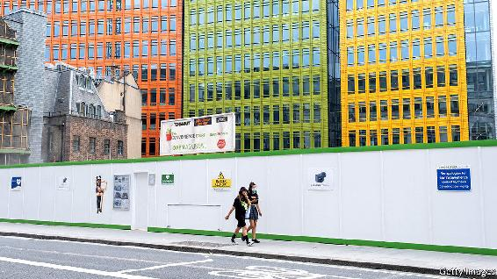

IN SEPTEMBER Dominic Cummings, chief adviser to Boris Johnson, wrote to government employees laying out the government’s ambition for post-Brexit Britain to become a hothouse in which to grow technology companies with trillion-dollar valuations. Freedom from the EU’s rules about what financial support states may and may not provide to the private sector would help, he said, as the government would be able to pump public money into technology companies, stimulating a new generation of British giants.

There’s a problem with this vision. In order to get a trade deal with the EU, the government may have to give up the freedom to pump money into companies. And if it does not get a deal, another impediment may prevent its unborn tech giants from seeing the light. If the EU does not judge its data protection rules to be adequate after January 1st, and British entities may process Europeans’ data only after jumping through regulatory hoops, any potential technology giant will be hamstrung.

That is because Britain’s 66m people cannot alone sustain a trillion-dollar tech firm. Alibaba, Google and the like serve user-bases ten times that large. The pool of users of similar size most immediately available to Britain’s future tech giants, in which they would not be competing with Chinese or American ones, is the 446m folk of the EU. But the hard Brexit that would hand the levers of state aid over to Mr Cummings would almost certainly cut British companies off from Europeans’ data.

That is because European courts do not approve of British intelligence practices to which Europeans’ data is subjected upon being processed in the UK. Most recently, on October 6th, the European Court of Justice (ECJ) ruled that telecoms providers cannot be required to gather data on their users on behalf of security services on an ongoing basis, as Britain’s Investigatory Powers Act insists. Britain has used the country’s membership of the EU to argue that it has the right, as all member states do, to carry out national-security functions without interference. This has left a stalemate, and EU-UK data flows untouched.

But once Britain is no longer a member of the EU, this defence falls apart. Britain will suddenly be in the same boat as America. The ECJ has been examining the transfer of EU citizens’ data to America for years, again citing concerns about overreach by its security services. In July the ECJ ruled that the blanket agreement which had facilitated EU-US data transfers, known as Privacy Shield, was not sufficient to protect Europeans from American spying.

The American technology giants are continuing to serve their European users through what are known as Standard Contractual Clauses (SCC), agreements negotiated directly with the EU over the terms of data transfer. Already onerous, the July ECJ ruling made them even more so, requiring companies seeking an SCC to prove that the transferred data will be treated according to EU law. Mature tech giants, with teams of expensive lawyers and data-protection experts, can easily bear those costs. Embryonic ones cannot.

These issues may be averted with a last-minute deal on data adequacy, even a temporary one. But any deal with the EU seems unlikely to come with the free-and-easy state aid rules that Mr Cummings seems to see as the key to building big tech companies. The EU wants tech giants too, to combat America’s and China’s digital influence. Quite why Mr Cummings imagines the EU would be keen on competition in the European market from state-backed British companies is unclear. ■

This article was downloaded by calibre from <https://www.economist.com/britain/2020/10/24/state-aid-data-adequacy-and-britains-tech-ambitions>

| Section menu | Main menu |

| Next | Section menu | Main menu | Previous |

Bagehot

What Joe Biden means for Boris Johnson

A Biden administration will make the prime minister’s life even more difficult

Oct 24th 2020 |

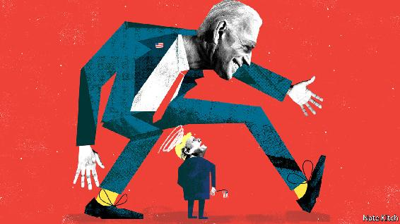

NEW ADMINISTRATIONS in America often cause problems for Britain. Bill Clinton was annoyed with John Major because Conservative activists publicised his dope-smoking at Oxford. George W. Bush initially regarded Tony Blair as a Clinton stooge. But these problems pale into insignificance compared with the ones that will confront the Johnson government if, as expected, Joe Biden wins the presidential election on November 3rd.

The Democrats see Boris Johnson through the prism of Donald Trump and the culture wars that he has inflamed. Mr Johnson was so close to Mr Trump that the 45th president dubbed the prime minister, ungrammatically but memorably, “Britain Trump”. Mr Johnson also fails the Black Lives Matter test that is now sacred to the Democratic left. As graduates of Barack Obama’s administration, Mr Biden and his closest foreign-policy advisers are particularly mindful of Mr Johnson’s claim, back in 2016, that America’s first black president removed a statue of Winston Churchill from the Oval Office because, as a “part-Kenyan”, he was prejudiced against Britain.

The government has been scrambling to improve its relations with the Biden camp ever since he established a sustained lead in the polls. But senior government figures, who are Brexiteers to a man and woman, have few if any links with the Biden team. Michael Gove, the Cabinet Office minister and intellectual engine of Johnsonism, is even more closely identified with the American right than his boss. And Britain’s diplomats are in no position to fill the gap. Kim (now Lord) Darroch, the diplomat with the best contacts in Bidenworld, was sacked as ambassador to America over a leaked memo which described Mr Trump’s White House as “uniquely dysfunctional”, among other disobliging phrases. His successor, Karen Pierce, who was moved from the United Nations in New York to replace him, has not had time to develop close ties with the Democratic establishment in Washington. The pandemic has transformed the embassy from a centre of the social whirl into a ghost ship. Mr Biden’s team refuse to meet foreign diplomats, including Britain’s, citing the furore created by Michael Flynn’s contact with a Russian ambassador, Sergey Kislyak, before the formal handover of power in 2017.

Britain has a good record of turning Anglo-American frostiness into romance. The Deep State provides a reliable resource: America has closer military and security relations with Britain than any other ally. Having served on the Senate Foreign Relations Committee for three decades, Mr Biden understands the art of strategic forgetting. And having morphed from a liberal mayor of London into a leader of the Brexit rebellion, Mr Johnson knows how to play to his audience. His most recent passion, for Franklin Delano Roosevelt, is calculated to appeal to a Democratic president who wants to launch an ambitious programme of domestic reconstruction and international engagement.

Mr Johnson also has some levers to pull. He can emphasise the two countries’ common interest in standing firm against China and Russia. He can burnish his environmental credentials. Britain’s hosting of the next UN Climate Change Summit in November next year may provide a useful opportunity for bridge-building. A Biden administration would be keener to repair America’s damaged interests around the world than to punish miscreants, and the Johnson government would have an interest in writing Mr Trump out of history: expect a stream of briefings from Downing Street proclaiming that he was all hat and no cattle when it came to negotiating a free-trade deal.

But it will not be that easy. A Biden victory would replace a president who, for all his quirks, supports Brexit—the most significant policy change in Britain for decades—with one who thinks that it’s a rookie mistake. A handover of power would, by its nature, set back progress on trade negotiations, and Mr Biden has no incentive to prioritise their resumption. More worrying for Downing Street, Mr Biden would also side with Europe (and particularly the Irish Republic) if Britain endangers the Anglo-Irish agreement. Mr Biden is a proud Irish-American (five-eighths Irish, according to genealogists) who made a point of saying, during the first presidential debate, that “aloof plutocrats” like Mr Trump “look down their nose at Irish Catholics like me”. He is also a proud member of a Democratic establishment that regards the agreement as one of its signature achievements.

Mr Biden’s biggest threat, though, is not to the pace of Brexit but to its meaning. With the election of Mr Trump in 2016, Britain could claim that it was in the slipstream of history, as one of the first to abandon a collapsing global order; the election of an inveterate multilateralist like Mr Biden would make it look as if it is stuck in a cul-de-sac while America moves on. Brexiteers hoped that Brexit would have a series of knock-on-effects: the contraction of the European Union as other countries looked for an exit, the rise of the Anglosphere, as Britain forged close relations with the old colonies (including America) and the restoration of self-confident nations at the centre of the global order. But the EU is looking stronger, not weaker, as a result of Brexit, and a Biden administration would push history further in the opposite direction, reinforcing global institutions and making talk of the Anglosphere sound out-of-touch if not barking mad. Indeed, the combination of Biden and Brexit would further erode the central pillar of the Anglosphere: Britain’s special relationship with the United States. Mr Biden and his foreign-policy team want to rebuild the old multilateral system, particularly the Atlantic alliance, but, at the same time, adapt it to the needs of a changing world.

That is bad news for a country whose vaunted special relationship with the United States depended, in the end, not on sentiment or tradition, but on Britain’s ability to act as a bridge between America and Europe. In the global architecture which Mr Biden would rebuild, Britain’s place would be a humbler one. ■

Dig deeper:  
Read the [best of our 2020 campaign coverage](https://www.economist.com/us-election-2020) and explore our [election forecasts](https://projects.economist.com/us-2020-forecast/president), then sign up for Checks and Balance, our [weekly newsletter](https://www.economist.com/checksandbalance/) and [podcast](https://play.acast.com/podcasts/2020/01/24/checks-and-balance-our-new-weekly-podcast-on-american-politics) on American politics.

This article was downloaded by calibre from <https://www.economist.com/britain/2020/10/24/what-joe-biden-means-for-boris-johnson>

| Section menu | Main menu |

# International

* Felonious fishing: The outlaw sea

| Next | Section menu | Main menu |

The outlaw sea

Illegal fishing fleets plunder the oceans

They devastate seafood stocks and treat their crews abominably

Oct 24th 2020 | GAMPO-EUP, HONIARA AND KAOHSIUNG

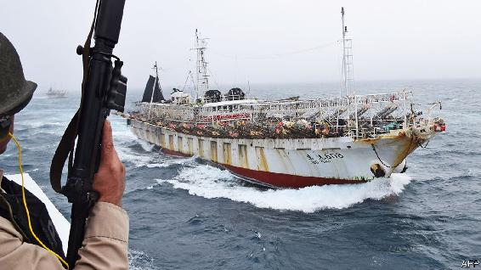

For more coverage of climate change, register for The Climate Issue, our fortnightly [newsletter](https://www.economist.com/theclimateissue/), or visit our [climate-change hub](https://www.economist.com/news/2020/04/24/the-economists-coverage-of-climate-change)

FOR SOME years wooden fishing boats, from another time as much as from another place, have been washing up on the western shores of Japan’s main island. Now numbering in the hundreds, these ghost boats are usually empty. Occasionally they contain the starved remains of North Korean fishermen. Life in North Korea is brutal and its fishing is primitive. But its inshore waters are known to have much marine life. Why would such unseaworthy craft head so far out to sea that they either get lost or are blown off course by the Sea of Japan’s notorious storms?

The mystery unravelled only recently, with the confirmation of another type of ghost ship. South Korea’s coastguard had for some time been aware of large Chinese fishing vessels steaming, fast and in single file, through South Korean waters. Their superstructures were festooned with racks of powerful electric bulbs—the identifying feature of squid boats, which use light to lure their prey from the depths at night. The Chinese skippers were less keen to attract the attention of the South Korean authorities. They had, in contravention of South Korean regulations, turned off their “automatic identification system”, or AIS. These transponders, which help prevent collisions, broadcast a vessel’s identity and position. When the Outlaw Ocean Project, a non-profit organisation with which The Economist collaborated on this story, put out to sea on a South Korean vessel in 2019 in hopes of collecting details on the Chinese fleet, one of nearly two-dozen Chinese vessels blared its horn, flashed its lights and veered towards the South Korean boat as if to ram it. The Koreans averted a potentially fatal collision by taking avoiding action when the Chinese vessel was metres away.

The South Korean authorities had asked Global Fishing Watch (GFW) to throw light on what the Chinese fleet was up to. GFW is another non-profit organisation set up four years ago by Google and others to monitor fishing around the world. It uses machine learning to overlay signals from vessels’ transponders (when switched on) with three types of satellite imagery: high-resolution optical images, images from cloud-penetrating radar, and infrared imagery that spots vessels operating at night. GFW’s conclusion was published in Science Advances in July: a “dark fleet” of nearly 1,000 industrial-sized Chinese fishing boats is hauling squillions of squid from the waters within North Korea’s 200-nautical-mile (370.4-km) exclusive economic zone each year. Squid is popular across East Asia, and demand is growing elsewhere, too—America imports 80,000 tonnes a year, most of it from China. Thanks to overfishing, South Korea and Japan have reported a fall in their catch of the Pacific flying squid of over four-fifths since 1983. That makes remaining stocks more valuable.

Yet the Chinese fleet’s activities in North Korean waters are certainly illegal. Possibly the Chinese Communist Party has struck a deal with the dictator, Kim Jong Un, for access to North Korean waters, in which case it is in breach of a UN Security Council resolution in 2017 imposing sanctions on the rogue regime for its nuclear weapons programme. More likely, its vessels are in North Korean waters without permission, in which case they are poaching on an industrial scale. Either way, China’s dark fleet is causing harm. Its depletion of coastal waters in the past few years coincides with a sharp rise in ghost boats washing up in Japan, as well as thousands of rickety North Korean boats entering Russian waters illegally. Desperate North Korean fisherfolk are having to go farther and farther to make their catch, leaving hungry villages full of widows behind.

China’s dark fleet is the world’s biggest, but it is not the only one. GFW and Trygg Mat Tracking, a Norwegian NGO that helps African states with fisheries intelligence, have uncovered nearly 200 Iranian fishing boats using drift nets to catch tuna off Somalia and Yemen. Epic, round-the-world chases by Sea Shepherd, a vigilante conservation group, to interdict rogue vessels fishing for the valuable Patagonian toothfish in the Southern Ocean have captured the imagination of ecowarriors.

Ships in the night

The crimes of such vessels are one part of what is known as illegal, unreported and unregulated (IUU) fishing. As national, regional and multilateral bodies struggle with the damage overfishing causes to marine ecosystems (see chart), IUU fishing highlights the woeful state of governance on the waters that cover over two-thirds of the planet. Dodgy fishing drives a harpoon through efforts to make seafood supplies sustainable. One international study concludes that of 1,300 commercial species of fish and marine invertebrates, 82% are being removed faster than they can repopulate. Illicit boats not only net without restraint; they also deprive governments of billions of dollars from selling access to fisheries. And they threaten the livelihoods of tens of millions of small legal fishermen in Indonesia, west Africa, the Pacific Islands and other coastal states. Some go hungry because their waters have been feloniously fished.

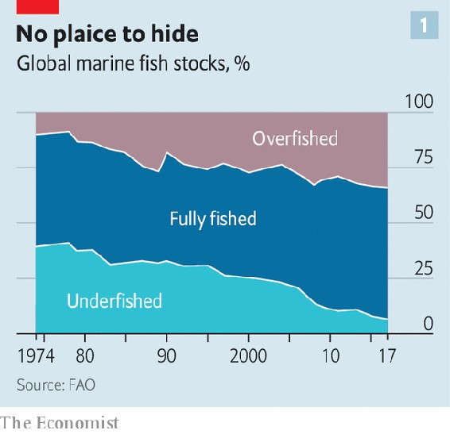

Shortly after the GFW report came another discovery, this time by the Ecuadorean navy: a Chinese fleet fishing for squid right up against Ecuador’s exclusive economic zone around the (famously biodiverse) Galapagos islands. Many of the 260-odd boats are likely to have taken part in the North Korean fishing foray. Some of these vessels may have broken the law by switching off their transponders and sneaking into Ecuadorean waters. HawkEye 360, an American firm, used faint radio signals to identify vessels near the Chinese fleet that had gone “dark” within Ecuador’s exclusive zone. But establishing them to be Chinese fishing boats proved impossible. For the most part, the fleet did not appear to be breaking any laws. It was in international waters. And though international agreements exist for key fish stocks, notably commercial species of tuna, fishing for squid is not regulated. Chinese boats were taking rapacious advantage of that.

Even the legal presence of the Chinese fleet in this part of the eastern Pacific has consequences, says Enric Sala, National Geographic’s explorer-in-residence. At the turn of the year the fleet typically moves to the edge of the Argentine shelf, hoovering up squid before the start of the season that Argentina recognises in January—after the cephalopods have bred (a confrontation between the Argentine coastguard and a Chinese squid boat is pictured top). All this hurts the livelihoods of thousands of South American fishermen.

Duncan Copeland of Trygg Mat Tracking says it has also spotted Chinese fleets rapidly expanding squid fishing in two vast but little-documented patches of the Indian Ocean. Sucking up squid on this scale is troubling. Fleets are increasingly going after squid because they have fished out so many of their predators—a case of “fishing down the foodweb”. Squid are an important food source for many other species, including tuna, that local fleets want to catch. Squid also lead what Mr Sala calls a “superquick life”, growing, reproducing and dying in just a year. So when even squid populations are crashing, that is worrying.

The world is gradually waking up to the problem of dark fleets operating under cover of night or beyond the arm of the law. However, Mark Zimring of The Nature Conservancy, an environmental NGO, says that most illegal fishing takes place on licensed fleets. They are responsible for more than 90% of infractions in the southern Pacific. Instances might include skippers catching more fish than they have a permit for, or misreporting the species they have caught. In the Pacific and elsewhere, many vessels licensed to catch tuna are engaged in the finning of sharks. Illegal drift nets, as well as nets with too fine a mesh, kill vast quantities of by-catch—other fish species that are thrown back into the water—as well as protected animals such as the critically endangered vaquita porpoise found in the Gulf of California.

With so many vessels up to no good, the agencies meant to enforce the rules are outmatched. Many are poorly staffed and trained, especially in the poor countries of west and east Africa, South-East Asia and the Pacific. The coronavirus has made matters worse. In July the Western and Central Pacific Fisheries Commission, which oversees the world’s biggest tuna fishery, absolved fishing boats purse-seining for tuna from carrying a fisheries observer.

Then there is the treatment of crews. Fishing has always been a dangerous profession. It is sometimes lucrative, but more often not. In Asia forced labour is rampant, as are other abuses of workers. Thailand has a huge fishery. But few Thais want to join it, leaving the fleet short of about 50,000 seamen a year. Tens of thousands of migrants from Cambodia and Myanmar are whispered into Thailand each year to make up the numbers (one is pictured on a boat below).

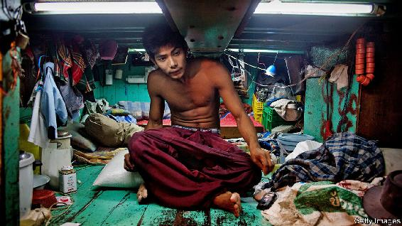

Unusally spacious

Unscrupulous captains buy and sell these men and boys like chattel. Your correspondent joined a vessel that fished about 100 miles off the Thai coast. Three dozen Cambodian men and boys worked barefoot, in 15-foot swells, on a deck made slippery by fish guts and ice, an obstacle course of jagged tackle and spinning winches. One boy proudly showed off two missing fingers, caught between a net and a drum. Some crew members’ hands had open wounds, the deepest of which they stitched up themselves. The captain had plenty of amphetamine to distribute, but no antibiotics. Shifts ran to 20 hours. Food was a once-daily bowl of rice, flecked with boiled squid. Drinking water was rationed. The whole ship crawled with cockroaches. Rats were as carefree as city squirrels.

Reports from Asian distant-water fleets are also horrific. In July Indonesian police impounded two Chinese vessels and arrested executives of a recruitment agency over the mistreatment of Indonesian crew members, one of whom was found dead in a deep freeze. The environmental and labour practices of Taiwan’s fleet were so egregious that in 2015 the European Union threatened to stop importing Taiwanese seafood. One Filipino former crew member of the Da Wang, a Taiwanese vessel registered in Vanuatu, says the skipper frequently punched him in the back of the head to make him work harder and whirled a large hook around to intimidate. The Filipino says he witnessed the first officer beat an Indonesian crew member, who later died. He says that after the vessel returned to Taiwan its owners and the recruitment agency threatened him. He is in hiding and giving evidence to an investigation.

The government has since tightened regulations governing the welfare of 35,000-odd foreign crewmen. Yet in October America’s Department of Labour classified fish caught by Taiwan’s long-distance fleet—with 1,100 vessels second only to China’s—as the products of forced labour. It said crews on Taiwanese vessels “face confiscation of documents, long days with little rest, physical and verbal abuse, and lack of payment”. Though the American government has yet to ban seafood from Taiwan, at a minimum American companies sourcing fish from Taiwan now face closer scrutiny at customs.

The Pacific’s tuna fishery has recorded one or two suspicious deaths of on-board fisheries observers every year since 2015—perhaps after seeing what they should not have. In March a Kiribati fisheries observer was found dead on a Taiwan-flagged tuna boat with a blow to the back of his head. His case is being treated as murder. The presence of one type of crime suggests the likelihood of others, says Emma Witbooi, one author of a report on organised crime in fisheries put out by the High Level Panel for a Sustainable Ocean Economy, a Norwegian-led initiative. Increasingly, fishing is used as a cover for running guns and drugs, trafficking labour and laundering money.

Belatedly, governments, multilateral institutions, conservation groups and even fishing interests are recognising the scale of illicit fishing and resolving to tackle it. Sally Yozell of the Stimson Centre, a think-tank in Washington, DC, estimates that illegal, unreported and unregulated fishing generates profits of $36bn a year and could account for between 20% and 50% of the global fish catch. Nearly everyone who has eaten fish has eaten the dodgy sort.

As work uncovering dark fleets is showing, technology can help curb maritime malefactors. At the Forum Fisheries Agency in Honiara, capital of the Solomon Islands, a giant screen covers one wall, showing a satellite view of the whole Pacific. The intergovernmental agency, backed by Australia, New Zealand and other donors, is tasked with helping 17 Pacific island states manage migratory tuna stocks within their vast exclusive economic zones. The screen shows the position of all tuna vessels licensed to fish in the members’ waters, broadcast via satellite. Most vessels are depicted as tiny green tadpoles, with tails showing their recent track. But some of them—one stationary in a Chinese port, another steaming towards Palau—are marked in red. Matthew Hooper, the agency’s deputy director, says that these vessels have either been caught red-handed or are suspected of having fished illegally. They are closely watched.

Experts say the scope for better monitoring is growing. For instance, when two vessels can be seen meeting far out at sea, it raises a red flag: they could be trans-shipping an illegal catch. For that reason, Mr Hooper says, Pacific countries are pushing for greater regulation of at-sea trans-shipment, even outside their waters, for tuna longline vessels they license to fish.

Mr Zimring says the next move is to bring electronic monitoring onto vessels themselves. Australian, American and Chilean boats are adopting on-board cameras that start recording when, for instance, a winch drum turns or a seine net is shot. In future the data might be processed with the help of machine learning to help spot abnormal behaviour. The Nature Conservancy says it is working with casino-security experts to improve the algorithms. Mr Zimring notes that these monitoring systems do not sleep or get sick, and cannot be bribed or knocked on the head.

Two other tasks are essential. One is to chase crime ashore. In the rare instances where fisheries infractions are punished, it is almost always through a fine on the vessel or its skipper. Cases rarely go to court. Many criminals see fines as a cost of doing business, says Mr Copeland of Trygg Mat Tracking. Fisheries inspectors have a narrow purview. Too often operators involved in crew abuse, drug-running and other crimes not connected to fishing risk punishment only for minor offences such as being caught with too fine a net. Vessels frequently change name or flag of convenience, while owners hide behind brass-plate companies or opaque joint ventures. Ms Witbooi says a more sophisticated approach is needed to go after the invisible owner who is the ultimate beneficiary of crimes at sea. It is like chasing the mafia.

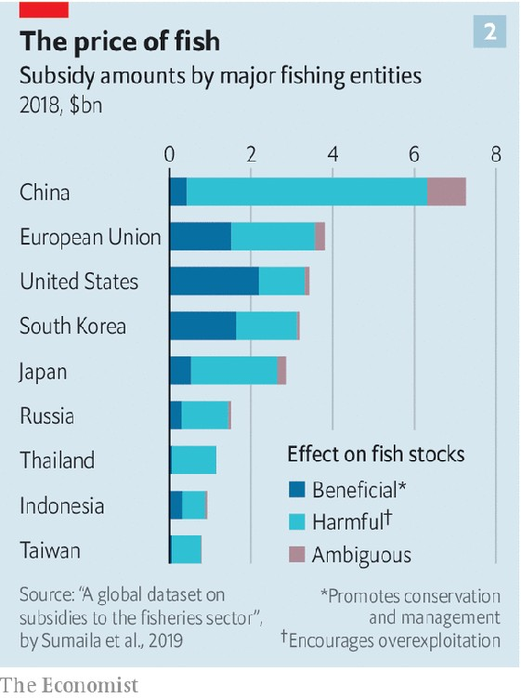

Above all, governments must cut subsidies for fishing fleets, economists suggest. These are by far the biggest factor motivating iffy fishing. Over $35bn of subsidies a year goes to fishing interests around the world (see chart). Much of that is well-intentioned, such as money that helps artisanal fishermen through support for small inshore fisheries. But roughly $22bn a year harms global fish stocks. Most is for fuel.

One of the world’s most environmentally destructive fisheries is bottom-trawling off the coast of west Africa. It turns the seabed into a wasteland. Most of it is done by Chinese operators working under the guise of joint ventures with well-connected locals. It is fuel-intensive. Without diesel subsidies, says National Geographic’s Mr Sala, this fishery would close tomorrow.

Without subsidies, China’s dark fleets in the eastern Pacific and the Indian Ocean would also be gone. Experts reckon that an end to subsidies and to forced labour would render half of all high-seas fishing unprofitable. Less fishing on the high seas would allow stocks of many species to recover. But the benefits go further, says Mr Sala: if just a fraction of the world’s harmful subsidies were diverted to better managing (more productive) coastal fisheries, a huge rebound in inshore stocks could take place, providing better food security and millions of jobs. In talks at the World Trade Organisation on limiting fishing subsidies, the Chinese government has proposed curbing others’ subsidies while protecting its own. But as this year’s furore over dark fleets shows, the cost to its reputation is rising.■

This article was downloaded by calibre from <https://www.economist.com/international/2020/10/24/illegal-fishing-fleets-plunder-the-oceans>

| Section menu | Main menu |

# Business

* Italian business: How the leopard lost its spots
* Technology and competition: Search query
* Utilities: What next
* Bartleby: Fighting spirit
* Schumpeter: Free the data serfs!

| Next | Section menu | Main menu |

Italian business

Italy SpA offers an object lesson in corporate decline

How the leopard lost its spots

Oct 22nd 2020 | MILAN



FEW WORKS of literature capture the challenges of managing decay better than “The Leopard”, Giuseppe Tomasi di Lampedusa’s masterpiece about Sicilian blue bloods struggling to adapt to the changes ushered in by Italian unification in the 1860s. Replace the “shabby minor gentry” with Silicon Valley parvenus and recently impoverished but now monied masses with emerging China, and the novel also serves as an apt metaphor for the decline of once-princely corporate Italy.

“We had the richest and most perfect region of the world but we are old aristocrats who are losing our momentum,” sighs Marco Tronchetti Provera, boss of Pirelli, a 148-year-old tyremaker based in Milan. Many of his fellow chief executives echo di Lampedusa’s Don Fabrizio, who pined for the days when “We were the leopards, the lions.” Like the fictional patriarch, they see the world in upheaval but find themselves unable to do much about it.

Ironically, when di Lampedusa’s novel was published in 1958 Italy was the opposite of decaying. Its GDP doubled between 1951 and 1963, and by 1973 added another two-thirds. Gianni Agnelli, Fiat’s dashing owner, hobnobbed with the Kennedys. The Red Brigades’ campaign of terror launched in 1970 shook business for over a decade but did not cripple it. Olivetti became the world’s second-biggest computer-maker, behind IBM. Montedison was its seventh-largest chemicals firm. Mediobanca rivalled Lehman Brothers and Lazard in merchant-banking prowess. Benetton brought colourful sweaters to the masses; Giorgio Armani, Gianni Versace and Dolce & Gabbana shoulder-padded Wall Street and Beverly Hills.

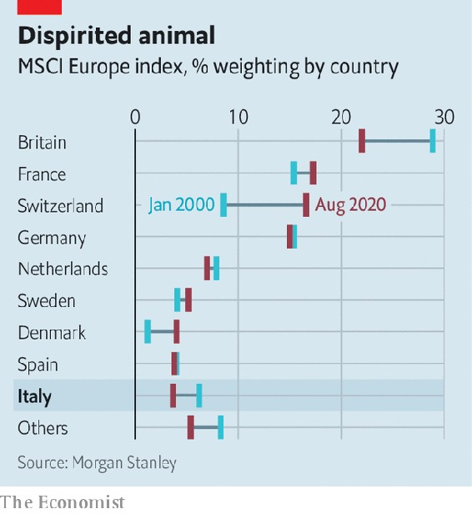

These days Italy SpA is out of style. The country’s doldrums aren’t news; The Economist called it “the real sick man of Europe” 15 years ago. “It escapes no one, and certainly not business,” says Carlo Bonomi, head of Confindustria, Italy’s main business lobby. Even before covid-19, its economy was smaller than it had been before the financial crisis of 2007-09. Its stockmarket is worth under €500bn ($590bn). It accounts for 3.7% of the MSCI index of European stocks, down from 6.2% in 2000, according to Morgan Stanley, a bank (see chart). Only seven Italian firms feature among the world’s 1,000 biggest listed ones. The €77bn market capitalisation of the most valuable, Enel, an electric utility, is a rounding error relative to that of America’s trillion-dollar tech titans.

Rather than confront these challenges, plenty of Italian tycoons have been flogging the family silver. Treasured Italian brands that have gone into foreign hands in the past decade include Bulgari, a jeweller (sold to LVMH, a French luxury group); Luxottica, which makes Ray-Ban shades (and merged with Essilor, a French spectacles firm) and Versace (bought by Michael Kors, an American fashion house). Since 2015 Pirelli’s biggest shareholder has been ChemChina, a state-owned giant. In 2018 Federico Marchetti sold Yoox Net-a-Porter, his online luxury startup and Italy’s rare tech success, to Richemont, a Swiss group.

Others have been departing il bel paese. After merging with Chrysler in 2014 Fiat moved its headquarters to London and legal seat to the Netherlands; it is now combining with PSA Group, a French carmaker. (Exor, the Agnelli family’s Dutch-domiciled investment vehicle which owns 28.9% of Fiat-Chrysler’s shares, is also a shareholder in The Economist’s parent company.) Ferrero, the maker of Nutella, has decamped to Luxembourg. This year Campari, producer of the bitter apéritif owned by the Garavoglia clan, picked the Netherlands. It may be joined by Mediaset, Italy’s biggest private broadcaster controlled by Silvio Berlusconi, a scandal-prone former prime minister, which is seeking to move the headquarters of its holding company there. “I keep less than 5% of my total wealth in Italy. I am very careful with this country,” confessed Francesco Trapani, scion of the Bulgari dynasty, in 2018.

Many other firms are shadows of their former selves. In 20 years the market value of Generali, an insurer, has more than halved, to €19bn. Telecom Italia’s has shrivelled by nearly 90%, to €7bn. Intesa Sanpaolo and UniCredit, two big banks, tried their hand at consolidation with ambitious deals in Europe, only to retrench.

Three main reasons explain corporate Italy’s slide into irrelevance. They have to do with a self-reinforcing lack of financial, social and human capital.

According to the OECD, a club of industrialised countries, 40% of Italian corporate assets are financed by short-term debt, more than among big European peers. Credit is granted on a basis of history, so new firms find it hard to raise money. Political risk—embodied by the rise to power in 2018 of the antibusiness Five Star Movement (M5S)—plays on the nerves. Reliance on banks means that when they get into trouble—as in the financial crisis and the ensuing euro crisis—all their corporate clients suffer, not just the delinquent ones.

All this constrains investment and makes Italian companies more vulnerable to macroeconomic shocks—of which the covid-19 pandemic is the latest. Cerved, a ratings agency, reckons that even in the best case perhaps 7% of non-financial firms are at risk of default this year. In the worst case that could rise above 10%.

Italy’s capital markets are shallow compared with the rest of Europe, let alone America. It has no venture-capital industry to speak of. Business elites grumble about Italians’ aversion to investing in their own stockmarket, despite being among the world’s most prodigious savers. Domenico Siniscalco, a former finance minister, likens it to “an oil producing country without an oil industry”. Investors are wary of putting money into listed firms controlled by founding families or the state, which dominate Italy’s shareholder registers—and which prevent their companies from raising new shares, fearing dilution.

Confidence in big business is further eroded by a constant gusher of scandals. Every few months a business bigwig gets into hot water. In July prosecutors requested an eight-year prison sentence for the boss of Eni, an oil major, for allegedly bribing Nigerian officials to secure an oil block. He and the company deny wrongdoing.

Roman tragedy

Disenchantment with corporate Italy sows more mistrust, depleting its already thin social capital. A recent report found that nine in ten Italians want caps on executive pay, the highest share among seven Western countries. That would add to already baroque red tape that is a barrier for upstart firms. Italy ranks 58th out of 190 countries in the World Bank’s “Doing Business” survey. It comes a dismal 97th on securing building permits, 98th for starting new businesses, 122nd at enforcing contracts and 128th on tax rules.

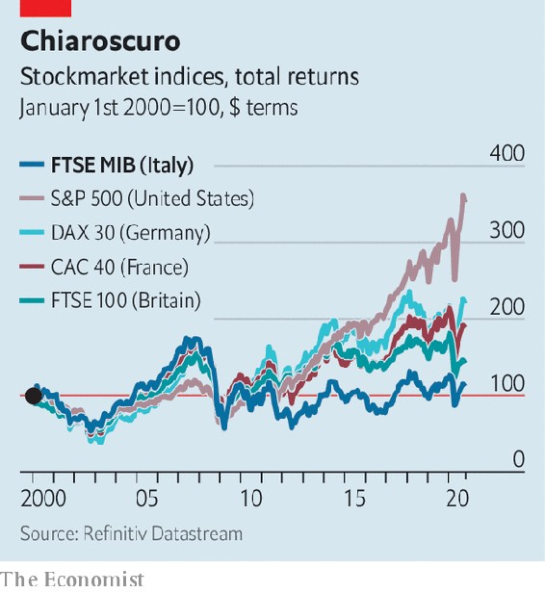

Rather than improving the physical and legal infrastructure that would help all firms, government money goes to bailing out perennial failures. This year the state once again rescued Alitalia, the endlessly loss-making flag-carrier. Italy has no equivalent of the Fraunhofer institutes that help Germany’s medium-sized firms stay at the cutting edge of their fields, observes Fabrizio Barca, an economist and former development minister. “If we had the infrastructure of the Germans we would be six or seven times more competitive,” says Marco Giovannini, boss of Guala Closures, a global leader in the niche market for bottle tops. “We have to compete against inefficiency.” In 2017 he opened Guala’s main research centre not in its Piedmont home but in Luxembourg.

Di Lampedusa’s characters might recognise the third shortage—of human capital—as the flipside of pride. In the post-war era, when it fuelled founders’ devotion to their creations, this was a virtue (as to some extent it is today in Silicon Valley). Now it looks like obstinacy. Bankers talk of multiple failed attempts to persuade Mr Armani to build a bigger group in the mould of LVMH. During Italy’s lockdown a photo of him dressing the windows of his Milan store added to the myth of Italian creative genius. LVMH’s billionaire owner, Bernard Arnault, gets others to do that menial task, so he can focus on business.

In 2017 Guido Corbetta of Bocconi University estimated that half of first-generation Italian firms have an owner-boss who is over 60, and a quarter have one who is at least 70. Italian boardrooms’ denizens seem almost as ancient as the Renaissance art adorning their walls. Italy’s most prominent businessmen—they are almost exclusively male—are octogenarians: Mr Berlusconi (84), Leonardo Del Vecchio of Luxottica (85), Luciano Benetton, the clothing clan’s patriarch (85), Mr Armani (86).

No wonder Italians feel the system is rigged in favour of a few ageing billionaires and plump for populists like the M5S. Talented youngsters shy away from a career in the unloved business world. “There is now little opportunity anywhere in Italy, even for the wealthy and well-connected,” says Andrea Alemanno of Ipsos, a research firm.

Despite this self-perpetuating cycle, examples of Italy’s post-war industrial vigour persist. Enel is a world leader in clean energy. In certain areas “pocket multinationals”, as Vittorio Merloni, an entrepreneur, dubbed them in the 1990s, churn out wares admired the world over: Lavazza and Illy (coffee), Moncler and Ermenegildo Zegna (fashion), IMA and Marchesini (packaging), or Technogym (fitness kit)

And Italy remains a country of enterprise. The OECD reckons nearly a quarter of Italian firms are high-growth, more than in most big European countries. Johann Rupert, the South African financier behind Richemont, has mused that Italy’s craftsmen might benefit from a failure to adapt to globalisation as the world comes to prize their old-fashioned skills. Pirelli’s Mr Tronchetti Provera praises the deal with ChemChina, which let the tyremaker’s headquarters and technology stay in Milan, as “an opportunity to further strengthen our position in China without giving up Italian roots”. Some see Italy’s less hard-edged capitalists as an antidote to Wall Street; last year Jeff Bezos made a pilgrimage to Brunello Cucinelli, founder of a posh-sweater company who advocates a humanistic capitalism.

In 2011, shortly before he became governor of the European Central Bank, Mario Draghi warned fellow Italians that Venice in the 17th century and Amsterdam in the 18th century planted the seeds of their collapse by putting elite privilege ahead of innovation. Corporate Italy can hang on to what is left of its sheen. But, as Don Fabrizio’s thrusting nephew, Tancredi, told his uncle, “If we want things to stay as they are, things will have to change.”■

This article was downloaded by calibre from <https://www.economist.com/business/2020/10/22/italy-spa-offers-an-object-lesson-in-corporate-decline>

| Section menu | Main menu |

| Next | Section menu | Main menu | Previous |

Search query

American trustbusters take on Google

The case against the technology giant is at once narrow and grand

Oct 21st 2020 | NEW YORK

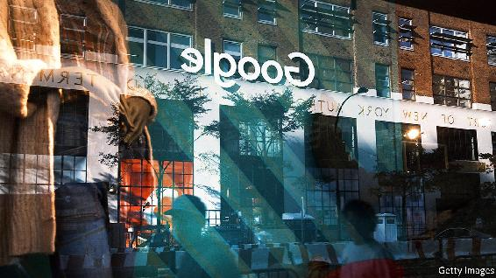

IT WAS A long time coming. On October 20th the Department of Justice (DoJ) at last launched a federal antitrust lawsuit against Google. It is the first time American trustbusters have gone after big tech since their protracted battle against Microsoft 20 years ago. Eleven states signed on to the suit, in which the DoJ accuses the technology giant of abusing its online-search monopoly. Others are likely to bring their own cases against the firm. William Barr, the attorney-general, called it “monumental”. He is both right and wrong.

Google and its parent company, Alphabet, are not the only ones to come under pressure. Amazon, Facebook and Apple (though not Microsoft, which has trodden carefully since its antitrust run-in) have been variously lambasted for enabling election manipulation, violating privacy and abusing their digital monopolies.

In that grand scheme of things, the Google case can seem piffling. It carves out only some alleged misdeeds in one part of the business of a single firm. Specifically, the DoJ’s lawyers accuse Google of an illegal monopoly in “general search services, search advertising, and general search text advertising”. They say that to retard rivals like Microsoft’s Bing search engine, Google uses a web of “exclusionary” contracts with smartphone-makers which, they claim, cover 80% of American search queries on mobile devices. They say Google pays Apple over $8bn a year in advertising revenue to ensure its search engine is the default on Apple devices, and has similar deals with manufacturers using its Android operating system. Google denies wrongdoing.

The sums involved are large but the charges are narrow, argues Mark Shmulik of Bernstein, a research firm. They cover only text search, not images or video. Fiona Scott Morton of Yale University, an antitrust expert critical of Google (and an adviser to Apple), notes that the suit does not tackle allegations that Google abuses its market power in digital advertising or the claims that it handicaps potential rivals in specialised searches such as travel.

The DoJ’s narrow focus may be shrewd. It is harder to prove Google has cornered digital advertising more broadly: it has less than a third of that market, and Facebook on its heels with a quarter. In product-specific search Google has been eclipsed by Amazon. An antitrust expert who supports Google acknowledges that the complaint is “well-crafted” and “is going to have legs”.

If so, it has a lot of walking to do—and could end in an unremarkable settlement, with Google making token changes to its behaviour and paying a fine that looks hefty until you consider its annual net profit of $34bn. By then, technology may have evolved to make the suit appear less relevant, as happened with Microsoft.

Nonetheless, the DoJ’s move does carry a whiff of grandness. It could rejuvenate America’s antitrust apparatus, decrepit after two decades of relaxed enforcement that has let many industries grow concentrated. It may prompt monopolists to curb bad behaviour, unleashing long-suppressed creative destruction. As Mr Barr put it, “If we let Google continue its anticompetitive ways…Americans may never get to benefit from the ‘next Google’.”■

This article was downloaded by calibre from <https://www.economist.com/business/2020/10/21/american-trustbusters-take-on-google>

| Section menu | Main menu |

| Next | Section menu | Main menu | Previous |

What next

Meet NextEra, America’s most valuable energy firm

The clean-energy utility has surpassed ExxonMobil in market capitalisaion—and shows no signs of slowing

Oct 24th 2020 | NEW YORK

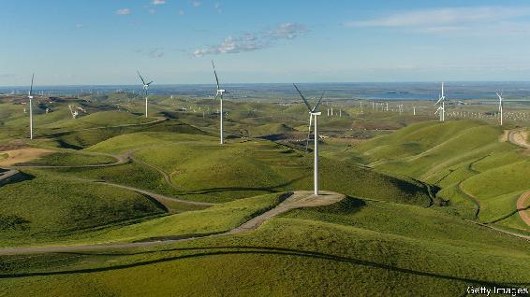

TO MANY INVESTORS, backing an American oil company looks only slightly shrewder than stuffing cash in a blender. Facing covid-19 and old concerns over low returns, the industry is scrambling to boost efficiency. On October 19th ConocoPhillips said it would pay $9.7bn for Concho Resources, a Texan fracking firm. The next day two other frackers, Pioneer Natural Resources and Parsley Energy, announced a $4.5bn tie-up. Across the sector, oilmen are vowing to put profits before growth. How about a firm that offers both?

As America’s oil industry flails, its most valuable utility, NextEra, has soared. It is already the world’s top generator of wind and solar electricity. When NextEra presented its latest quarterly results on October 21st, it said it now has about 15 gigawatts of renewable projects in its pipeline, larger than its entire existing renewables portfolio. Net profit jumped to $1.3bn, up by 13% year on year.

Oil bosses have long dismissed utilities as solid but staid, less energy goliath than grandpa. “We have much higher expectations for the returns on the capital we invest,” Darren Woods, boss of ExxonMobil, proclaimed in 2018. Since then his oil major’s market capitalisation has sunk, by 60%. NextEra’s has soared past it to $147bn. It is now America’s most valuable energy company. And it is not slowing down.

NextEra does not have the global reach of European utilities, with foreign outposts from the Amazon to South Africa. But under the leadership of Jim Robo, it has become a titan. It has two main businesses. Florida Power & Light, a utility that earns a regulated rate of return, serves more than 5m customers in the sunshine state. NextEra Energy Resources builds and operates energy projects—mostly wind farms, but also solar and nuclear, as well as gas pipelines and transmission lines. In 2020 neither business seems revolutionary. But NextEra set winning strategies early and pursued them well, argues Michael Weinstein of Credit Suisse, a bank.

Florida Power & Light, for instance, was among the first to replace coal-fired power plants with gas, benefiting from cheap supply from America’s fracking boom. The company improved reliability by being an early adopter of machine learning, notes Vivek Wadhwa, who has advised the company and features NextEra in a new book on innovation. The utility is growing healthily—earnings jumped by 11% in the third quarter—and customers’ bills have remained relatively low.

But it is large-scale renewables that are NextEra’s forte. It was quick to take advantage of generous tax credits to build wind farms across the Midwest. When Mr Robo became its president in 2006, it was already America’s top producer of wind power. And it bet that renewables would grow as costs fell while those of coal-fired power stayed flat. The unsubsidised cost of wind and solar farms (spread over their lifetime) has fallen by about 70% and 90%, respectively, since 2009. Green-minded voters have pushed things along. More than half of American states now mandate that a share of their electricity comes from renewables. The logic for replacing old coal plants with renewables that run on costless inputs—wind and sun—looks obvious.

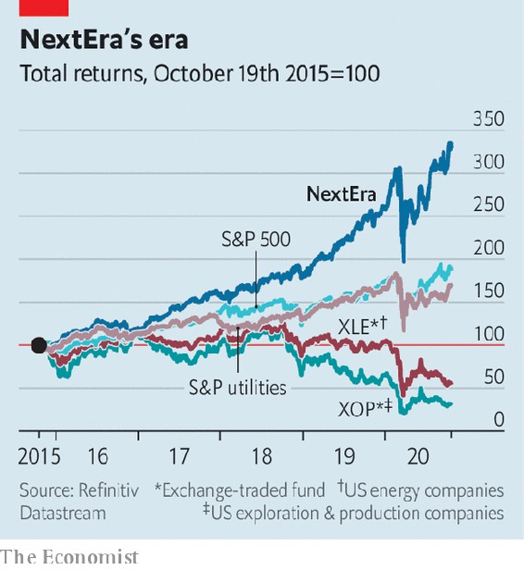

Investors agree. NextEra has outperformed not just other utilities and oil firms but the stockmarket as a whole. Total shareholder returns over the past three years have declined by 47% for an index of American energy companies, and 52% for ExxonMobil. NextEra’s have jumped by 112%, more than the broad S&P 500 index (see chart). Credit-rating agencies like the stability provided by Florida Power & Light. NextEra Energy Resources has used its expertise to make competitive bids for contracts, and its scale to lower costs, explains Stephen Byrd of Morgan Stanley, a bank. Sometimes NextEra sells assets to a company in which it has a stake and which uses power projects’ cashflows to pay reliable dividends.

Other utilities have cottoned on. Mr Byrd points out that Xcel Energy, a midwestern utility that is one of NextEra’s biggest customers, is now building its own wind farms. But NextEra’s size and know-how give it an edge.

It may grow further through acquisition. In 2019 it completed the purchase of Gulf Power, another Floridian utility. It is rumoured to be eyeing Duke, a regulated utility in North Carolina. “There is not a utility in the country that we couldn’t run more efficiently and better for customers,” Mr Robo declared in July.

NextEra will also keep investing in generation and grids—this month it raised planned capital spending to $60bn between 2019 and 2022. In the second quarter capital expenditure exceeded that of all but nine American firms. In the energy industry only ExxonMobil spent more. Projects include big solar farms and underground power lines in Florida to make the grid more resilient to storms.

NextEra has already bought or leased many of America’s most attractive remaining sites for wind and solar energy, says Mr Weinstein. As the grid becomes more reliant on intermittent renewables, demand will rise for batteries. With trademark foresight, NextEra is investing in those, too. ■

For more coverage of climate change, register for The Climate Issue, our fortnightly [newsletter](https://www.economist.com/theclimateissue/), or visit our [climate-change hub](https://www.economist.com/news/2020/04/24/the-economists-coverage-of-climate-change)

This article was downloaded by calibre from <https://www.economist.com/business/2020/10/24/meet-nextera-americas-most-valuable-energy-firm>

| Section menu | Main menu |

| Next | Section menu | Main menu | Previous |

Bartleby

What the armed forces can teach business

Fighting spirit

Oct 24th 2020 |



WHEN CAPTAIN Gareth Tennant was patrolling with the Royal Marines in the Gulf of Aden in 2010, his team intercepted some Somali pirates on two skiffs. The pirates’ weapons were confiscated and the marines waited for clearance to release their prisoners. The plan was to tow the ne’er-do-wells back to Somali waters. But the pirates misread the troops’ intentions, and thought they were about to be abandoned at sea; a few jumped into the water while the rest attacked Mr Tennant’s team.

For a brief period, there was chaos. Mr Tennant was unable to give any orders. But his team acted anyway. One boat rescued the Somalis who had jumped into the water; another came alongside to offer support in ending the fight.

His team acted that way, Mr Tennant argues, because they were used to working with each other and they had war-gamed what might go wrong. In contrast, the pirates were suffering from fear, stress and fatigue, and acted on gut instinct. “If you haven’t gone through the decision-making process in advance, then gut instinct tends to kick in,” Mr Tennant says.

Now Mr Tennant is back in civilian life, acting as an adviser to the Future Strategy Club, an association of consultants. And he believes the habits learned in the Royal Marines can be useful for business life.

Given the long history of blunders in warfare (such as friendly-fire incidents), it may seem odd to turn to the armed forces for tips on efficiency. It is an old joke that “military intelligence” is an oxymoron. But many a corporate titan has sought wisdom in the philosophies of strategists like Sun Tzu and Carl von Clausewitz. And military expertise in emergencies was exploited by the British government to help build “Nightingale hospitals” early in the covid-19 pandemic, just as the armed forces had been used to counter Ebola in west Africa in 2014.

Soldiers regularly have to deal with the four forces dubbed VUCA (volatility, uncertainty, complexity and ambiguity). In particular, Mr Tennant cites the concept of mission command which developed during the Napoleonic wars. Armies found that, by the time messages had arrived at the front, the military situation had changed. The lesson was to establish what the army was trying to achieve before the battle and allow junior commanders to use their initiative and take decisions as the situation demanded.

The ideal command structure is not a rigid hierarchy, he argues, but a sphere, where the core sets the culture and the parts of the organisation at the edge are free to react to events outside them. In effect, the contrast is between centralised command and decentralised execution.

Business has been hit by two huge events this century: the financial crisis of 2007-09 and now the pandemic. These showed the extreme importance of resilience—and of preparation. The organisations that are dealing with the pandemic best are those which were already prepared for the unexpected, he says. The key lesson, Mr Tennant argues, was not having stocks of hand-sanitiser and plastic sheeting but knowing how to manage large changes in society and shifts in supply chains. It also requires training for the type of situations that managers may face.

Mr Tennant argues that in recent years companies have become overenamoured with predictive analytics, trying to make precise forecasts about the direction of markets. Instead, they should get involved in war-gaming, where they can discuss ideas that push the boundaries of what is possible. “The more we think about hypotheticals, the less space there is for unknown unknowns,” he says, echoing that well-known American strategist (and ex-defence secretary), Donald Rumsfeld. Corporate executives know their own business really well. But when the environment changes, experience counts for less. The answer is to apply a test and adjust the process, in a feedback cycle.

When a crisis happens, bosses display a tendency to hold on tight and take control. But that is losing the benefit of the diversity of the organisation, Mr Tennant thinks. Companies need those at the sharp end of the business to be adaptive and responsive. Senior managers need to relinquish authority and allow juniors to make decisions. In a crisis, companies which have invested in building up leaders at the lowest ranks of the organisation are more likely to prosper. In business, as in conflict, it isn’t the generals who carry the burden of the war; it’s the troops.

This article was downloaded by calibre from <https://www.economist.com/business/2020/10/24/what-the-armed-forces-can-teach-business>

| Section menu | Main menu |

| Next | Section menu | Main menu | Previous |

Schumpeter

Who owns the web’s data?

The fightback against Big Tech’s feudal lords has begun

Oct 22nd 2020 |

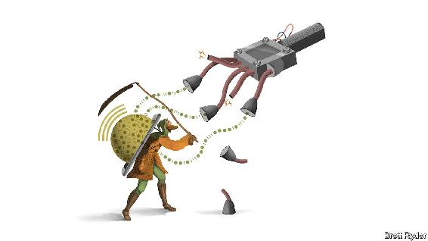

SIR TIM BERNERS-LEE had a Romantic vision when he created the World Wide Web in 1989. In his words, he helped “weave” it together as a way of connecting anything to anything—as if he were sitting at a loom, not at CERN, a particle-physics laboratory in Geneva. But those were halcyon days. Now the web risks falling into what he has called a dystopia of prejudice, hate and disinformation. People around him talk of “digital feudalism” to describe the control big technology platforms have over data. As a result, Sir Tim has co-founded a startup, Inrupt, that aims to shift the balance of power. It is one of many incipient efforts aimed at putting data back into the hands of the people.

It sounds quixotic. The use of data, after all, is now the world’s biggest business. Some $1.4trn of the combined $1.9trn market value of Alphabet (the owner of Google) and Facebook, comes from users’ data and the firms’ mining of it, after stripping out the value of their cash, physical and intangible assets, and accumulated research and development. They are not sated yet. Around the world, sensors on everything from cars to kitchens are expected to churn out exponentially more personal information as the “Internet of Things” expands. The tech giants have their beady eyes on it.

Their relentless appetite for data is a mounting concern for policymakers in two ways. The first is political. The platforms’ business models depend on network effects and scale to keep users engaged and to sell more advertising. The result is a culture of virality that, while entertaining, poisons public discourse and disquiets governments. The second is economic. The bigger the tech firms are, the harder it is for potential rivals to overcome their data advantage, which suppresses innovation. Viktor Mayer-Schönberger of Oxford University notes that access to capital is no longer the biggest problem for startups. It is access to data.

So trustbusters are on the warpath. The Department of Justice lawsuit in America against Google, filed on October 20th, accuses the company of using contracts with device-makers, such as Apple, to block other search engines. Google denies this, saying people use its services because they choose to, not because they have to. Whatever the merits of the case, for some the only remedy is to break up the tech giants. That is simplistic. The problems will not be solved just by cutting big tech down to size. Any solution must make data more evenly accessible so that potential rivals can grow.

This can be done in several ways. One is to empower individuals. Another is to consider collective action. A third is to rely on governments. All three will need to reinforce each other to have a chance of success.

Start with the individual. It is seductive to argue that each person should have ownership rights over their data. Yet unless laws change radically, in practice it is hard to wrest control back from the tech platforms, because an individual’s bargaining power is woefully weak. Fortunately, other options are surfacing.

One is a subscription model, along the lines of Netflix or Spotify. MeWe, an “anti-Facebook” social network (with Sir Tim on its board), spares its users bombardments of advertisements and targeted news, and charges fees instead. Another option is to start gathering data on behalf of the individual from all sorts of sources. Inrupt, for instance, is working with the government of Flanders, a region of Belgium, to give every citizen a “pod” to store personal data. It hopes private firms will build user-friendly apps around the data, with people’s consent, says John Bruce, its co-founder. The better the apps, the more eager people will be to furnish it with their data. In India something similar is happening in financial services. Individuals’ and firms’ financial data can be transferred to financial-services firms via “account aggregators” that obtain the owners’ consent. This can help speed up credit-scoring and loan underwriting. It could also be an alternative to huge data guzzlers such as Ant Financial, a Chinese fintech firm.

A second way to strengthen the power of those who provide data is by collective action—particularly important when so much value on the web comes not from individuals’ data but from their interactions with others. Glen Weyl, an economist at Microsoft, a software colossus, proposes “unions” that bargain on behalf of groups of people for a share of the income generated from the use of their data. The aim, says Mr Weyl, is not to destroy the platforms, just as labour unions do not want to shut down factories. Andrew Yang, a former American presidential hopeful, has proposed a “digital dividend” to individuals via collective bargaining.

These efforts, however valiant, are in their infancy. They may not amount to anything unless governments, too, weigh in—as they have done with the European Union’s General Data Protection Regulation, and the California Consumer Privacy Act. Though the chief aim of both is privacy, they have dramatically bolstered individuals’ rights over their own data. The European Commission, the EU’s executive arm, long more interventionist than America on tech regulation, plans to go a step further, proposing a Data Act in 2021 that will seek to wrench open the bloc’s public and private data vaults. As with the American government, the EU continues to threaten the cudgel of antitrust law against the tech giants.

Domesday

Silicon Valley says it has got the message. This year Facebook offered to pay users for recordings of their own voice, to improve speech recognition. The tech firms are making it easier for users to shift photo files to other platforms. But they are token moves. Switching platforms remains fiendishly hard. Scale and virality are so vital to their business models that they lobby fiercely against regulation. They reassure themselves that most consumers continue to support the exchange of data for free stuff. Yet they must be aware that access to data is becoming one of the philosophical issues of the age. Feudalism eventually gave way to greater property rights. One day data serfdom will go the same way, too.■

This article was downloaded by calibre from <https://www.economist.com/business/2020/10/22/who-owns-the-webs-data>

| Section menu | Main menu |

# Finance & economics

* Millennials and finance: The generation game
* The World Trade Organisation: The home straight
* Lael Brainard: Top contender
* Emerging markets: The rule-makers
* Price gouging: Disaster profiteering
* Buttonwood: A new career in a new town
* Free exchange: Graduates of the world, unite!
* We’re hiring: Wanted: a new writer to cover finance

| Next | Section menu | Main menu |

The generation game

Wall Street will soon have to take millennial investors seriously

There is more to young investors than Robinhood and TikTok

Oct 20th 2020 |

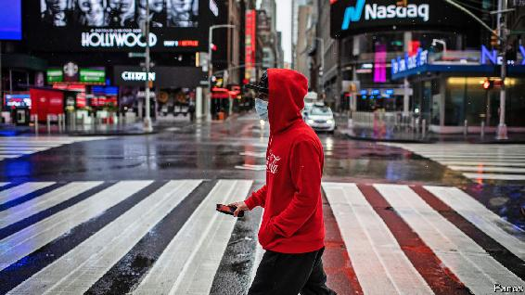

THINK OF A millennial investor, and you might picture someone like Vincent Iantomasi, one of a legion of amateur traders dishing out investment advice on TikTok, a social-media app. With “Blueberry Faygo” by Lil Mosey, an 18-year-old rapper, playing softly in the background, Mr Iantomasi tells investors looking for racy returns to pile into SPXL, a leveraged exchange-traded fund. Or you might think of users of “r/wallstreetbets”, a forum on Reddit, another social-media site, who post “loss porn”: screenshots of their accounts on Robinhood, an investing app, after betting their life savings on short-dated derivative shares in Tesla, an electric-car maker.

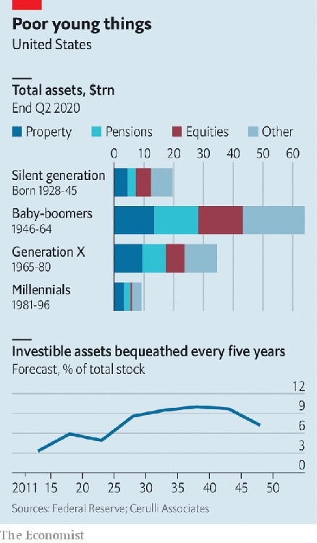

Young investors have become infamous during the pandemic. As markets have rocketed, budding punters have engaged in a frenzy of day-trading on their phones. Look past the notoriety, though, and a profound shift in the ownership of investment assets looms. Millennials, typically defined as those born between 1981 and 1996, still hold a tiny share of total wealth (see chart). In America they own $9.1trn in assets, just 7% of the total, well below the 26% held by baby-boomers when they were of a similar age. But savings and inheritance windfalls mean that millennials’ share will rise rapidly. And shifts in technology and pension policies will allow them to exert more control over their assets than their parents did. The implications for investment firms and markets are already becoming apparent.

The young acquire wealth by inheriting or earning it. Already more than a third of America’s labour force is millennial and they have been the largest cohort since 2016 (even though some are still in education). Bank of America Merrill Lynch reckons that, worldwide, their earning power will rise by nearly three-quarters in 2015-30 as more start work and others gain seniority.

Inheritance flows are set to speed up. The population structure in most rich countries bulges outwards for the baby-boomer generation and then again for their children, many of whom are millennials. Every five years $1.3trn in investible assets, or 5% of the stock, passes down the generations in America. The pace of the wealth transfer will probably double by 2036-40 as boomers die. According to Cerulli Associates, a research firm, millennials will inherit $22trn by 2042.

It is a mistake to assume that millennials will invest as their parents did. Two forces will lead them to seek more control over their assets: changes to pensions, and advances in technology. Consider pensions first. In the 1970s most schemes were “defined-benefit” (DB). Beneficiaries were paid a fixed income based on their final salary and had no say in how their pots were invested. Then in 1978 the Revenue Act created the 401(k) plan in America—a “defined-contribution” scheme where savers have more control over where their cash goes. Assets held in such pensions have exceeded those in DB schemes since 1995. Where investment firms used to compete to win the mandate for a company’s pension pot, today they are likely to be one of many managers that staff can choose from.

Even as they gain more control over workplace pensions, millennials are using technology to invest in shares and bonds directly. When most boomers began saving a handful of investment firms loomed large, offering high-fee mutual funds. But electronic trading makes it much easier and cheaper to buy and sell directly. The cost of investing $100 on a stock exchange has fallen from $6 in 1975 to less than a thousandth of a penny today. In 2019 the four big retail-trading platforms—Charles Schwab, E*Trade, Fidelity and TD Ameritrade—cut commissions to zero as Robinhood, a pioneer of the zero-commission model, gained popularity. A generation reared on smartphones is as likely to trust an app as a well-heeled broker.

Fintech firms are working to capitalise on the coming windfall. Robinhood may have attracted the headlines, but millennials are just as keen to use other digital services. One example is “robo-advisers”, which automatically allocate invested assets across low-cost index funds based on age and risk-preferences for a low fee. According to BlackRock, an asset manager, four in five millennials who are aware of these advisers are keen to use them. As much cash—perhaps $40bn combined—is parked in Betterment and Wealthfront, two robo-advisory startups, as in Robinhood. Though Betterment has some older clients, the average customer is 35, says Jon Stein, its founder. Robinhood does not disclose the amount of cash held on its platform, but JMP Securities, a research firm, estimates that the average account holds $1,000-5,000. This would put total assets across its 13m accounts at $13bn-65bn.

Some incumbents are trying to catch up. In 2019 Morgan Stanley bought Solium, which manages vesting stock options for tech workers, in the hope that they will one day be rich clients. Others are gloomier. Most wealth managers surveyed by Accenture, a consultancy, expect to lose a third of their customers’ wealth at the point of succession. When the reaper comes for their clients, their business will go with them.

What goals will millennials pursue? Some 87% of them believe corporate success should be measured by more than financial performance, according to Deloitte, another consultancy. They also seem to act on that impulse. Morgan Stanley finds that the under-35s are twice as likely as others to sell a holding if they consider a company’s behaviour to be environmentally or socially unsustainable. Of course, millennials may become more hard-nosed as children and mortgages come along. Then again, having lived through two economic crises in a decade or so, they may want to shake up shareholder capitalism. The butt of jokes in 2020, millennial investors will eventually change how asset management works—and perhaps the economy, too. ■

This article was downloaded by calibre from <https://www.economist.com/finance-and-economics/2020/10/20/wall-street-will-soon-have-to-take-millennial-investors-seriously>

| Section menu | Main menu |

| Next | Section menu | Main menu | Previous |

The home straight

Ngozi Okonjo-Iweala is the favourite to lead the WTO

The leadership race tells you something about thorny trade issues

Oct 22nd 2020 | WASHINGTON, DC

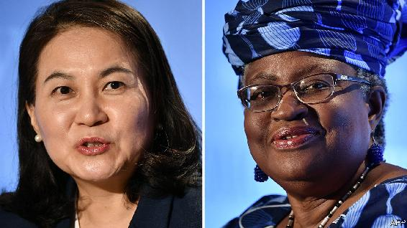

MEMBERS OF THE World Trade Organisation (WTO) are not known for co-operating with each other. So when in June they began the process of choosing a new director-general, many feared deadlock. But now, as the process draws to a close, officials are feeling hopeful. Two candidates are still in the running: Nigeria’s Ngozi Okonjo-Iweala, the chairwoman of GAVI, a vaccine-finance agency, and a former World Bank official and finance minister; and Yoo Myung-hee, South Korea’s trade minister. A winner is due to be announced between October 28th and November 7th, and support seems to be coalescing around Ms Okonjo-Iweala. Yet the contest says more about the discord in the trading system than the harmony.

The candidates themselves did a good job of highlighting various divisions in the course of the selection process (while dutifully noting that only members have the power to resolve them). Between them they identified a long list of problems: jammed negotiations that have left the WTO’s rule book out of date; a broken system of solving disputes; members’ lacklustre commitment to transparency; and a trade war between America and China.

Disagreements between members also explain the candidates’ rather limited ambitions. A bold agenda might include a grand bargain on agriculture that lowers tariffs in poor countries and limits subsidies in rich ones. Ms Myung-hee is a seasoned negotiator and not one to shy away from tricky talks. Even so, rather than shooting for a big deal, she now reckons that restoring the WTO’s credibility as a negotiating forum means just agreeing on something. She would prioritise ongoing talks to curb members’ fishing subsidies. (Even that narrower deal will be a stretch, given that negotiators do not yet agree on what counts as fish.)

Ms Okonjo-Iweala has emphasised her experience fighting covid-19 as her strong suit. As head of GAVI she understands the importance of open trade so that vital supplies can get to where they are needed. But this too is a thorny topic. Rich countries are more interested in lowering others’ tariffs than limiting their own right to apply export controls. They also hate a recent proposal from India and South Africa to suspend intellectual-property protection for products that could prevent, contain or treat the disease. So instead Ms Okonjo-Iweala has spoken only vaguely of exploring new trade rules and intellectual-property and licensing rights for drugmaking.

If she wins, Ms Okonjo-Iweala has also promised to empower the WTO’s secretariat. That could be controversial—some members will resist what they see as a threat to their power over negotiations. But it could also help poorer countries, some of which lack the capacity to draft proposals on their own, making it hard to participate in talks. Her political clout will be useful too. If the problems of the global trading system were purely technical, “they would have been solved long ago”, she told members in July.

But Ms Okonjo-Iweala’s success would also say something about the geopolitics of trade. China could reject Ms Myung-hee if that allows it to keep its deputy-director-general spot. (Historically, jobs have been divvied up among regions.) Japan’s nasty trade dispute with South Korea makes it unlikely to support Ms Myung-hee. Brazil, a big exporter of farm products, may be put off by South Korea’s membership of the G10 group of countries, which staunchly defends agricultural subsidies. The agreement on the next director-general could be born from a host of disagreements. ■

This article was downloaded by calibre from <https://www.economist.com/finance-and-economics/2020/10/22/ngozi-okonjo-iweala-is-the-favourite-to-lead-the-wto>

| Section menu | Main menu |

| Next | Section menu | Main menu | Previous |

Top contender

The front-runner for Joe Biden’s Treasury boss has a mighty CV

Lael Brainard, a Fed official, has worked for two presidents

Oct 24th 2020 |

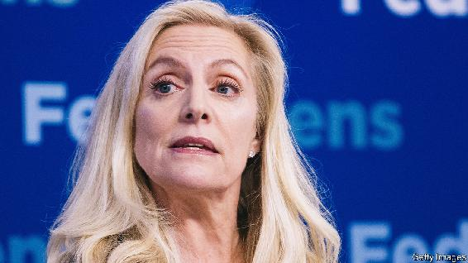

IN EARLY 2009, faced with an economic crisis and a host of jobs to fill, Barack Obama, the newly inaugurated president, went hunting for talent. For the role of the Treasury department’s top diplomat he chose a capable economist named Lael Brainard, who had also worked in Bill Clinton’s administration. Ms Brainard later moved from the Treasury’s stately headquarters next to the White House to the Federal Reserve, where she has been on its Board of Governors since 2014. Should Joe Biden defeat President Donald Trump on November 3rd, she may well make a return journey, this time to occupy the grander office of the treasury secretary.

If Mr Biden wins his choice of team will be watched closely for clues as to how he might govern. His party’s left wing remains sceptical of his commitment to the sort of progressive reforms championed by Bernie Sanders and Elizabeth Warren, his challengers during the primaries. Conservatives and business leaders, on the other hand, are bracing themselves for higher taxes and stiffer regulations. Ms Brainard’s appointment to the Treasury could help neutralise the worst fears of each.

A consummate technocrat, Ms Brainard was born in Hamburg, during her father’s foreign-service posting to communist East Germany and Poland. After completing a PhD in economics at Harvard University, she spent time with McKinsey, a consultancy, and as a professor at the Massachusetts Institute of Technology. Between spells in government she was a fellow at the Brookings Institution, a think-tank in Washington.

Her stints in government earned Ms Brainard a reputation for competence and toughness. She led America’s engagement with Europe during the euro-area crisis. Though the zone’s leaders sometimes bristled at advice from Uncle Sam—whose own missteps had so recently plunged the world into financial crisis—they gained respect for Ms Brainard’s calm but firm presence. Her familiarity with the continent, and fluent German, may have helped.

She is no populist; the Democratic left would prefer a treasury secretary with more anti-corporate credentials, like Ms Warren, also thought to be a contender for the role. But Ms Brainard has shown a willingness to buck Wall Street. At the Fed she repeatedly voted against measures to ease regulatory restrictions on financial institutions. In 2019 she was the lone member of its Board of Governors to support activating the countercyclical capital buffer, which forces banks to increase capital ratios during economic booms, to temper risky lending that might fuel financial instability. Earlier this year Ms Brainard objected to a measure to cap banks’ dividend payments (intended to nudge them to preserve capital), arguing instead for payments to be suspended entirely.

Ms Brainard has not dissented on interest-rate policy. In 2015-18 she voted to raise rates, alongside the majority. But in early 2016 she urged the Fed to move slowly, warning that rate increases would tighten global financial conditions, the growth-suppressing effects of which could spill back to the American economy. The argument proved prescient, as both global and American economic growth slowed in 2016, encouraging ratesetters to support a slower pace of rate rises. More recently she has been an advocate of the Fed’s move towards a more flexible inflation target and a greater emphasis on full employment.

Progressives look askance at parts of Ms Brainard’s record. When in the Clinton administration, she helped implement the North American Free Trade Agreement, and supported China’s accession to the World Trade Organisation; Mr Obama’s Treasury repeatedly refused to label China a currency manipulator. Yet both Democratic politics and economic orthodoxy have since moved leftward, and perhaps Ms Brainard with it. She would probably be far more open to deficit spending than past secretaries, including Tim Geithner, who ran the department during Mr Obama’s first term. Disputes with Europe over trade and technology may be put to rest. The demands of the moment are such that Ms Brainard’s Treasury could mark a progressive departure from the norm. ■

Dig deeper:  
Read the [best of our 2020 campaign coverage](https://www.economist.com/us-election-2020) and explore our [election forecasts](https://projects.economist.com/us-2020-forecast/president), then sign up for Checks and Balance, our [weekly newsletter](https://www.economist.com/checksandbalance/) and [podcast](https://play.acast.com/podcasts/2020/01/24/checks-and-balance-our-new-weekly-podcast-on-american-politics) on American politics.

This article was downloaded by calibre from <https://www.economist.com/finance-and-economics/2020/10/24/the-front-runner-for-joe-bidens-treasury-boss-has-a-mighty-cv>

| Section menu | Main menu |

| Next | Section menu | Main menu | Previous |

The rule-makers

Who decides what counts as an emerging market?

A glimpse into the mysterious world of benchmark providers

Oct 22nd 2020 |

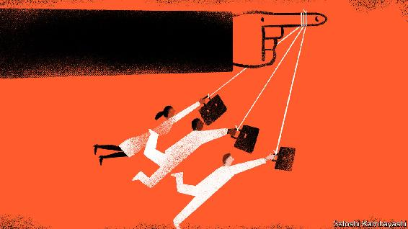

WHAT DOES Saudi Arabia, with an income per head of $23,000, lavish public services and oodles of oil, have in common with Zambia, where incomes are 94% lower and the government is on the brink of default? Not much, on the face of it. But the two countries are lumped together, along with 71 others, in JPMorgan Chase’s definition of “emerging markets”.

Index providers build the gauges that passive funds track and active managers use as a yardstick. Those, like JPMorgan, that construct emerging-market-bond benchmarks are especially powerful. They wield influence over an asset class that amounts to $30trn, about a quarter of global fixed income. For borrowers, benchmark inclusion opens the door to foreign capital. The inclusion of onshore Chinese debt in three big benchmarks this year and next, for instance, is expected to draw in $450bn of foreign money. For investors, index changes can force them to overhaul their portfolios by selling holdings to make way for new debt. “Indices are almost tyrannical in their influence,” says Jan Dehn of Ashmore Group, a fund manager.

The main providers include Bloomberg, FTSE Russell and JPMorgan. The first two construct global bond indices that include emerging markets. JPMorgan dominates the market for dedicated emerging-market-debt investors; some $780bn tracks its set of benchmarks, launched in the 1990s. It is one of the few banks to still be in the business. Morgan Stanley, another bank, offloaded MSCI, its index unit, over a decade ago. Others, including Bank of America, Barclays and Citigroup, have also sold theirs; the industry has been trying to reduce regulatory risk after the rate-rigging scandal surrounding the London Interbank Offered Rate (LIBOR).

Classifying a country as an emerging market requires a great deal of subjectivity—more, say, than is needed to work out what companies should be included in a country’s benchmark equity index. In order to be representative and predictable, providers publish chunky rule books to help investors understand which bonds might be added or ejected. They also solicit views from investors to find out which bonds are liquid, accessible or otherwise fit enough for inclusion. Still, the rules can sometimes be applied in seemingly arbitrary ways. To see this, consider recent big adjustments to JPMorgan’s benchmarks, which have left investors scrambling to rebalance their portfolios.

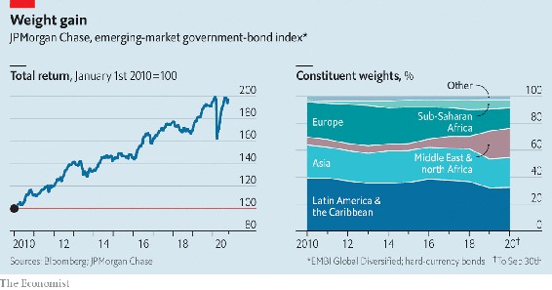

In 2019 the bank added Gulf countries to its hard-currency government-bond index, after the oil-price crash of 2014 led to a rush of issuance. Places like Saudi Arabia and Qatar had been too rich to qualify, but the bank tweaked its rules to include them. It also slashed the weight on defaulted Venezuelan government bonds to 0% last year, instead of removing them altogether. That unprecedented move spared some bondholders from having to offload the debt, which is under American sanctions.

In February this year JPMorgan began adding a selection of debt issued by China’s government and its policy banks to its local-bond benchmark. As China will eventually make up 10% of the bank’s main benchmark, it will be risky for investors to stay uninvested. But some say the decision was rushed. They cite a long list of operational issues in trading the debt, including low liquidity and complications in settling transactions. Last month FTSE Russell said it would also include local Chinese bonds in its government-bond index from October 2021—contingent on reforms making it easier for foreigners to trade the debt.

JPMorgan’s clients include both issuers and investors, potentially posing conflicts. Other parts of the bank have dealings in emerging markets. (JPMorgan says it has Chinese walls in place to separate its businesses.) It won valuable deals to raise funds for Saudi Arabia’s mammoth oil firm, Aramco, months after the index group said the government’s debt was going into its benchmarks. The bank also has other interests in China’s bond market. It underwrites government bonds and is an official marketmaker on Bond Connect, a trading platform that allows foreigners to invest through Hong Kong.

Another concern is that some clients are listened to more than others. “It’s hard to avoid the impression that the index providers are responsive to the needs or the desires of their bigger clients,” says Paul McNamara at GAM, an investment manager. Bloomberg and FTSE Russell arrange roundtables for groups of clients on a regular basis. Some investors aren’t shy about giving providers their view. Hayden Briscoe of UBS Asset Management recalls pressing the man in charge of one of the popular bond indices to include Chinese debt three years ago. “The quicker you get the bonds into the index, the quicker you become a rock star,” he advised.

JPMorgan dismantled its advisory committees in 2015 in favour of individual conversations, in order to reach a wider group of investors. It says it strives to keep the playing field level, so nobody gets an early whiff of plans and front-runs the market. Still, small fund managers suspect their larger rivals have the index team’s ear and lobby for assets they own to be included.

Yet miffed investors cannot easily move away from established indices. The barriers to entry are high. Building a benchmark involves spending a lot of money on marketing to build a trusted brand; there is little sign of new entrants yet. A network effect encourages fund managers to use the same yardstick so that clients can compare performance. Switching indices involves heaps of paperwork to inform clients. As a result, even though JPMorgan has produced an ex-China version of its main gauge, interest has been low. Investors will be rule-takers for some time yet. ■

This article was downloaded by calibre from <https://www.economist.com/finance-and-economics/2020/10/22/who-decides-what-counts-as-an-emerging-market>

| Section menu | Main menu |

| Next | Section menu | Main menu | Previous |

Disaster profiteering

Price gouging: a cautionary tale

New York City’s new rules show the difficulties of regulating prices

Oct 22nd 2020 |

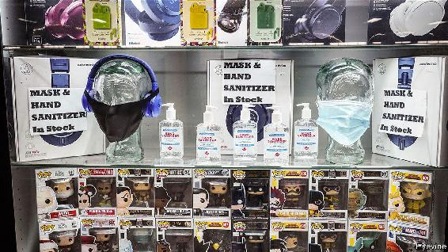

UNSCRUPULOUS TRADERS use a crisis to charge exorbitant prices. Politicians, wanting to protect consumers, crack down on profiteers. But how to work out what price is too high, and what redress is appropriate? The story of your correspondent’s local corner shop offers a cautionary tale.

This type of shop was once familiar in New York, but has largely been squeezed out by chains and bank branches. The owner is an immigrant who opens early and closes late. In crises the shop stocks the products that customers need. When flooding from Hurricane Sandy caused a blackout in 2012, it sold batteries, torches, candles and board games. During the pandemic it has been piled high with boxes of sanitiser, bleach, masks and gloves.

Stocking up comes with risks. Acquiring inventory is costly. Demand drops off when normality returns—unwanted board games linger in the back of the shop. And this time, the rules changed. In March a woman bought a box of masks (each mask costing $2), and then said she was from the city’s office of consumer affairs, and charged the shopkeeper for violating new price-gouging rules. Two days later, says the shopkeeper, another inspector charged the shop again, this time offering guidance on the right prices. Masks should cost no more than $1; gloves selling at $19.95 should sell for only $14.95. Each package marked above the permitted price would be fined $500. There were many packages.

Most economists oppose restrictions on price gouging not because they like fat profits, but because higher prices lead to more supply. Indeed, in many places sanitiser and face-masks are now ubiquitous and cheap. Then there is the tricky question of what counts as price gouging—in a pandemic. New York City banned price rises of more than 10% from pre-pandemic levels. But what if the shop had not sold the items before? And why 10%? Price increases “in excess of an amount reflecting normal market fluctuations” were banned. But what, in March, was normal?

In response to a summons, the shopkeeper went twice to court, enduring the security check and the queues, only to find that, because of covid-19, it was not in session. The first time, a guard explained that the summons had been mistakenly sent by computer. Another defendant in a different case said that she had tried calling several times to ask if the court was sitting, but had not got through. (She would have been presumed guilty had she not shown up.)

Shortly before a rescheduled hearing, the shop’s proprietor received an offer to settle the first charge for a little over $7,000. That is much more than his monthly profit, he says from behind the plastic screen now distancing him from customers, looking glumly at a stack of legal papers on his counter. But the fines would be ruinous.

New York City’s consumer-protection agency says it has issued more than 14,600 citations. The shopkeeper will settle, but worries that he may have to pay again for the second charge. Justice in the Big Apple has been opaque and costly—and raises the question of who precisely is being gouged.

This article was downloaded by calibre from <https://www.economist.com/finance-and-economics/2020/10/22/price-gouging-a-cautionary-tale>

| Section menu | Main menu |

| Next | Section menu | Main menu | Previous |

A new career in a new town

How Berlin has become a centre for European venture capital

Once edgy, the tech scene is in danger of going mainstream

Oct 22nd 2020 |

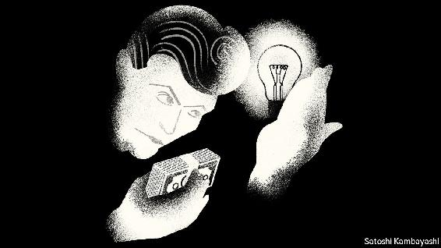

FOR BRITS of a certain age and inclination, Berlin is a city that is forever linked with David Bowie. When he lived there in the late 1970s, Bowie’s life was in flux. He was estranged from his wife, splitting from his management and trying to slough off rock-star excess. Berlin was similarly unsettled: a refuge for artists, misfits and draft-dodgers on the front line of the Cold War. Bowie lived anonymously above a car-parts store. He did some of his best work there.

The block of flats where Bowie lived with Iggy Pop, another celebrated rock star, still stands. Berlin remains an edgy, in-between sort of place—it is Germany’s capital, but is not quite German. And it remains a place where people go to try something new. It now vies with London and Paris as Europe’s leading hub for technology startups.

That seemed unlikely a decade ago. Berlin had no real industrial base. Its early venture-backed successes were often knock-offs of American e-commerce firms. Risk capital was scarce. Berlin had no vast ranks of home-grown techies. In a strange way, these and other deficiencies have been strengths. For Berlin has no competing hierarchy for all-important status. Paris has fashion and food. London has famous musicians. In Berlin, the venture capitalists (VCs) and entrepreneurs are the rock stars.

Berlin’s VC scene emerged in the years following the global financial crisis of 2007-09. The city had three things to recommend it. First, it was cheap. Berlin was a poor capital city by the standards of Western Europe. The only competing industry was government. So housing and office space were plentiful. If you were part of the early wave of startups that settled in the city, you might be offered office space rent-free for several months. Second, it was hip. There were lots of cheap, cool places to eat and to meet others. Part of the allure was Berlin’s history as a bolthole for creative types, such as Bowie and Iggy.

A third factor is that Germany is welcoming to migrants. Berlin has always been a cultural melting pot. High youth unemployment in southern Europe in the wake of the euro area’s debt crisis was a spur to migration. A lot of engineers came from Eastern Europe. The Swedish founders of SoundCloud, a music-streaming site to which independent artists upload their output, based their company in Berlin, despite a vibrant scene in Stockholm. Often the working language is English; but it might be Russian or Portuguese. Plenty of people have poured in from other German cities, too. That reflects a cultural shift. A talented engineer who used to go to work for BMW or Mercedes now thinks about starting a company, says Ciaran O’Leary of BlueYard, a Berlin-based venture-capital firm.

The idea that one capital will dominate Europe is seen as old hat. Berlin’s VC firms typically invest in startups in other European cities, which are all a short hop away. A lot of the money they deploy comes from outside Europe—from America or Asia. In Berlin this is mostly seen as a strength, an external validation. Another outdated notion is that Berlin is a location for “shallow tech”, rather than original ideas. That is in part the legacy of Rocket Internet, a Berlin-based “clone factory”, an incubator that aped the business models of America’s online firms. But Berlin had to start somewhere, and there has since been a shift from consumer clones to tech startups that serve businesses.

The pandemic may be a kind of coming of age for Berlin’s tech scene. Two of its listed graduates—HelloFresh, which sells meal kits, and Delivery Hero, a food-delivery firm—have been bolstered by it. Tech looks more than ever a better bet than Germany’s old industries, such as carmaking. Even the government has taken notice. Its stimulus package included tailored support for startups. “It was the first time the government listened to us and heard what we need to do to build a strong ecosystem,” says Christian Miele of the German Startup Association. There are hopes of a change to the tax treatment of share options, a bugbear of VCs. From a frayed and frazzled San Francisco, though, the stodgier bits of the German model (its bureaucracy, health care and social-safety-net) might now seem rather enviable.

With time, the hip becomes conventional. Bowie’s Berlin-period recordings were not universally embraced on their release. But by the 1980s every other pop group in Britain claimed them as a big influence. Similarly, Berlin’s VC hipsters no longer look like misfits. Its tech scene is in danger of going mainstream.

This article was downloaded by calibre from <https://www.economist.com/finance-and-economics/2020/10/22/how-berlin-has-become-a-centre-for-european-venture-capital>

| Section menu | Main menu |

| Next | Section menu | Main menu | Previous |

Free exchange

Can too many brainy people be a dangerous thing?

Some academics argue that unhappy elites lead to political instability

Oct 24th 2020 |

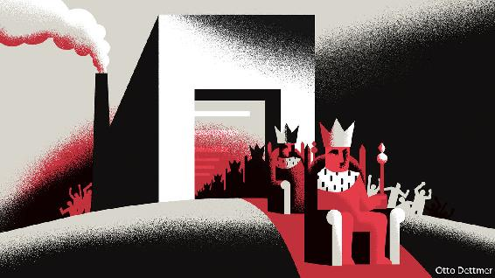

TEN YEARS ago Peter Turchin, a scientist at the University of Connecticut, made a startling prediction in Nature. “The next decade is likely to be a period of growing instability in the United States and western Europe,” he asserted, pointing in part to the “overproduction of young graduates with advanced degrees”. The subsequent surge in populism in Europe, the unexpected votes in 2016 for Brexit and then for President Donald Trump in America, and a wave of protests from the gilets jaunes to Black Lives Matter, has made Mr Turchin something of a celebrity in certain circles, and has piqued economists’ interest in the discipline of “cliodynamics”, which uses maths to model historical change. Mr Turchin’s emphasis on the “overproduction of elites” raises uncomfortable questions, but also offers useful policy lessons.

As far back as ancient Rome and imperial China, Mr Turchin shows, societies have veered from periods of political stability to instability, often at intervals of about 50 years. Consider America. Every pundit knows that Congress has become gridlocked, with Democrats and Republicans unwilling to compromise with each other. Fewer know that it was also highly polarised around 1900, before becoming more co-operative in the mid-20th century.

What causes these lurches from calm to chaos? Mr Turchin views societies as large, complex systems that are subject to certain patterns, if not laws. That is an entirely different approach from much of academic history, with its preference for small-scale, microcosmic studies, argues Niall Ferguson of Stanford University. In a paper published this year Mr Turchin (with Andrey Korotayev of the Higher School of Economics in Russia) examines the prediction of instability he made in 2010. His forecast model contains many elements, but like Karl Marx Mr Turchin seems to believe that “the history of all hitherto existing society is the history of class struggles.” Where Marx focused on the proletariat, though, Mr Turchin is more interested in the elite—and how its members struggle against each other.

Who counts as the elite, and how competition manifests itself, varies from place to place; one example could be a large number of highly educated folk relative to the number of government offices (and therefore jobs). But a struggle is most likely when economic inequality is high. The rewards for being at the top are then especially lucrative, both in terms of earning power and political influence, and those who miss out feel their loss more keenly. The feeling of resentment is particularly strong among people brought up to believe that they ought to be in the elite. Worse still, societies tend to produce ever more would-be elites, in part because access to education tends to improve over time. Mr Turchin sees all this as a recipe for political chaos. Articulate, educated people rebel, producing a scramble for political and economic power. Elites stop co-operating, counter-elites emerge, and order breaks down.

The argument undoubtedly papers over historical nuance. Yet focusing on dissatisfied elites is not a bad way of understanding political instability. Hugh Trevor-Roper, a historian, noted that “social crises are caused not by the clear-cut opposition of mutually exclusive interests but by the tug-of-war of opposite interests within one body.” The French Revolution was not primarily the product of misery but instead of a battle between an underemployed educated class and hereditary landowners. Historians identify “the problem of an excess of educated men” as contributing to Europe’s revolutions of 1848. Mr Turchin suggests that though slavery was the proximate cause of the American civil war, a more fundamental one was resentment from up-and-coming Northern capitalists towards stuck-in-their-ways Southerners.

Elite overproduction can also help explain the malaise gripping the rich world of late. It has become extraordinarily difficult for a young person to achieve elite status, even if she works hard and goes to the best university. House prices are so high that only inheritors stand a chance of emulating the living conditions of their parents. The power of a few “superstar” firms means that there are few genuinely prestigious jobs around. Mr Turchin reckons that each year America produces some 25,000 “surplus” lawyers. Over 30% of British graduates are “overeducated” relative to their jobs.

All this goes some way to explaining an apparently puzzling trend: why apparently well-off people are drawn to radicalism. Under Jeremy Corbyn Britain’s Labour Party attracted more upper-middle- and middle-class folk than it used to, even as it moved further left from the Tories; its lead among recent graduates was clear. Joe Biden’s lead over Bernie Sanders in opinion polls during the Democratic primaries was far smaller among college-educated Americans than among those who did not finish high school.

Predicting an earthquake

Mr Turchin’s theories predict that political tremors eventually subside. “Sooner or later most people begin to yearn for the return of stability and an end to fighting,” he argues. Already the data show that support for both left- and right-wing populist parties in Europe is waning. Polls suggest Mr Trump will soon be voted out of office. Another option for those looking to avoid instability is to reduce the number of aspiring elites. Boris Johnson, Britain’s prime minister, has pressed for better vocational education, saying that “We need to recognise that a significant and growing minority of young people leave university and work in a non-graduate job.”

Yet enlightened elites can prevent the emergence of political instability in more effective ways. In the early 20th century American reformers raised inheritance taxes to prevent the emergence of a hereditary aristocracy, and engaged in massive trust-busting. Modernising urban-planning systems could lower housing costs, and deregulating labour markets would help create good jobs for “excess” elites. Mr Turchin’s analysis of the structural forces governing societies is an intriguing explanation of political unrest. But cliodynamics need not be destiny. ■

This article was downloaded by calibre from <https://www.economist.com/finance-and-economics/2020/10/24/can-too-many-brainy-people-be-a-dangerous-thing>

| Section menu | Main menu |

| Next | Section menu | Main menu | Previous |

We’re hiring

Wanted: a new writer to cover finance

Oct 24th 2020 |

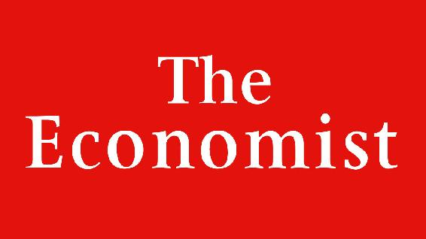

Job ad: The Economist is looking for a writer to cover global finance and the City of London. Please send a CV, a covering letter and an unpublished 800-word article suitable for publication to financewriter@economist.com by November 7th 2020.

This article was downloaded by calibre from <https://www.economist.com/finance-and-economics/2020/10/24/wanted-a-new-writer-to-cover-finance>

| Section menu | Main menu |

# Science & technology

* Controlling the pandemic: When doctors disagree
* Autonomous vehicles: Look, no hands!
* Space exploration: Close encounters of the sampling kind
* Ecology: Time to unwire

| Next | Section menu | Main menu |

Controlling the pandemic

Should covid be left to spread among the young and healthy?

Two petitions by scientists clash on the matter

Oct 21st 2020 |

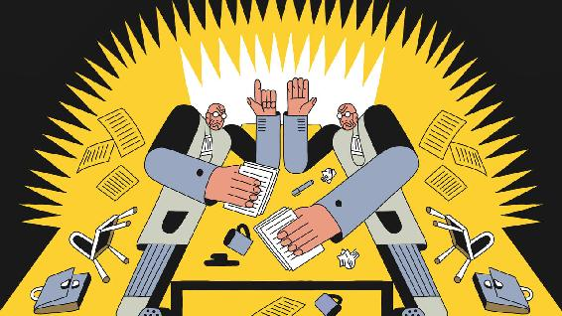

Editor’s note: Some of our covid-19 coverage is free for readers of The Economist Today, our daily [newsletter](https://my.economist.com/user#newsletter). For more stories and our pandemic tracker, see our [hub](https://www.economist.com/news/2020/03/11/the-economists-coverage-of-the-coronavirus)

AS NEW WAVES of covid-19 sweep the world, lockdowns are back in fashion. This time, though, they are a harder sell. They certainly save lives. But it is now clear that the lost jobs, the disruption to education and medical services, and the harm to mental health that they cause all exact tolls of their own—and these are paid not just in misery, but in deaths. Systems of “test and trace”, intended to stop those exposed to the virus from passing it on, seem to have worked in some places, but not in others.

In the absence of a vaccine, or of effective drug treatments, the question of how much longer this can go on for is thus being asked more insistently. And on October 4th a trio of public-health experts from Harvard, Oxford and Stanford universities put out a petition calling on governments to change course in a radical way.

The Great Barrington Declaration, named after the town in Massachusetts where it was signed, proposes that the contagion be allowed to spread freely among younger and healthier people while measures are taken to protect the most vulnerable from infection. This approach rests on the concept of “herd immunity”, whereby the disease would stop spreading when a sufficient share of the population had become immune as a result of infection.

Thesis

That is a controversial idea. And on October 14th another group of health experts published a rebuttal in the Lancet, calling the declaration “a dangerous fallacy unsupported by scientific evidence”. Their letter has a grand title, too: the John Snow Memorandum, named after an Englishman who established the principles of epidemiology in the 1850s. It urges governments to do whatever it takes to suppress the spread of SARS-CoV-2, the coronavirus that causes the illness. In particular, it calls for continuing restrictions until governments fix their systems to test, trace and isolate infected people. Online, the duelling petitions have each gathered thousands of signatures from scientists around the world.

The Great Barrington proposal is a risky one. Any judgment about whether natural infection can create herd immunity to SARS-CoV-2 is premature. It has not yet been established whether infected people develop durable immunity against reinfection—and if so, how common that immunity might be. Few cases of reinfection have yet been confirmed conclusively. (This is done by establishing that the genomes of the virus particles found the first and second times around are indeed different, meaning the second infection cannot be a continuation of the first.) Lots of reinfections could, though, be happening undetected. About 80% of those infected with SARS-CoV-2 have mild symptoms, or none at all. The vast majority of these mild cases are not getting tested, even in countries with ample testing capacity.

The ideal study to settle this uncertainty would involve retesting frequently a large cohort of people known to have been infected in the past, to see how many become infected again. But identifying those who have had mild or symptom-free infection is hard. Tests that look for antibodies against SARS-CoV-2 in big surveillance studies often fail to detect those antibodies in mild cases. Some studies have found that antibodies in these patients wane over time. But whether that equates to waning immunity is still unknown.

If the immune response to SARS-CoV-2 is anything like that to the other six coronaviruses which infect human beings, letting it spread would eventually slow transmission down—for a period. The question is how long that period would be. Four of the six cause symptoms described as “the common cold” (though other types of viruses cause colds as well). Infection with these confers protection that typically lasts for less than a year. The other two human coronaviruses, SARS and MERS, cause serious illness. Immunity to these is estimated to last for several years. If protection in the case of SARS-CoV-2 is short-lived or not particularly strong, the virus will keep surging in recurrent epidemic waves, much as happens each winter with other respiratory bugs. If it is longer-lived, the Great Barrington argument is more plausible.

Antithesis

The authors of the John Snow memorandum argue, though, that deaths and disability under the Great Barrington plan would be huge, even if the herd-immunity gamble is on the money. The share of the population which would need to be infected depends on how easily SARS-CoV-2 spreads. In its simplest form, the herd immunity threshold as a fraction of the population is 1-(1/R), where R is the average number of people who catch the virus from an infected person. With no social distancing, the R values for Europe are in the range of 3-4, meaning that herd immunity would kick in when two-thirds to three-quarters of people have been infected (see chart 1). This formula, though, assumes everyone has the same chance of infection, which is not the case in reality. If chances of infection vary, then the threshold is lower than the formula suggests. And this may matter. Young people, for example, have more contacts than oldsters, and are thus more likely to pick the virus up. Some models which assume plausible variety in contact rates have concluded that the herd-immunity threshold in western Europe could therefore be as low as 43%.

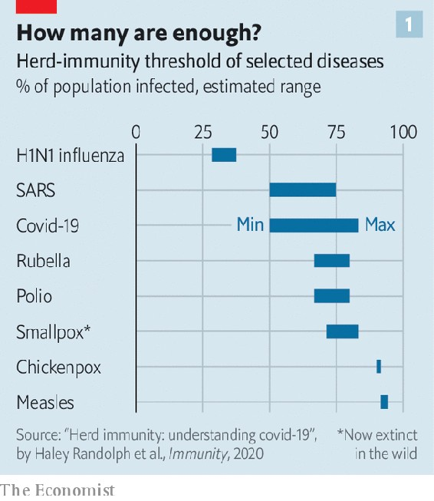

It is also possible that this threshold has been lowered by pre-existing immunity conferred by past infections with cold-causing coronaviruses. That sort of protection would come from memory T-cells, another part of the immune system’s armamentarium. Unlike antibodies, which are custom-made to attack a given pathogen, T-cells are less picky in recognising and going after a harmful invader. Several studies of blood samples taken before SARS-CoV-2 emerged have found T-cells that put up a robust reaction to that virus in 20-50% of cases. This is an exciting result. But it is not yet known whether people with such T-cells will have less severe covid-19 disease, or none at all, if they are exposed to SARS-CoV-2 in real life. An outbreak of covid-19 on a French aircraft-carrier did not come to a halt until 70% of the crew had become infected, which suggests that cross-protection from common-cold infections may just be a nice theory.

All this means that if SARS-CoV-2 is left on the loose perhaps half or more of people will become infected over the course of six months. The Great Barrington proposal is that, as this happens, countries must double down on protecting the most vulnerable. Identifying who these vulnerable people are is not a foolproof task, but knowledge about the worst combinations of risk factors is getting better. A paper published in the BMJ on October 20th describes a covid-19 risk calculator that predicts an individual’s probability of hospitalisation and death, using data on 6m people in Britain. Validation of this algorithm on 2m others showed that the 5% of people predicted to be at greatest risk by the calculator accounted for 75% of the covid-19 deaths.

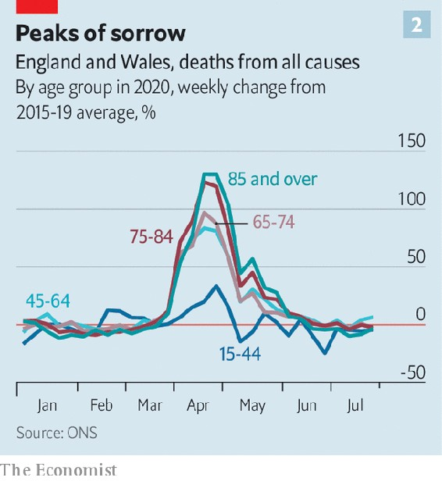

But awareness of such risk scores or simpler markers of high risk (old age, obesity and diabetes in particular) is all too often of little use in practice. Most people cannot change their lives in ways that eliminate their risk of infection, particularly when there are lots of infections all around. Those who care for them, or live in the same home, would get infected at some point—and unwittingly pass the virus on. Though most deaths from covid-19 are among the elderly, many adults in younger age groups are at high risk. At the peak of the covid-19 epidemic in England and Wales deaths among people aged 45 to 64 years were 80% higher than usual (see chart 2) despite a lockdown and official advice to the most vulnerable to “shield” from the virus by not leaving their homes at all.

Although the vast majority of people do not get seriously ill if covid strikes, as many as 5% of those who develop symptoms may remain unwell for at least eight weeks (a condition known as “long covid”). Some of them have not recovered after six months, and there are fears that they may never get back to normal. Even if less than 1% of the infected end up in this unlucky group, for a country the size of Britain that would be hundreds of thousands of people with lifelong disability. Another big unknown is whether there are any hidden health consequences of the virus that may show up in the future. Some studies have found subtle heart changes following mild covid-19. It may not be clear for years whether these lead to serious heart problems for some people, or do not matter at all.

Synthesis?

The Great Barrington plan, then, is a high-risk, high-reward proposition. The John Snow one, by contrast, would minimise covid deaths in the short term, but lives lost in the long-term, because of lockdowns and other disruptions, might end up being more numerous. Over time, as governments fix the test and trace systems that are needed to replace the broader restrictions, the motivation for the Great Barrington course of action will become less potent.

With luck, this whole debate will be rendered irrelevant by the invention of a vaccine or the development of suitable drugs to treat covid. The results of several efficacy trials of vaccines, and tests on promising pharmaceuticals, are expected in the coming weeks. If covid-19 is less deadly and some herd immunity comes from a vaccine, the paths charted by the two petitions will, eventually, come together. ■

This article was downloaded by calibre from <https://www.economist.com/science-and-technology/2020/10/21/should-covid-be-left-to-spread-among-the-young-and-healthy>

| Section menu | Main menu |

| Next | Section menu | Main menu | Previous |

Look, no hands!

A driverless lorry takes on the “Top Gear” track

It is ready to start earning a living

Oct 20th 2020 | DUNSFOLD AERODROME

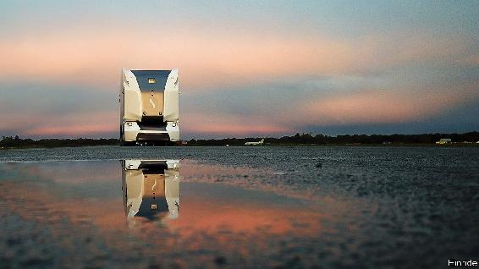

THANKS TO “Top Gear”, a British television show for motoring enthusiasts that is now a global brand, a former second-world-war airfield called Dunsfold has become one of the best known testing tracks in the world. On October 15th, however, instead of reverberating to the roar of supercars driven by the show’s anonymous racing driver, the Stig, it witnessed the sight of what appeared to be the cabless trailer of an articulated lorry belting almost silently around the course at over 80kph.

The Pod (see picture), as this vehicle is known, was made by Einride, a Swedish firm founded in 2016 by Robert Falck, an engineer who used to work for Volvo. Mr Falck thinks that the technology of vehicle autonomy, long experimental, has now evolved sufficiently for driverless goods vehicles to begin earning their livings properly. Some Pods are already in trials for real jobs: running between warehouses, hauling logs from forests and delivering goods for Lidl, a supermarket group.

Pods use the same technology of cameras, radar, lidar (the optical equivalent of radar) and satellite-positioning as other contenders in the field, but they differ from those others in the way their maker tries to deal with the regulatory concerns which prevent fully autonomous vehicles from being let loose on public roads. Einride’s approach, at least at the moment, is to avoid these by avoiding the roads in question. Instead, the Pod’s first version operates on designated routes within the confines of enclosed, private areas such as ports and industrial parks. Here, Pods act like bigger and smarter versions of the delivery robots which already run around some factories—though by having the ability to carry 16 tonnes and with room on board for 15 industrial pallets’-worth of goods they are indeed quite a lot bigger.

The second difference from most other attempts at vehicle autonomy is Einride’s approach to the word “autonomy”. Some makers take the idea literally, and aim to keep humans out of the decision-making loop entirely. Others, often prompted by traffic regulations, arrange things so that a normally passive human occupant can take the controls if necessary. Pods represent a third way. They always have a human in the loop to keep an eye on what is happening and to take over the driving for a difficult manoeuvre or if something goes wrong. But this human operates remotely.

Having the driver sitting back at HQ rather than in the vehicle itself is a departure from convention, but not a huge one. Aerial drones are usually controlled in this way. The radical step is that Mr Falck believes you do not need a remote driver for each Pod. Einride already uses one person to control two Pods, but plans eventually for a single driver to look after ten.

How regulators will take to that for use on open roads remains to be seen. Much will depend on how often the remote driver has to intervene. If not very often then monitoring simultaneous Pods might be considered acceptable. Again, this could come about in a similar way to that in which drones have entered the market. At first regulators banned flights that were out-of-sight of the remote pilot, but as operating experience has shown such flights to be safe, they are often allowed these days. Now, some test flights using multiple drones controlled by one remote pilot have been given permission.

Having tested the area-restricted version of the Pod, Einride is now developing Pods intended to venture onto local roads, and one suitable for motorways is planned for 2023—with remote operators, if allowed. Though Pods working in private enclosed areas have their speeds restricted to 30kph or so, to help with multiple remote-monitoring, those intended for public roads will operate at higher speeds and be equipped with more powerful, long-range sensors. All these vehicles, if successful, promise not only a change in the way that goods are delivered, but also the possibility of another of the oddball races “Top Gear” is famous for—between the Stig in a conventional lorry and, with its speed governor disabled for the day, the electronic system guiding one of Mr Falck’s creations. ■

This article was downloaded by calibre from <https://www.economist.com/science-and-technology/2020/10/20/a-driverless-lorry-takes-on-the-top-gear-track>

| Section menu | Main menu |

| Next | Section menu | Main menu | Previous |

Close encounter

An American spacecraft, OSIRIS-REx, grabs a bit of an asteroid

A sample should now be on its way to Earth

Oct 21st 2020 |



ON OCTOBER 20TH an American spacecraft called OSIRIS-REx played tip and run with Bennu, an asteroid it has been orbiting since December 2018. At 10.12pm Universal Time its three-metre-long sampling arm puffed a blast of nitrogen onto Bennu’s surface. This liberated small pieces of rock, some of which, it is hoped, will have entered the arm’s collection chamber. The aim was to gather at least 60g of material. If that proves not to have happened, then the craft carries enough nitrogen for two more attempts to be made in future months.

The plan is that OSIRIS-REx will return its booty to Earth in September 2023. If all has gone well this will, by then, be the third asteroid sample brought back by a space vehicle. One was delivered in 2010 by Hayabusa, a Japanese probe. A second, now on board Hayabusa’s successor, Hayabusa2, should arrive on December 6th this year.

Bennu belongs to the C (for carbonaceous) class of asteroid. That its surface is rich in carbon compounds is known from the spectrum of its reflected sunlight. About three-quarters of asteroids so far discovered are C-class. They are thought to be composed mostly of material that has not been exposed to high temperatures since the beginning of the solar system (many other types of asteroid, by contrast, were once part of planetoids with stony mantles and metallic cores formed by melting of the materials those bodies coalesced from). That there were a lot of carbon-based molecules around so long ago is of particular interest to those trying to understand the origin of life.

Though bits of asteroids fall to Earth every day as meteorites, samples collected directly from those bodies provide material unaffected by the heat and chemical change caused by high-speed passage through Earth’s atmosphere and subsequent contact with the ground. Just how valuable it will be to have such pristine but costly material to study as well as the free stuff delivered from the sky remains to be seen. But as a demonstration of technological expertise, OSIRIS-REx’s pick-up was awesome.

This article was downloaded by calibre from <https://www.economist.com/science-and-technology/2020/10/21/an-american-spacecraft-osiris-rex-grabs-a-bit-of-an-asteroid>

| Section menu | Main menu |

| Next | Section menu | Main menu | Previous |

Ecology

Fences are bad for wildlife

Where possible, they should be removed or redesigned

Oct 24th 2020 |

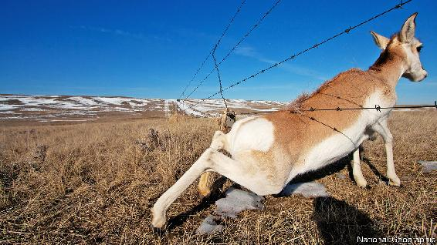

EARTH’S LONGEST artificial structure is usually said to be the Great Wall of China. Just how long that is is hard to say, for northern China actually has many walls, built at different times and not always interconnecting. Earth’s second-longest artificial structure, though, is not a wall, but a fence. Its length is known exactly. It stretches for 5,614km across eastern Australia and is intended to stop the country’s native feral dogs, the dingoes, which live mainly to its north, from preying on sheep, which are farmed mainly to its south.

Australia’s dingo fence is remarkable. But it does not stand alone. Millions of kilometres of fences wrap the world, outstripping the collective length of its roads by something like a factor of ten. Some are intended to curb the movement of animals, some the movement of people, and some merely to mark the limits of territory, so that everyone knows who owns what.

Even fences built for other purposes, though, often serve to constrain animals, too. For example, some ecologists worry that the barrier now being erected along the border between America and Mexico, to stop the movement of human migrants, will also disrupt movement of endangered large mammals such as the Sonoran pronghorn and the desert bighorn sheep.

Such worries are not foolish. Hardening borders in Central Asia, coupled with the expansion of fenced railways, have reduced numbers of another large, endangered mammal, the saiga antelope. Highway fencing in Sweden, erected to separate elks from speeding Volvos, limits those animals’ ability to range freely, and thus to find enough food. The region around the Maasai Mara game reserve, in Kenya—one of the world’s most famous—has also suffered. Growth in the amount of local livestock has led to the erection of fences that restrict the migration of wildebeest, zebras and Thomson’s gazelles, threatening a severe decline in their population.

Disputed boundaries

Until recently, data like these on the effects of fences on wildlife have been piecemeal. That has changed with the publication, in Bioscience, of a report compiled by Alex McInturff of the University of California, Santa Barbara. Dr McInturff and his colleagues have attempted a comprehensive review of the scientific literature about fences and their environmental impact.

One discovery they have made is that more than half of published fence research focuses on just five countries—America, Australia, Botswana, China and South Africa—with America alone making up over a fifth. A second is that only a third of these studies examined the impact of fences on anything other than the target species involved, meaning the animals explicitly intended to be kept in or out.

Non-target species, however, are often those that have their fortunes most drastically reshaped by the appearance of poles and wire. Australian fences intended to keep out dingoes and other pests are also barriers to long-necked turtles, which travel great distances over land when moving between nesting sites. In Botswana veterinary fences erected to spare cattle from wildlife-borne disease result, as in the case of the Mara, in serious interference with wildebeest migrations. Fencing intended to protect the Qinghai-Tibet railway, in China, has similarly affected the migration routes of Tibetan antelope. Pangolins curl up into a ball when endangered, in order to protect their soft underbellies. This is generally a wise move, but not when it causes them to embrace the wire of an electrified fence. Pronghorn tend to crawl under fences rather than jump over them (see picture), leading to hair loss that can increase the risk of hypothermia. And so on.

Not every creature fares badly. Hawks in Montana gladly perch on newly erected livestock fencing to prey on small herbivores, while fence-dwelling spiders in South Africa outperform their tree-based cousins when it comes to catching insects. Often, though, the winners are creatures that cause trouble for existing ecosystems. Excluding dingoes from large parts of Australia has allowed invasive red foxes to multiply, free from attack by what is, since the extinction of the thylacine, the country’s top predator. Native rodents have suffered as a result. Some have been brought to the brink of extinction. And fences erected around Tawharanui, a reserve in New Zealand, have successfully excluded many undesirable large mammals that threaten the indigenous birdlife, but also keep out predators of house mice, an egg-eating alien whose numbers continued to rise.

No sitting on the fence, please

Smarter fencing can help. In the American West, for example, Montana and Wyoming are mounting campaigns to replace decades-old fences with ones that are more ecologically friendly. The changes required are often small. Making fences low enough for deer to jump over helps. So does raising the bottom wire sufficiently to allow pronghorn to crawl underneath. Adding horizontal poles improves a fence’s visibility, stopping unfortunate collisions at speed. And not all wire need be barbed.

There is, though, also a need to paint a clearer picture of where fences are, and to remove those past their prime. Such flimsy structures are seldom well-documented and are difficult to pick out in satellite photographs, so doing this can be hard. Jeffrey Masek, a specialist in Earth-imaging at NASA, America’s space agency, suggests instead using commercial drones, which fly at low enough altitudes to capture detailed pictures. Derelict fences are of use to neither man nor beast. To beasts, in fact, they are positively anathema.■

For more coverage of climate change, register for The Climate Issue, our fortnightly [newsletter](https://www.economist.com/theclimateissue/), or visit our [climate-change hub](https://www.economist.com/news/2020/04/24/the-economists-coverage-of-climate-change)

This article was downloaded by calibre from <https://www.economist.com/science-and-technology/2020/10/24/fences-are-bad-for-wildlife>

| Section menu | Main menu |

# Books & arts

* Internal exile: Worlds of their own
* American fiction: Made for you and me
* The Spanish civil war: ¡No pasarán!
* North Korean architecture: Despot decor

| Next | Section menu | Main menu |

Worlds of their own

Giving up on politics is often tempting. It is also risky

In a polarised age, some on both left and right are choosing internal exile

Oct 24th 2020 |

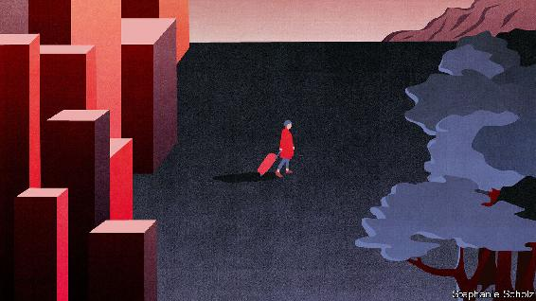

Live Not By Lies. By Rod Dreher. Sentinel; 256 pages; $27.

WORLDLY SUCCESS has not made Rod Dreher fonder of the world as he finds it. In “The Benedict Option”, published three years ago, the veteran commentator on religious affairs lamented that conservatives like him had been utterly vanquished in America’s culture wars. The moral gap between liberals and traditionalists had become unbridgeable, he argued; the only hope for the godly lay in abandoning the fight for power and withdrawing from the social mainstream into self-contained families and communities.

“The Benedict Option” was a bestseller. So warm and widespread was the acclaim that its Manichean pessimism seemed to have been disproved. But Mr Dreher has not mellowed. In his new book he compares the situation of observant Christians in America to dissidents, especially religious ones, in the Soviet Union. The title, “Live Not By Lies”, invokes Alexander Solzhenitsyn, who told his compatriots that even if they could not oppose Soviet rule, they should avoid colluding with it.

Plenty of believers, in America and elsewhere, share Mr Dreher’s sense of alienation. But his work resonates for another reason. Many others who disavow the rest of his worldview have confronted the basic choice that he lays out: participation or flight. That fraught dilemma seems especially acute in an age of sharply polarised politics, but it is ancient.

Visiting Russia, Mr Dreher learns how honest Soviet citizens tried to avoid having much to do with the system. Geology was a popular discipline among scientists, as it let researchers spend a good portion of their lives in far-flung and unsullied places. (Humbler jobs as furnace-stokers or nightwatchmen were another refuge for free spirits.) Mr Dreher also speaks to people who lived through communism and know modern America. These battle-hardened folk say they find something horribly familiar about the emergence of intolerant thought police who can ruin careers, in academia or the professions, as punishment for dissent from the new orthodoxies on gender, race or sexuality.

Whatever you make of that analogy, there are some fundamental parallels between the two places. Like Russia, America is vast, meaning retreat has always seemed physically possible, even enticing, whether in the mountains of Idaho or the Arizona desert. Motives for withdrawal have included ideological dissent, Utopian experiments, eschatological hopes, the avoidance of social or technological change or the acceleration of such change. America has its Amish communities; the taiga and steppe of tsarist Russia accommodated schismatic groups such as the Old Believers, who were theologically conservative but economically progressive.

Today the kind of flight proposed by Mr Dreher need not be physical. You can live on a remote island and engage furiously in political battles (Mr Dreher wages his own from Baton Rouge, Louisiana). Conversely, a city-centre flat can be a place of isolation, embraced for intellectual reasons as well as pandemic-related ones. And in many modern democracies lots of liberal-minded people, too, have been tempted to desert the political and social mainstream, with or without a change of place. That has been most starkly true in cantankerous America and Brexit-era Britain.

Anthony Barnett, an English writer on democracy, observes a mood of retreat among older, left-leaning people in England and America: some over 50 are, he says, withdrawing from active politics into un-ideological passions such as gardening. The impulse, he thinks, derives less from fatalism than from an awareness that the job of fixing a broken system properly belongs to a younger, untarnished generation. The older cohort “know they were part of the problem”.

Retreat and reflection are a healthy response for liberal-minded activists chastened by populism, reckons Hugo Dixon, a co-leader of the failed campaign for a second popular vote on Brexit. They must ponder why the old managerial style of politics was rejected in favour of abstract values like meaning and community. Nor are they the only ones to feel desolate or, for the time being, politically homeless. Linda Bilmes, a professor of public policy at Harvard who served in Bill Clinton’s administration, points to the cadre of moderate Republicans who have been driven to abandon the fray. Whatever its outcome, the impending presidential election may push some Americans into a sort of internal exile.

The case of Socrates

Conservatives longing for a safe space to marry and bring up children as they see fit; liberals in search of a quiet spot to lick their wounds: another category of people may harbour a different worry—about the impact on social cohesion when the disillusioned withdraw. One risk is that their flight from the arena will leave it free for opportunists and cynics, and that politics enters a degenerate spiral. Alongside that concern is a long-standing question of personal morality. If you are deeply convinced that the present order is wrong, do you have the right to opt out rather than remaining engaged and working for change?

Among the philosophical currents that shaped the West, a powerful one insists not merely on the right to engage in public debates, but on the duty. The great Anglo-Irish theorist Edmund Burke reputedly warned that evil would prevail if good people stood aside. You need not be a totalitarian to find merit in Karl Marx’s adage that philosophers must change the world as well as understand it.

More recently some of the Frankfurt School of German thinkers, such as Theodor Adorno, took refuge from Nazism in the United States; but their critique of modern society and populist culture, for all its cerebral opacity, was meant for active use, not just idle observation. Their ideas probably helped shape post-war German culture and immunise it against fresh totalitarian temptation.

In some circumstances, the calculus changes. Former dissidents of the kind Mr Dreher meets might insist that the Soviet regime offered no leeway for improvement. Preserving their own integrity was as much as they could do—and that in itself could amount to a profound moral statement, incurring harsh retribution. Rancorous as they can be, though, have America and other democracies really reached a similar point now? After all, for those who abhor national politics, there is a glorious array of alternative forms of engagement—from voluntary groups and local civic initiatives to conservation movements, not to mention the free exercise of speech online and elsewhere.

As it happens, the world’s first democracy, in ancient Athens, also fretted over degrees of participation and the price of withdrawal. Many Athenians resented the apparent indifference to politics of the city’s wisest person, Socrates; some alleged, not absurdly, that his seeming apathy had opened the way for vicious interludes of authoritarianism.

On trial for his life, Socrates insisted he was anything but indifferent to the city’s welfare. He simply chose to stand a few paces back, challenging his fellow-citizens by asking basic, awkward questions and hence prodding them, like a gadfly, to act more wisely. “Socrates was not a quietist,” says Paul Cartledge, a British expert on ancient democracy. The trouble was that some of his compatriots “saw politics, like religion, as something to be done in public if it was done at all”.

Today’s representative democracy finds it easier to accommodate a division of labour between thinkers and doers, actors and observers, participants and abstainers. Many citizens eschew even the minimal commitment of voting. But those who abstain will always face hard questions about whether leaving the stage was the only way to enact their principles. ■

This article was downloaded by calibre from <https://www.economist.com/books-and-arts/2020/10/24/giving-up-on-politics-is-often-tempting-it-is-also-risky>

| Section menu | Main menu |

| Next | Section menu | Main menu | Previous |

Made for you and me

Ayad Akhtar is a bard of American discontent

“Homeland Elegies” dwells on the question of belonging

Oct 24th 2020 |

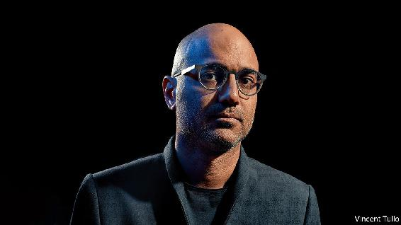

Homeland Elegies. By Ayad Akhtar. Little, Brown; 368 pages; $28. Tinder Press; £18.99.

AYAD AKHTAR is best-known for his fearless theatre plays about Muslims, America and finance, the first of which, “Disgraced”, won a Pulitzer prize. “Homeland Elegies”, his new novel, affirms his talent for storytelling and dazzling prose. This tale composed of many tales also delivers a blistering critique of America’s trajectory over the past 20 years.

Recently named president of PEN America, a literary and human-rights organisation, Mr Akhtar has written prolifically on American society. His first novel, “American Dervish”, was about Muslim life in the Midwest; this one follows his parents’ generation of Pakistani immigrants and their struggle to assimilate, a struggle that divides a father and his American-born son. Partly autobiographical, it is at once funny and furious, despairing and indignant.

The narrator, a prizewinning playwright like the author, kicks off his excoriating portrait of a dysfunctional country with a hilarious set piece on his father’s infatuation with Donald Trump. It is the 1990s and Sikander, a renowned cardiologist, is sent to treat the reality-TV star for a heart problem, and becomes his greatest fan. Yet as the book unfolds, America proves to be as gripped by “irrational paranoia” as Pakistan. Along the way the narrative takes dozens of detours: it is an enfilade of stories, succeeding one another like the rooms at the Palace of Versailles.

Personal and family episodes mix with riffs on economics and history, from Indian Partition to antitrust law and Islamic beliefs. Riaz, a hedge-fund manager, makes the narrator rich; a pro-Taliban “uncle” is killed by the CIA. Anti-Muslim prejudice bubbles up. When the narrator tries to donate blood on 9/11, a white American screams: “Nobody wants your fucking Arab blood.”

Again and again Mr Akhtar returns to the question of belonging, in both senses. Whose America is this really? Attacks on corporate power and Reaganomics round out his jeremiad from the left. But even readers whose politics differ will be enthralled. The registers somehow fit together, as Scheherazade meets Cassandra in a chain of stories and dreams. He has hit on an ingenious form for the snapshot age of Instagram, as he updates an enduring American drama: from rags to riches—and back again.

This article was downloaded by calibre from <https://www.economist.com/books-and-arts/2020/10/24/ayad-akhtar-is-a-bard-of-american-discontent>

| Section menu | Main menu |

| Next | Section menu | Main menu | Previous |

¡No pasarán!

The tragic idealism of the International Brigades

They remain heroes of the left for their self-sacrifice in the Spanish civil war

Oct 24th 2020 |

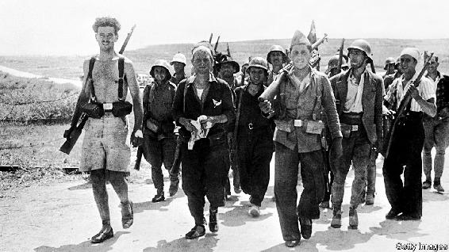

The International Brigades. By Giles Tremlett.Bloomsbury; 720 pages; £30. To be published in America in July 2021; $30.

HISTORY MAY often be written by the victors, but that has never applied to the Spanish civil war. The standard version tells of the Republic’s heroic but doomed struggle against the nationalist forces of Francisco Franco—whose triumph was made possible by Hitler and Mussolini, while Britain and France stood idly by. The role of the International Brigades, in which around 35,000 idealists and adventurers from 65 different countries served, has contributed mightily to the romantic view of a horrible conflict, as have the works by Hemingway, Orwell and Auden that it inspired. Yet it is four decades since a comprehensive history of the Brigaders’ exploits was last published in English.

Making good use of the surviving parts of the International Brigades’ own archive in Moscow, Giles Tremlett, a former Madrid correspondent for this newspaper, sets out to fill this gap. He provides an almost blow-by-blow narrative of what befell the Brigaders, from the arrival of the first foreign volunteers to defend Madrid in August 1936 to the Brigades’ eventual disbandment in September 1938, after a string of bloody defeats by Franco’s superior forces.

Only a handful of the volunteers had military experience and many, particularly the anarchists and the more Utopian socialists, had unrealistic notions of martial discipline. Despite a largely British myth that they were all leftish intellectuals, most came from working-class backgrounds, often sent to Spain by local Communist parties on orders from the Comintern in Moscow. Many were unemployed or refugees from other parts of Europe—Germany and Italy, but also Poland and Hungary.

Though an attempt was made to organise battalions on the basis of shared language, communication in such a polyglot outfit was a perpetual problem. Yet often with only a few hours’ training, and armed with obsolete rifles, they were thrown into the fight, used as shock troops because of their (initially) high morale, almost suicidal courage and capacity for improvisation. In their first test, the bid to repel the nationalists from the University City area of Madrid, Brigade machine-gunners found that thick library books on German philosophy made excellent sandbags (the bullets rarely got past page 350). Grenades with their pins pulled out were sent in lifts to floors held by Franco’s Moroccan snipers.

Success in the battle for Madrid flattered to deceive. The Republican militias and the International Brigades had shown that they could doggedly secure a position against nationalist attack. The largely defensive battles of Jarama and Guadalajara in 1937—in which the Brigades, taking heavy losses, had played a vital part—were also seen as Republican victories. But prosecuting an effective offensive against a well-equipped professional army was a different matter.

Poor strategic leadership, inferior weapons (the Soviet T26 tank was a rare exception), political divisions, the imported infection of Stalinist paranoia (many Soviet military advisers were sent home to be purged), and, above all, the honing by Franco’s Nazi allies of the Blitzkrieg techniques they were to apply across Europe—all these led to a succession of grim blows to the Republic. By the end of the war, Hitler and Mussolini had sent powerful air forces and 90,000 well-trained troops to ensure Franco’s victory, more than twice the total of foreign volunteers fighting for the Republic, which hoped in vain that the Western democracies would drop their policy of non-intervention.

When the Brigaders staged their farewell parade in Barcelona, only 7,100 were still fit enough to march. The casualties they suffered in two years of combat are disputed, but estimates suggest nearly 10,000 died and about 8,000 were counted as missing. Mr Tremlett reckons one in five of the volunteers became, in Hemingway’s words, “part of the earth of Spain”.

Inevitably, this book is only a very partial account of the civil war, eschewing analysis (particularly of the political context) to maintain a narrative momentum that sometimes stumbles in the fog of war. But as a history of the International Brigades it is meticulously researched and engagingly written. Mr Tremlett resurrects an extraordinary cast of characters, such as the flamboyant generals Kléber and Lukács (the former died in Stalin’s Gulag, the latter in action); the sinister British NKVD spy David Crook; Winston Churchill’s rebellious nephew Esmond Romilly; the young American economics teacher Robert Merriman, who commanded the Lincoln Battalion and was taken prisoner and shot by the nationalists; and the repulsive French Communist leader André Marty, who claimed to have ordered the executions of more than 500 Brigaders.

The best way to describe the Brigaders in all their varieties is as sincere anti-fascists, the author says; as he points out, a disproportionate number were Jewish. But he does not flinch from the brutality, the betrayals and the incompetence of their largely Soviet-directed leaders. The Brigaders remain heroes of the left for their internationalism and self-sacrifice. Mr Tremlett has done them proud. ■

This article was downloaded by calibre from <https://www.economist.com/books-and-arts/2020/10/24/the-tragic-idealism-of-the-international-brigades>

| Section menu | Main menu |

| Next | Section menu | Main menu | Previous |

Despot decor

The curious design features of North Korean hotels

A book of photography offers an offbeat look at a little-seen city

Oct 24th 2020 |

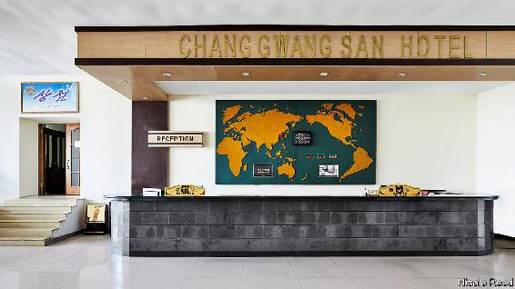

Hotels of Pyongyang. By James Scullin and Nicole Reed. Astral Horizon Press; 200 pages; £50.

AT THE BEGINNING of “Pyongyang”, a song of 2015 by the British band Blur, Damon Albarn, the vocalist, sings about looking down from his window “to the island where I’m held”. The line is a reference to the Yanggakdo Hotel, a 47-floor, 1,000-room monstrosity that sits on an island in the middle of the Taedong, the river that runs through the capital of North Korea.

Most Westerners who come to Pyongyang on organised tours are put up in the same grey tower, which is topped by a revolving restaurant. Though not quite “held” in the hotel, visitors are brought back there by their minders at the end of a day’s supervised sightseeing; wandering around the city by themselves is strictly forbidden. Even inside, it is important to observe the rules. In 2016 Otto Warmbier, an American student, was arrested after allegedly trying to steal a propaganda poster from a restricted area of the Yanggakdo. He fell into a coma in North Korean custody and died shortly after his release in 2017.

Such cautionary tales are not the focus of “Hotels of Pyongyang” by James Scullin, who leads tours of North Korea, and Nicole Reed, a photographer. A short foreword by Mr Scullin acknowledges the importance of hotels as propaganda showcases for the regime, but he stresses that after a few drinks with their guides at the bar, tourists might hear stories about the country that go beyond the party line. Anecdotes about the buildings accompany the images. The Pyongyang Hotel, for instance, is known for having the best coffee in town, as well as the most eye-wateringly expensive. (Mr Scullin does not mention that you have to wait at least half an hour for a cup.)



But the book’s main interest is in the unique design features of the hotels. Even those few Westerners who have ventured to North Korea are unlikely to recognise most of them (the vast majority of visitors to the country are Chinese). Because of the pandemic, North Korea has been off-limits to overseas tourists since the end of January. So, for the moment, those tempted to go—and the many more who never will—can get no closer to a Pyongyang hotel than Ms Reed’s engrossing pictures.



Taken during a trip in April 2019, mostly during the day when guests were on their sightseeing tours, the images are eerily devoid of people. That allows Ms Reed to concentrate on the eccentric details of the hotels’ decor. They all feature a curious combination of Soviet kitsch, pastel colours and individual quirks such as unexpected fairy lights or plastic plants.

Vast breakfast salons boast ballroom-style chandeliers, lurid wall-sized landscape paintings, exuberant tablecloths and ornate chairs. Karaoke parlours have tasselled curtains, elevated stages, marble floors and psychedelic upholstery. Two plastic dolphins dangle forlornly from the ceiling above a blue-tiled pool at the Sosan Hotel. And if there is ever a North Korean remake of “Mad Men”, the curvaceous, turquoise-topped bar at the Pothonggang Hotel would make a fitting set. ■

This article was downloaded by calibre from <https://www.economist.com/books-and-arts/2020/10/24/the-curious-design-features-of-north-korean-hotels>

| Section menu | Main menu |

# Economic & financial indicators

* Economic data, commodities and markets

| Next | Section menu | Main menu |

Economic data, commodities and markets

Oct 22nd 2020 |

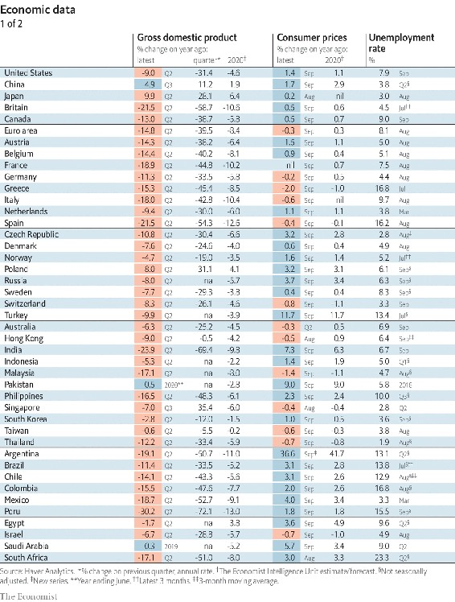

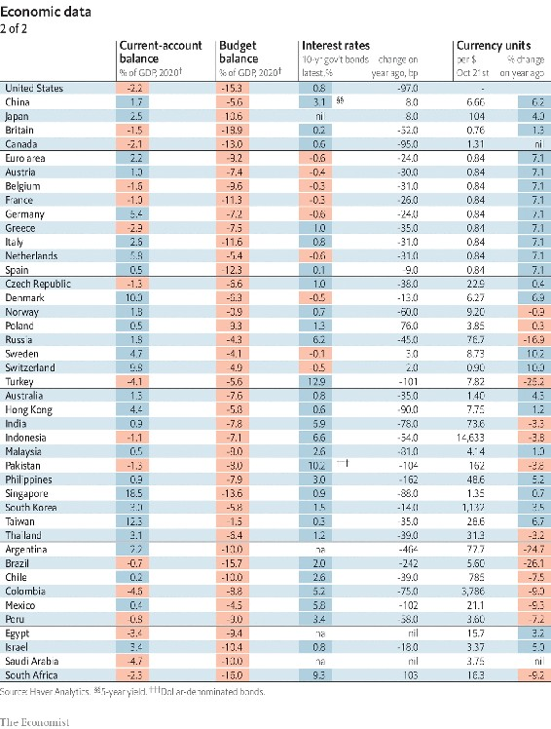

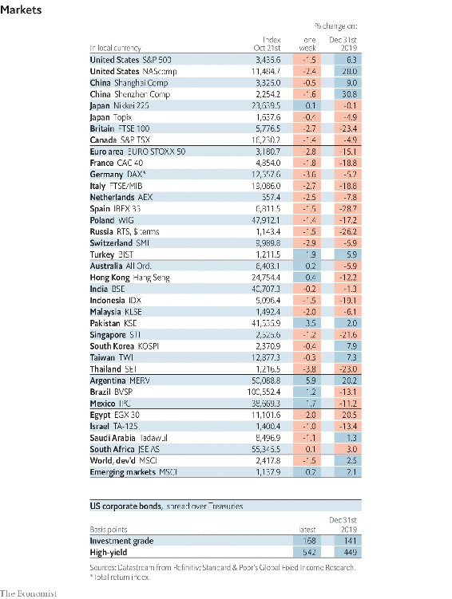

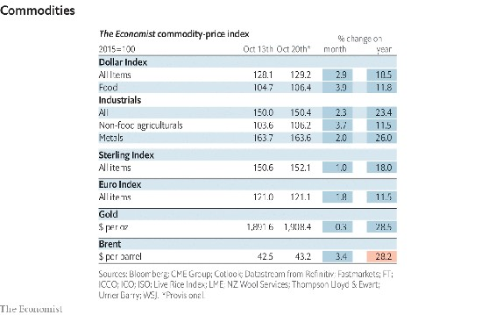

This article was downloaded by calibre from <https://www.economist.com/economic-and-financial-indicators/2020/10/22/economic-data-commodities-and-markets>

| Section menu | Main menu |

# Graphic detail

* Voting in America: Mailing it in

| Next | Section menu | Main menu |

Mailing it in

Postal voting could put America’s Democrats at a disadvantage

Rejection rates for absentee ballots have fallen since 2016, but are higher for non-whites than whites

Oct 24th 2020 |

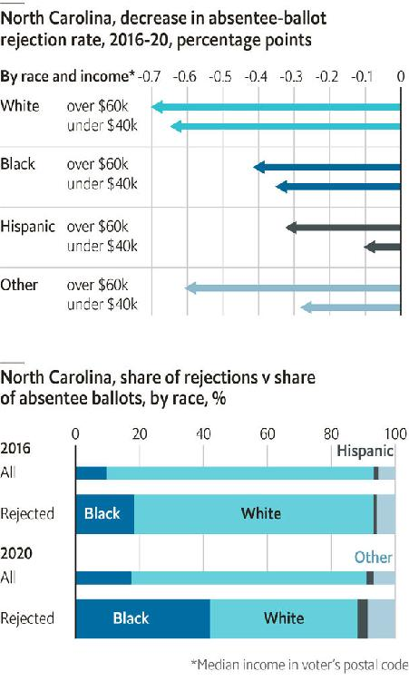

BY THE TIME covid-19 took off in America, the presidential primaries were already wrapping up. However, some later-voting states creaked under a historic load of postal ballots. In primary elections in June, 21% of absentee ballots in New York City were rejected, mainly for hiccups like missing signatures. Such a rate in the general election would put its legitimacy in doubt.

The final impact of a surge in postal voting will not be known until weeks after the election. Yet North Carolina, a closely contested state, releases detailed data on ballots as they arrive. So far, its figures suggest that a tarnished election is unlikely—but that Democrats could be hurt by their disproportionate embrace of voting by mail.

The Tar Heel state has received eight times as many postal votes as it had by this point in 2016. Despite fears about first-time absentee voters botching their ballots, the share that are rejected has in fact fallen to 1.3%, from 2.6% in 2016. This is probably due in part to campaigns educating supporters on voting by mail, and also to new efforts by the state to process such ballots.

However, these gains have been concentrated among white and richer voters, causing North Carolina’s already large racial gap in rejection rates to widen. In 2016 black voters sent in 10% of postal ballots, but 18% of discarded ones. This year, those shares are 17% and 42%. That hurts Democrats, who rely on black voters’ support.

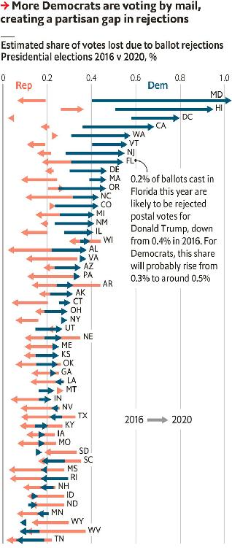

Partisan differences over voting by mail exacerbate this effect. In the past, Democrats and Republicans were equally likely to do so. But polling by YouGov now shows that 51% of likely Democratic voters plan to vote absentee, compared with 32% of Republicans. Extrapolating North Carolina’s patterns nationwide, a model built by Merlin Heidemanns of Columbia University finds that 0.7% of ballots intended for Joe Biden, the Democrats’ presidential nominee, will be rejected postal votes, versus 0.3% of those cast for Donald Trump. The gap is largest in safe Democratic states, but also affects battlegrounds like Florida.

Postal voting does offer Democrats a silver lining. Although absentee ballots are less likely to be counted than are those cast in person, they do not require voters to find a polling place, wait in queues or show ID. They are also immune to illness, weather or other election-day emergencies. If the ease of postal voting raises Democrats’ tally by more than the spoilage rate reduces it, the party would still come out ahead. ■

Sources: Merlin Heidemanns; North Carolina Board of Elections; US Census Bureau; YouGov;The Economist

Dig deeper:  
Read the [best of our 2020 campaign coverage](https://www.economist.com/us-election-2020) and explore our [election forecasts](https://projects.economist.com/us-2020-forecast/president), then sign up for Checks and Balance, our [weekly newsletter](https://www.economist.com/checksandbalance/) and [podcast](https://play.acast.com/podcasts/2020/01/24/checks-and-balance-our-new-weekly-podcast-on-american-politics) on American politics.

This article was downloaded by calibre from <https://www.economist.com/graphic-detail/2020/10/24/postal-voting-could-put-americas-democrats-at-a-disadvantage>

| Section menu | Main menu |

# Obituary

* Samuel Paty: Liberty’s foot-soldier

| Next | Section menu | Main menu |

Liberty’s foot-soldier

Samuel Paty was killed on October 16th

The French schoolteacher, beheaded for instructing children in French secular values, was 47

Oct 22nd 2020 |

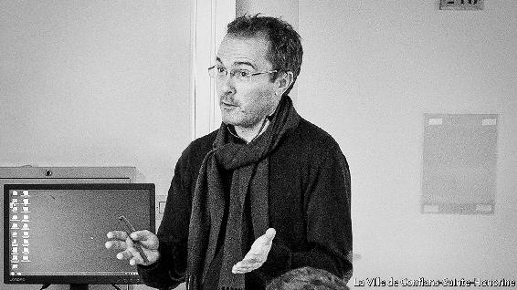

IN CASE ANYONE found his lessons boring—though it was hard to think that even teenagers would be turned off by history, geography or moral and civic education—Samuel Paty liked to pep them up. Art was a good way to do it. For the centenary of the Armistice in November 2018 he took over the art room, spread a white sheet on the floor, and picked seven pupils from troisième, all 14 or 15, to make a splattering mess on it with paint, to represent the war. One of them lay sprawled on it as a dead soldier, while the others, in black, knelt round. Another played a mother reading a letter from her son at the front. A third was a soldier made mad by the fighting, repeating words over and over. At the end they held a minute’s silence. The performance was moving, and made the children think.

The next year he got his class to illustrate “Liberté, Egalité, Fraternité”. They copied each other a bit. Those who drew “Equality” mostly showed it as a body or a face with two equal halves, boy and girl, or brown and white. (The school, the Collège du Bois d’Aulne in Conflans-Sainte-Honorine, north-west of Paris, had a diverse intake of races and religions, though the suburb itself was largely white and middle-class: small detached houses, well-trimmed hedges, tree-lined streets.) Those who drew “Fraternity” based their pictures on a globe, with white and brown hands cradling it into the shape of a heart. “Liberty” proved hardest for them. Quite a few drew the Statue of Liberty combined with the tricolore, and one depicted an open book winged like an angel. The drawing that stood out, when he pegged them up and proudly photographed them for the school website, was a bald staring head with sticking-out ears and, instead of a mouth, a cage.

This sort of thing not only livened up the lessons but also made the pupils think him sympa, even exciting, the teacher they hoped they would get when they changed years. He didn’t look the sort: a shy slight figure with glasses, living in a second-floor flat in an even quieter place, Éragny, with his five-year-old son. (He had moved to the town and to Bois d’Aulne, after a succession of placements in Seine-et-Marne, five years before, when his partner had to transfer for work, but then the relationship had crumbled.) His out-of-school life was mostly tennis, not competitive, just social at the local club, several times a week. Otherwise he kept himself to himself, not seeing much of the neighbours except when he picked up his bread on his walk back from school.

In class, though, he taught with passionate energy, especially on Athenian democracy and the French revolution. He was strict with his pupils, but he cared about them, and had regularly phoned their homes during lockdown to check they were OK (as well as to see where their homework was). Since many were Muslim, he went for a day-course last November at the Institut du Monde Arabe to get a little more into their world. Afterwards he wanted to invite its staff to give a presentation at the school, comparing the music of the Maghreb with that of the medieval French trouvères. Teaching was about opening minds; his, too.

When it came to teaching free speech as part of the national curriculum, he liked to show his quatrième class two caricatures from the magazine Charlie Hebdo which, in January 2015, had been attacked by murdering Islamists. He had done so for several years; this year it had added edge, with the trial of the accomplices going on. The caricatures were, first, Muhammad holding a “Je Suis Charlie” sign, blasphemous to Muslims merely for giving him a face. Most pupils might be unimpressed with that, but the second caricature was clearly rude: Muhammad on all fours, naked, with a star emerging from his backside and the caption “A star is born!”.

Once his pupils had seen the drawings he would explain that French law protected them, as part of the liberty enshrined in the Republic. Then they would debate why and whether it should, not angrily—he insisted on that—but reasonably, carefully marshalling their arguments. Being aware, though, that the caricatures were strong stuff for many 13-year-olds, especially the Muslim children, he warned his pupils at the start that they could look away if they thought they might be offended. He had to be careful, as it was against the law to identify anyone by their religion; the warning had to be general. But he had done all this before, and the result had been a mutually respectful conversation.

This time the backlash was furious. A number of Muslim parents objected, and one filed a complaint to the police. He also posted a video on Facebook to mobilise others, identifying who the teacher was and calling him a voyou, a thug: “He should no longer teach our children. He should go and educate himself.” A known Islamist agitator, Abdelhakim Sefrioui, came to the school and made a video decrying “irresponsible and aggressive behaviour”. The mobiliser’s daughter, Zaina, said the prof wanted to attack Islam, and had done so that day by asking Muslims specifically to raise their hands and then, if they liked, to leave.

That was lies, as he told the police. Zaina had not even been in the class. But at the first claim that the teacher of histoire-géo was an Islamophobe the principal called him in, and her superiors requested a visit by an inspector from the local education authority. They, like the police, supported him, and said he had followed correct classroom procedure. He would not face disciplinary action. The moral and legal weight of the French state was on his side, and he felt confident enough, as well as angry enough, to file a defamation complaint against the parent who had abused him.

He also felt threatened, though. The level of hate in the attacks was quite new, and it had spread wide, far beyond Conflans. Now he kept his head down in the corridors, and was noticeably out of sorts. His walk home from school, a short stroll through a wood, no longer felt safe, so he took the more open, still quiet, still leafy streets. As he set off for home on the 16th he had just finished teaching a class of petits sixièmes about prehistory, a relatively calm subject. The All Saints’ break was about to start, a chance to let things cool down a bit. The tennis court beckoned. He wished his pupils, and they wished him, “Bonnes vacances.” ■

This article was downloaded by calibre from <https://www.economist.com/obituary/2020/10/22/samuel-paty-was-killed-on-october-16th>

| Section menu | Main menu |

Table of Contents

The Economist [Thu, 22 Oct 2020]

The world this week

Politics this week

Business this week

KAL’s cartoon

Leaders

Free speech: Who controls the conversation?

Brexit: Seal the deal

Some lessons from Microsoft: Blue-sky thinking

Financial markets: Young, but not dumb

Illegal fishing: Monsters of the deep

Letters

On the Uyghurs, Venus, Catholic voters, Zoom meetings: Letters to the editor

Briefing

Social media and free speech: The great clean-up

Microsoft: After the reboot

United States

Election uncertainties: The known unknowns

Donald Trump’s record: Pumped up

Trade: Tariff man

Mining for votes in Montana: Gold in them hills

Museum funding: Going, going, gone

The Equality Act: Liberalism and its contradictions

Lexington: The blue wave

The Americas

Chile: In need of a new edifice

Bello: Don’t mess up the miracle

Asia

Disinformation in Myanmar: Anti-social network

North Korea and the world: Not-so-splendid isolation

New Zealand’s election: Labour day

Drugs in India: Weed killers

Banyan: A feverish mood

China

Opinion polls: The 1.4bn-people question

Economic rebound: A big splash

Chaguan: Be China’s friend, or else

Middle East & Africa

Egypt: No contest

America and the Middle East: Waiting game

Tanzania’s elections: The bulldozer rumbles on

Conservation in Africa: Elephants’ graveyard no more

Police violence in Nigeria: The young have had enough

Europe

Covid-19 in Europe: A patchwork of red, yellow and green

Swedish defence: Less neutral, more beefy

Georgia: Misha’s return?

France: The sacred right to offend

Charlemagne: A powerful yet puny parliament

Britain

London as a financial centre: Brex and the City

Elected mayors: Our friends in the north

Social care: Big old problem

Brexit and data firms: Inadequate

Bagehot: What Biden would mean for Boris

International

Felonious fishing: The outlaw sea

Business

Italian business: How the leopard lost its spots

Technology and competition: Search query

Utilities: What next

Bartleby: Fighting spirit

Schumpeter: Free the data serfs!

Finance & economics

Millennials and finance: The generation game

The World Trade Organisation: The home straight

Lael Brainard: Top contender

Emerging markets: The rule-makers

Price gouging: Disaster profiteering

Buttonwood: A new career in a new town

Free exchange: Graduates of the world, unite!

We’re hiring: Wanted: a new writer to cover finance

Science & technology

Controlling the pandemic: When doctors disagree

Autonomous vehicles: Look, no hands!

Space exploration: Close encounters of the sampling kind

Ecology: Time to unwire

Books & arts

Internal exile: Worlds of their own

American fiction: Made for you and me

The Spanish civil war: ¡No pasarán!

North Korean architecture: Despot decor

Economic & financial indicators

Economic data, commodities and markets

Graphic detail

Voting in America: Mailing it in

Obituary

Samuel Paty: Liberty’s foot-soldier